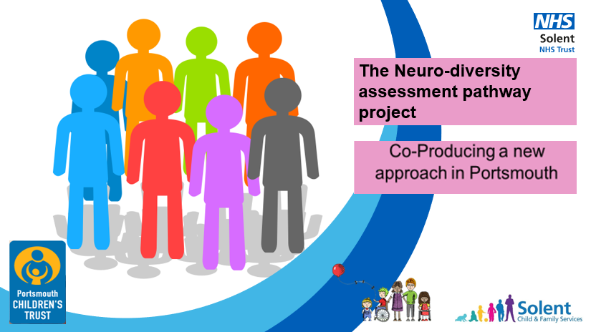

What is the Neurodiversity assessment pathway project?

Solent NHS Trust and Portsmouth Local Authority are working together with Portsmouth Parent Voice to produce a new assessment profile. It is designed for the universal workforce, in partnership with parents, in order to confidently describe the presentation and needs of children and young people with neurodevelopmental differences. It focuses on needs and support strategies. It is a way of profiling needs that does not rely on diagnosis alone; it is something which everyone understands and to which everyone can contribute.

We are asking you to join us in a multi-agency training to learn about the new profiling tool so that you can complete this profile with parents.

We are delivering this training remotely using Team and have split the training in to three shorter sessions instead of one whole day.

This is not a training session for beginners or experts!

Participants will already have:
- An understanding of child development
- Some understanding of neurodevelopmental differences
- An understanding that nature and nurture have a role to play in child development and behaviour
- A no-blame "restorative" approach to understanding the needs of children, young people and parents
- A belief in the value of co-production with parents ("doing with not doing to")

Following the training participants will:
- Share your learning with other people in your setting
- Feel confident to start the conversation with parents about neuro-diversity
- Explain the approach to and complete the profile with parents
- Provide ideas and strategies to support parents and children
- Provide feedback for the research project
- Promote the approach to others so we can increase understanding and support for children and young people with neuro-diverse profiles and build confidence and competence in your setting or team.

Dates
1st Cohort
9th March – 10:30-12:30
16th March – 10:30-12:30
23rd March – 12:30-14:30
2nd Cohort
7th June – 10:30 – 12:30
14th June – 10:30-12:30
21st June – 10:30 – 12:30

Please reply with your name, role and work email and which cohort you would like to be a part of. Then return to Queralt Barrau at SENDStrategy@portsmouthcc.gov.uk. There is no charge for attending the training. Joining details will be sent to you nearer the first training date.

NAME………………………………………………………………………….
ROLE…………………………………………………………………………...
WORKPLACE…………………………………………………………………
WORK EMAIL ADDRESS……………………………………………………
COHORT………………………………………………………………………

