How to set up an account to access Best Start Speech and Language training on the NHS Health Education England
e-learning website.
https://www.e-lfh.org.uk/
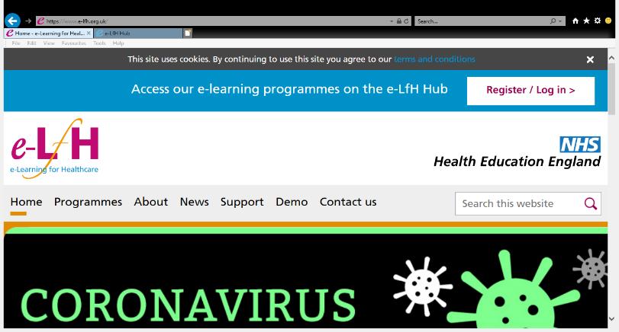
- Click on link above or type into search bar.
- Click on ‘Register’ to set up an account.
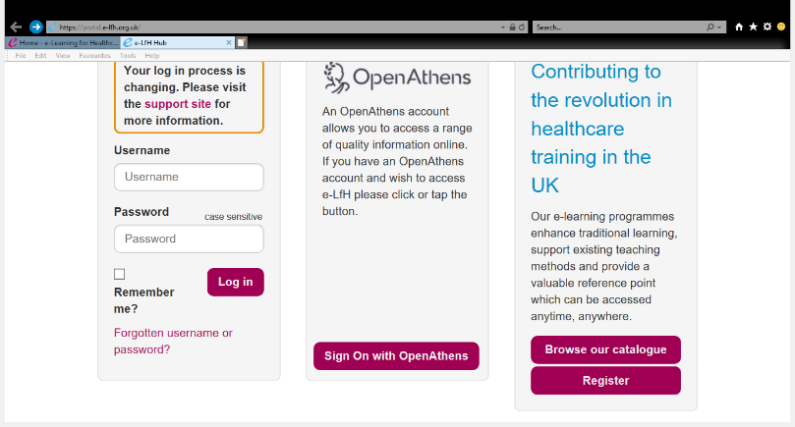
- Click on ‘Register’ on the bottom right hand corner as shown.

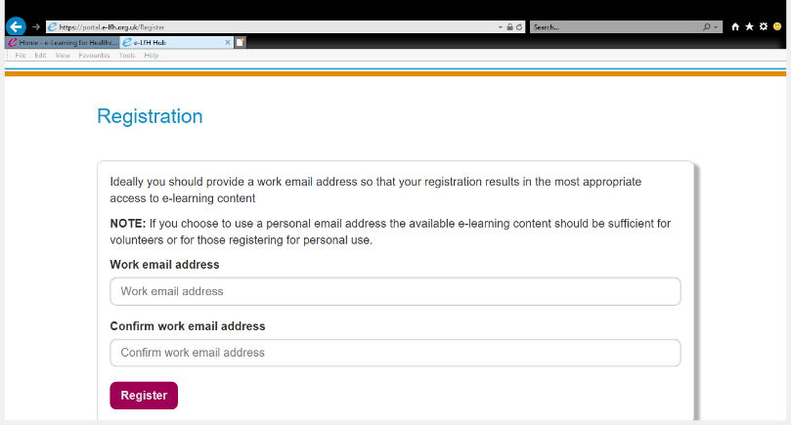
- Type in email address twice, then click ‘Register’
- This will then take you to a screen to add your detail.
- Await confirmation email to activate account.
You can then access the Best Start training from the ‘Course Catalogue’.

