Parent/Carer Contribution for Transition to School
Please give as much information about your child. Either ask your child's setting to send this to the school your child will attend in September or you could send it to the school yourself. It will be really helpful for the teachers to understand who your child is and what they can do.
Name of child:

Date of Birth:

Name of Nursery/Pre-school setting:

Name of school for September 2021:

Name of person completing this:

Relationship to child:

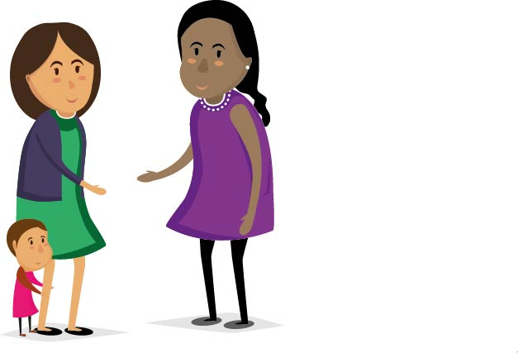
Tell us about your child and family……
What is your child’s position in the family e.g. has one older sister aged six:
Who is important to your child?

What does your child particularly like doing e.g. a favourite activity or toy:
Do they have a favourite story or song?

What is really important to your child? e.g. they really like to play outside or they don't like to get messy or he/she prefers to play alone or in a very small group:

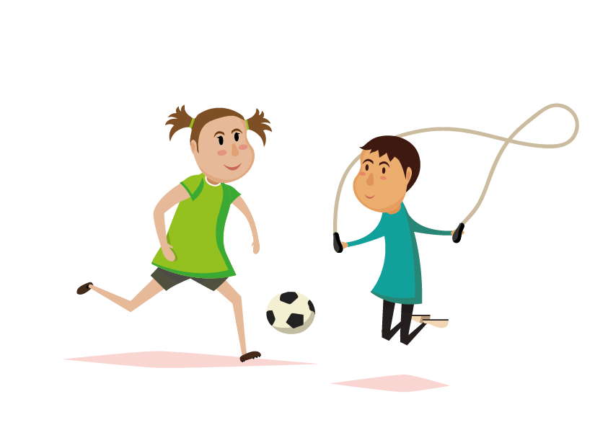
Do you or your child have any particular concerns or worries about moving on to school?

If my child gets upset worried they might need you to….

Would you like to tell us anything else to help support your child start school?

Please tell us what your child can do by ticking one of the boxes
"I can do it" | I need lots of help with this | I need a little bit of help with this |  | I can do it on my own
- Wash hands and dry my hands independently
- Use the toilet independently
- Can wipe myself after using the toilet
- Eat with and manage a knife and fork
- Put my arms in the sleeves of my coat
- Do a zip to the top
- Do and undo buttons
- Put on my socks
- Put on my shoes
''l can tell you" | Not yet | Now and then |  | On a regular basis
- Respond when you say my name
- Wait my turn in a conversation
- Ask and answer simple questions
- Listen to stories or songs and can remember familiar words and phrases from them
- Talk to you about what I am doing or what I am interested in
- Tell you what I need, how I feel and what I am thinking about
- Can use and understand lots of different sentences and words
''I can join in'' | Not yet | Now and then |  | On a regular basis
- Take turns with a game or toy
- Share toys with a friend and /or sibling
- Know it's important to be kind to my friends
- Understand right from wrong and usually try to do the right thing
- Understand that there are rules and consequences
- Can follow simple instructions
- Can separate from my parent or main carer
How does your child like to learn? | Not yet | Now and then |  | On a regular basis
- Are they curious about new things?  - Do they take risks and challenge themselves to do new things?  - Can they use their senses to explore the world?  - Do they like to pretend and take part in role play?  - Do they keep on trying if they find something hard to do?  - Can they concentrate at an activity for a short amount of time?  - Do they find ways to solve problems?  - Do they make plans and carry them out?  - Do they try to make changes to their plans and adapt them when they need to?  - Can they listen to other people's ideas? |  |  |  | 