INFORMATION FROM THE SEN TEAM : SPRING 2020
EHC NEEDS ASSESSMENT REQUESTS AND SPECIALIST PLACEMENTS

WHAT DOES THE SEN TEAM DO?

The SEN Team holds responsibility for ensuring young people with SEN receive the support they need to succeed in their educational setting. We hold statutory responsibility for running Education, Health and Care (EHC) Needs Assessments, monitoring and funding EHC Plans, commissioning and allocating placements within specialist settings, and overseeing and managing appeals to the First-Tier SEN&D Tribunal Service.

If you would like a young person to be considered for an EHC Needs Assessment (because it is clear that their needs are significant, long term and complex and cannot be met through Ordinarily Available Provision or SEN Support within a school setting), you should submit an EHC Needs Assessment request directly to the SEN Team: sen.education@portsmouthcc.gov.uk. Please do not submit assessment requests to the Early Years Panel.

EHC NEEDS ASSESSMENT REQUESTS

It is really important that you submit any EHC Needs Assessment requests to us as early as possible in the academic year before a pupil is due to start school, to ensure that (if agreed) we can complete the whole 20 week assessment process before the end of the academic year to allow school placement to be confirmed and meaningful transition to take place alongside their peers. Therefore, for any young people starting school in September 2021 who may need the support of an EHC Plan, we would recommend that their assessment requests are submitted to us by the end of February 2021.

In order to make an informed decision on whether an EHC Needs Assessment may be necessary, we need particular information to gain an understanding of a pupil's needs, details of which can be found below. The reports listed shouldn't be collected solely for the purpose of submitting an EHC Needs Assessment request - they should form part of the 'Assess, Plan, Do, Review' cycle (more information below) that should be undertaken before considering whether to submit an assessment request, and should be used to inform the support you provide to the young person within your setting.

We understand that it can sometimes be difficult to obtain reports, and current circumstances may make completing any request paperwork more difficult, however it is important that you submit as much information as possible - if limited information is provided, there is a risk that the request will be declined and the young person could be disadvantaged.

Information to provide | What if this is not available to me?
Clear indication of parent / carer involvement in discussion of special needs, and agreement to EHC Needs Assessment request  Why? The EHC Needs Assessment is a legal process - we are not allowed to run an assessment without permission from parent / carer. | As an exceptional circumstance (e.g. difficulties speaking with parent due to covid) we are able to accept indication that a parent / carer has provided verbal consent to the request being submitted - please make this clear on the request paperwork, including the date verbal consent was given, and by whom.
A completed Early Years EHC Needs Assessment request form  Why? This is the only educational information we will have at this stage, which is a vital aspect of our consideration process.  This will also be your formal evidence for the EHC needs assessment and EHC Plan, if agreed. | This is available on the Portsmouth Local Offer website www.portsmouthlocaloffer.org and must be completed as part of your request submission.
Baseline assessment data, attainment records and any other reviews of progress  Why? We need to see how a young person is progressing in the setting to try and understand whether an EHC Needs Assessment would be useful. | Please provide as much information, and evidence of review of progress, as possible - you need to demonstrate that the 'Assess, Plan, Do, Review' cycle has been undertaken (see below).
Professional reports - e.g. EP, Community Paediatrician, SALT, OT, Portage  Why? We need to know which agencies are involved with the child and the advice and recommendations they have made. Evidence from professionals can explain why the child may be struggling in nursery. Reports can also provide an indication as to the level of need (e.g. a diagnosis of Autism doesn't mean that an EHC Plan is required - it is important to understand how this diagnosis affects the young person in an educational setting). | We understand that medical reports are not automatically shared with settings. However, as part of the preparation process for the EHC Needs Assessment we request that every endeavour is undertaken to obtain a copy of existing reports - the request paperwork should be completed collaboratively with parents / carers and all professionals.  However, if you have been unable to obtain a report please indicate this clearly on the request submission including details of attempts made to get a copy.

Early Help Assessment / Stronger Futures Toolkit  Why? We are required to demonstrate that we have undertaken a thorough assessment of a young person's Social and/or Care needs - the Early Help Assessment / Stronger Futures Toolkit fulfils this statutory requirement for children who don't have Social Care involvement.  An EHA / Stronger Futures Toolkit must be completed for each young person - we cannot accept a document for (e.g.) a sibling. | For children who already have an EHA in place the Health Visitor / Lead Professional should share a copy of the EHA / Stronger Futures Toolkit with you - this is an important document that all professionals supporting a young person should have reference to.  However, if you have been unable to obtain a copy of the EHA / Stronger Futures Toolkit please indicate this clearly on the request submission including details of attempts made to get a copy. Please do not advise that a separate professional will forward directly to us - we cannot hold onto requests while we wait for additional reports. All reports should be submitted as one request pack.  Parents may decline to participate in an Early Help Assessment / Stronger Futures Toolkit (although they should be encouraged to do so as it is an extra measure to ensure they have access to all of the support and services they need) - if this is the case, please indicate clearly on the request paperwork that parent declined.

ASSESS, PLAN, DO, REVIEW

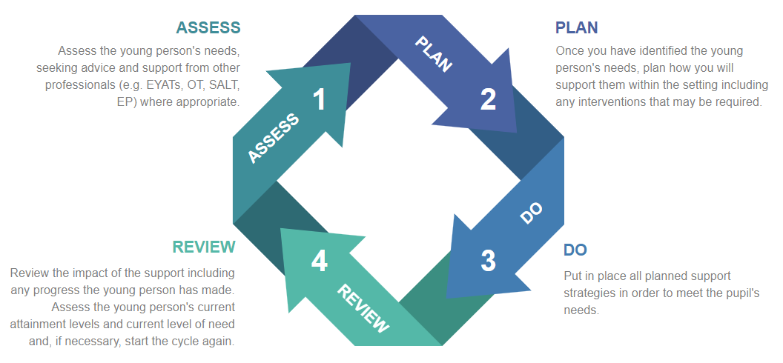

WHY DO WE NEED EHC NEEDS ASSESSMENT REQUESTS SO EARLY?

We understand that you may have only known some of your young people since the beginning of the academic year which can make it difficult to have a clear picture of their needs. However, if it is clear that a young person may need support once they start school, a lot of things needs to happen in preparation for their transition into school:

EHC Needs Assessment | This is a statutory 20 week process - any requests received at the end of February (if agreed) won't be completed until the end of the academic year.  An EHC Needs Assessment does not guarantee that an EHC Plan will be issued.
School allocation / consideration of specialist placement | All parents should have applied for a mainstream school placement by 15 January 2021. If an EHC Plan is agreed at the end of the 20 week process:  - The document needs to be formally referred to the allocated school, who must agree that they can deliver all of the provision detailed in the EHC Plan.  - The young person could be considered for a specialist placement (if this is parental preference). Our specialist panels will take place in April 2021 (information below) and moderation of requests can take a number of months to ensure that the children with the most complex needs are allocated placement.
We may need to seek an alternative placement | There are very few reasons that a school can decline placement for an SEN pupil. However, this is a possibility and we must allow time for negotiations between schools and the SEN Team as well as opportunities for parents to consider alternative placements.
Parents may wish to appeal against the allocated placement | Parents may be unhappy with the placement named in the EHC Plan - this may be because we have been unable to agree to a specialist placement, or because they had a preference for an alternative mainstream school. The appeal process is a legal process - it is heard in a Court of Law - and can take a significant number of months.  We will always try to reach an amicable conclusion with parents, however they must be offered opportunity to appeal. The later into the academic year an EHC Plan is issued, the more likely that the Tribunal will not be heard until after the pupil should have started school.

 | It is important to remember that the EHC Plan evidence, including the educational evidence you have provided may be subject to an appeal.
The receiving school must have opportunity to put in place appropriate support and the pupil must be allowed a thorough transition | A receiving school will want time to ensure that they have appropriate support in place for a pupil with an EHC Plan; this may involve recruiting an additional member of staff or undertaking staff training. If an EHC Plan is not agreed until the end of term, or summer holidays, they will not have opportunity to do this.  We would expect all settings and receiving schools to put in place a thorough transition programme for a young person regardless of where they are in the assessment process, but this could be far better informed if an EHC Plan is already in place.

WHAT HAPPENS IF AN EHC NEEDS ASSESSMENT REQUEST CAN'T BE SUBMITTED IN TIME?

We can receive requests at any point during the academic year. However, submitting a request during the late Spring term / Summer term is likely to risk delays in the assessment process as professionals do not assess young people during the school holidays. This would mean that the assessment is refused or put 'on hold' until September, causing unnecessary anxiety for parents.

If a young person with SEN enters school without an EHC Needs Assessment request being submitted, or an EHC Plan in place, schools still have a responsibility to provide whatever support is required in order to meet their needs; they will not be left to struggle. There is an expectation that schools use their notional SEN budget to provide appropriate SEN support. The young person will not be significantly disadvantaged and could, in fact, benefit from a far more thorough EHC Needs Assessment if the school submits the request once the child has had the opportunity to settle - they will be able to demonstrate the support required in a school environment, are likely to have had opportunity to obtain reports from Health and Educational Psychology, and can demonstrate a thorough 'Assess, Plan, Do, Review' cycle.

SPECIALIST SETTINGS

There are a number of specialist settings across the city:

Cliffdale Primary Academy | Battenburg Avenue  Portsmouth  PO2 0SN  www.cliffdaleprimaryacademy.info | Years R - 6  Pupils with complex learning difficulties and Autism
Mary Rose Academy | Gisors Road  Southsea  PO4 8GT  www.maryroseacademy.info | Years R - 14  Pupils with severe learning difficulties, profound and multiple learning difficulties and Autism
Devonshire Infant School (Inclusion Centre) | Francis Avenue  Southsea  PO4 0AG  www.devonshire.portsmouth.sch.uk | Years R - 2  Pupils with communication and interaction difficulties
Southsea Infant School (Inclusion Centre) | Collingwood Road  Southsea  PO5 2SR  www.southsea.portsmouth.sch.uk | Years R - 2  Pupils with communication and interaction difficulties
Milton Park Primary School (Inclusion Centre) | Eastney Road  Southsea  PO4 8ET  www.miltonparkprimaryschool.co.uk | Years R - 6  Pupils with communication and interaction difficulties
Portsdown Primary School (Inclusion Centre) | Sundridge Close  Portsmouth  PO6 3JL  www.portsdownprimary.co.uk | Years R - 6  Pupils with communication and interaction difficulties
The Victory Primary School (Inclusion Centre) | Allaway Avenue  Portsmouth  PO6 4QP  www.thevictoryprimary.co.uk | Years R - 6  Pupils with communication and interaction difficulties

Information for all of these settings, as well as admission criteria, can be found on the Portsmouth Local Offer (www.portsmouthlocaloffer.org).

SPECIALIST MODERATION PANELS

We receive a significant number of requests for specialist placement each year, which always outnumber the spaces available. To consider placement requests we undertake a panel process to identify which pupils meet the admission criteria for each setting, and then moderate and prioritise allocations. It is highly likely that we will be unable to offer specialist placement to all pupils for whom requests are received.

Parents must be advised that they can indicate a preference for placement, but the final allocation will be the decision of the local authority - this will be based on which setting is most appropriate to meet needs, spaces available, and distance from home to school.

For those pupils who meet criteria for specialist placement but are not prioritised, a mainstream placement will be secured and appropriate support will be provided through their EHC Plan. It is important to manage parental expectations - at no stage should parents be advised that their child's needs can only be met with 1:1 support, or within a specialist setting. This may not be the case, and will be determined through the EHC Needs Assessment process.

Specialist placement requests for September 2021 will be considered during panels in April 2021 - the deadline for requests will be 12 March 2021. All requests should be submitted directly to the SEN Team, and we need the following information:

Clear parental preference for specialist placement | The SEN Code of Practice states that the local authority must take into consideration parental preference when allocating placement; we are not allowed to consider a pupil for a specialist placement without parental agreement, and we cannot force a parent to accept a specialist placement if they wish for their child to attend a mainstream setting, regardless of professional opinion.
EHC Needs Assessment underway, and nearing completion | The admission criteria for every specialist setting states that a pupil must have an EHC Plan.  We also need to ensure that we have the information necessary to make an informed decision on appropriateness of placement, and enough to clearly moderate and prioritise pupils to ensure fairness - this is gained through the EHC needs assessment process.

USEFUL POINTS OF REFERENCE

All of our information can be found on the Portsmouth Local Offer website (www.portsmouthlocaloffer.org) which is available for parents / carers as well as professionals. The following pieces of information may be useful to settings:

EHC Needs Assessment Documentation  Document Hub > EHC Needs Assessment Documents and Guidance | All documentation required when submitting an EHC Needs Assessment request
Early Years EHC Needs Assessment Request Form  Document Hub > Early Years Key Documents | The request form required for any Early Years EHC Needs Assessment request.  (This is in the process of being updated; the updated document will be uploaded to the Local Offer)
Ordinarily Available Provision  Document Hub > SEN Support and Ordinarily Available Provision Documents | Detailed guidance about the support available to every pupil within a mainstream school setting, which can be delivered without the need for an EHC Plan
Information Sheets from the SEN Team  Document Hub > SEND Information Sheets | Guidance about every part of our statutory processes including the EHC Needs Assessment and EHC Plans
Early Help Assessment Form / Stronger Futures Toolkit  Document Hub > Early Help and Stronger Futures | This can be completed by settings if not already done by the Health Visitor / Lead Professional

FURTHER INFORMATION
If you have any queries about the EHC Needs Assessment process or specialist settings, please contact the SEN Team:
sen.education@portsmouthcc.gov.uk

