EMAIL SIGNATURE GUIDE
Please follow this guide to setup your signature on your Outlook.

EMAIL SIGNATURE GUIDE

Document Information
Document Name | E-mail Signature Guide
Date | 27/09/2023
Author | Max Proctor
Version | 1.0

Document Control
Date | Author | Version | Details
27/09/23 | Max Proctor | 1.0 | Document Creation

Review
Date | Name | Role | Email

Distribution
Date | Name / Location
Step 3
Click on the Primary VPN and click Connect
Step 2
Click the Wi-Fi globe icon and connect to either Cowplain EA BCP 1 or 2

eMAIL SIGNATURE GUIDE

sTEP 1: nEW EMAIL
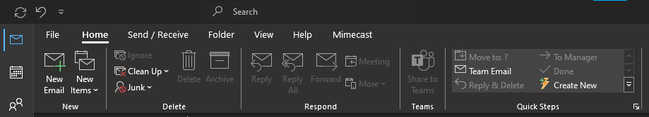
At the top of your Outlook, please press ‘New Email’ as shown in the red box above.
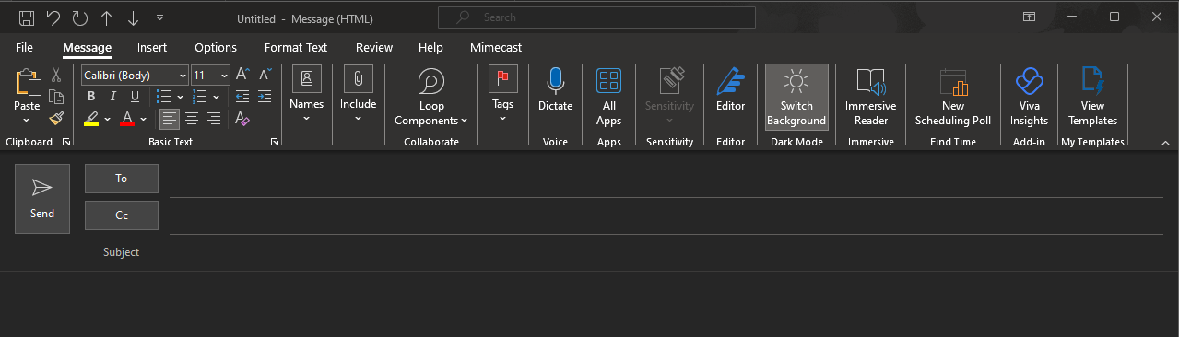

Step 2: Signature
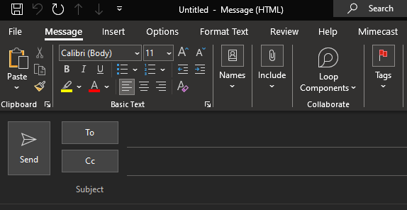
Please press ‘Include’ as displayed in the red box.

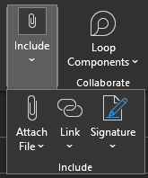
Please press ‘Signature’ as displayed in the red box.

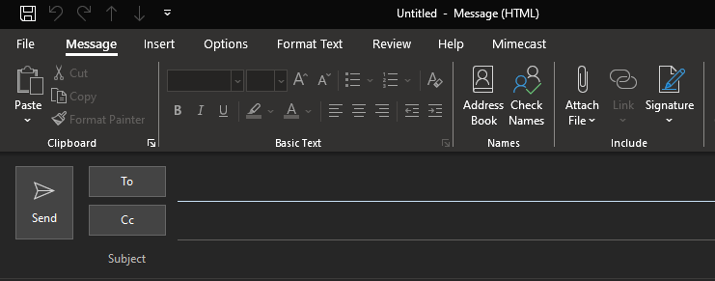
Alternatively, please press ‘Signature’ as shown in the red box.
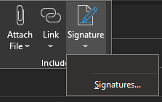
Please press ‘Signatures’ as displayed in the red box.

Step 3: new signature
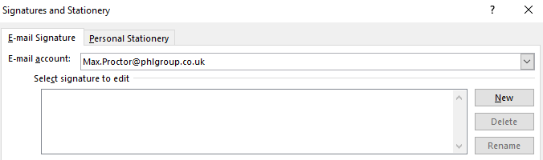
Please press ‘New’ as displayed in the red box above.

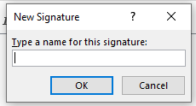
Please choose a name for this signature. For example: ‘Signature 1’.

Step 4: Adding signature
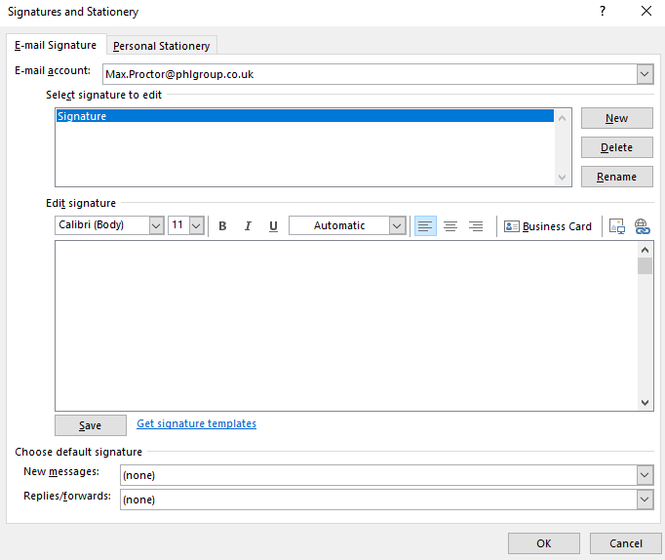
Please use the template below. Once you have filled it out, please paste it into the box highlighted in Red.
Then press ‘OK’.

STep 5: signature template

Highlight all the above information and press ‘copy’ or ‘ctrl c’.
Then paste this into Edit Signature blank box, then press ‘Save’ and ‘Ok’.
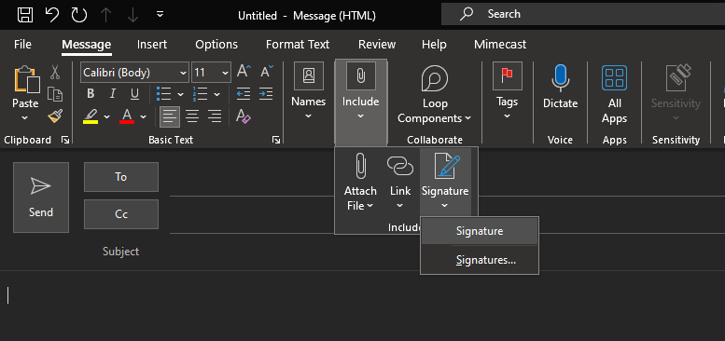
Once you have typed your Email, press ‘Signature’.
It will look like this:

