FOR MORE INFORMATION & BOOKING PLEASE CONTACT
fasst.enquiries@northlincs.gov.uk 01724 298521

**FREE Baby Courses**

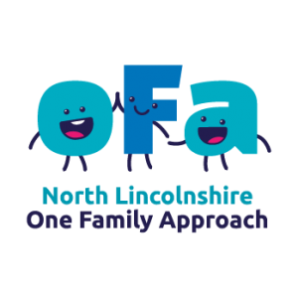
ASHBY COMMUNITY HUB
Ashby High Street, Scunthorpe, DN16 2UT

Baby Massage
Monday afternoon, 1:30pm -2:30pm
4 Week Course
Starting Monday 15 January 2024
Suitable for babies aged 8+ weeks
Not suitable for crawling babies.
*Please bring a towel & sunflower oil*

Baby Sign Language
Thursday mornings 10:00am – 11:00am
8 Week Course
Starting Thursday 18 January 2024
Suitable for babies aged 8+ weeks
(No session during February ½ term)

OASIS HENDERSON AVENUE SCHOOL
Henderson Avenue, Scunthorpe, DN15 7RW

Baby Yoga
Tuesday morning, 10:00am – 11:00am
4 Week Course
Starting Tuesday 16 January 2024
Suitable for babies aged 8+ weeks
Not suitable for crawling babies.

BARTON FAMILY HUB
Council Terrace, Barton-Upon-Humber, DN18 5AP

Baby Yoga
Tuesday afternoons, 1:30pm – 2:30pm
4 Week Course
Starting Tuesday 16 January 2024
Suitable for babies aged 8+ weeks
Not suitable for crawling babies.

