

First Steps Forward
Information for Families
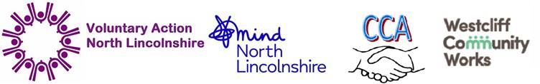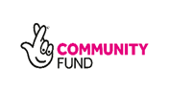

About us:
First Steps Forward is a voluntary organisation within VANL working alongside our delivery partners who are MIND, Westcliff Community Works and Crosby Community Association.
We are a new family support service in which volunteers, who are carefully selected, trained and managed by our Family Support Coordinators, work with families living in the Scunthorpe area, with at least one child under 5, or expecting a new baby, who are struggling with adversity, inequality or disadvantage.
First Steps Forward is set up to support you and your family achieve any of these aims:
- Help you to be a better parent
- Offer practical non-judgemental help and advice with the problems you face
- Help keep you and your children safe
- Work with you to improve your relationships within your family and other agencies such as schools, health visitors and other professionals.
- Offer support with unresolved trauma, mental and or physical health
- Support you around your own needs and aspirations, help you to achieve goals

Our Team has experience running similar support services throughout Scunthorpe and a wealth of knowledge and experience within the team to support the needs of families.
If you would like to benefit from our help and advice, or would like more information you can contact us yourself, or you can be referred by any agencies your family is involved with. Please note that First Steps Forward is independent and confidential and we will only share information about you or your family with your prior consent, unless there are exceptional circumstances. Your involvement is entirely voluntary and needs to be with your agreement.

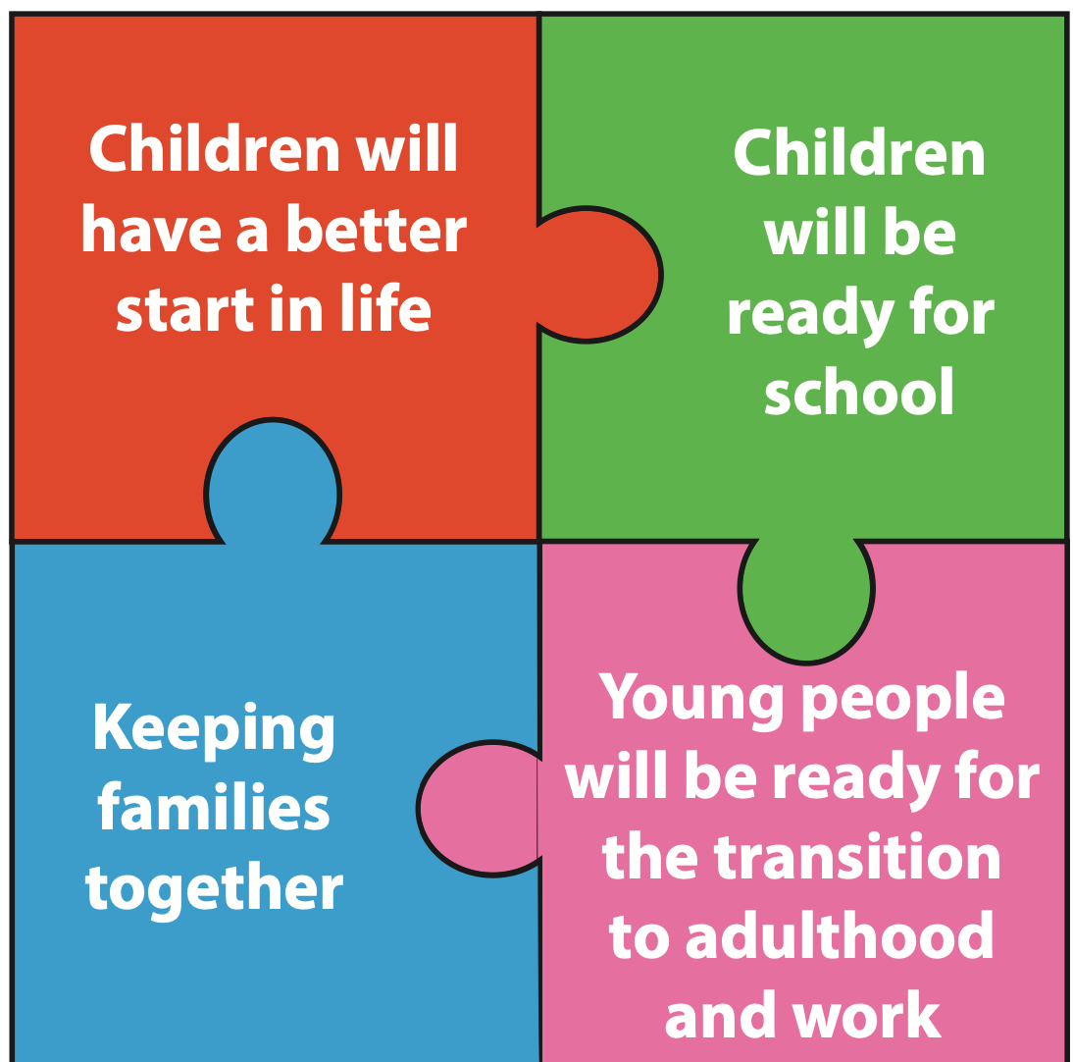
Improved family
health and wellbeing

How to find us:
Email: beststartforall@vanl.org.uk. Telephone 01724 845155 option 7

Lynne Rodgers 07961541075 lynne.rodgers@vanl.org.uk

Or call into VANL 4-6 Robert Street, Scunthorpe and ask for Lynne



