What will happen with the information on my child’s two-year-old assessment?
The two-year-old assessment helps professionals to understand your child’s progress, strengths and needs in order to promote their health and wellbeing, learning and behaviour. It also helps them to be able to offer additional support for children and families, especially those for whom progress is not quite as expected.
A copy of the assessment will be kept securely within your child’s EYFS record of progress at their early years setting. This will then be forwarded to your child’s health visiting team. Your child’s nursery, pre-school or childminder will also share a copy with their school reception class or school nursery at age 3-4 years. A copy will also be shared with and stored by North Lincolnshire Council in line with the GDPR requirements outlined in the Early Years, Early Education, SEND and Statutory Assessments privacy notice (https://www.northlincs.gov.uk/site/privacy/).

Unsure or concerned about your child’s learning and development?
If you are concerned or have any questions regarding your child’s two-year integrated assessment or their development please:
• Talk to a health professional such as your GP or Health Visitor
• Discuss your concerns with your child’s nursery, pre-school or
childminder
• Contact the North Lincolnshire Family support team (FaSST
and Children Centres) FaSST.enquiries@northlincs.gov.uk
• Visit the North Lincolnshire Local Offer website
(www.northlincslocaloffer.com)
Integrated Assessment for two-year-olds

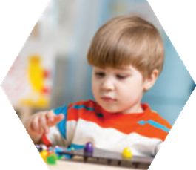

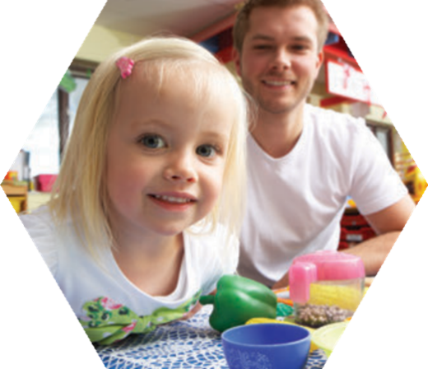


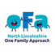


Is your child aged two?

The early years are a period of rapid growth, learning and development in a young child’s life. Lots of brain development happens during this time, which lays the foundations for later learning. All two-year-olds have a health and developmental review with their Health Visitor or Community Nursery Nurse. This may happen at your home, or children’s centre. If your child also attends an Ofsted registered early years setting such as a nursery, pre-school or a childminder, they will also complete a learning and development review using the Early Years Foundation Stage (EYFS) (https://foundationyears.org.uk/wp-content/uploads/2021/09//What-to-expect-in-the-EYFS-complete-FINAL-16.09-compressed.pdf).

Where possible, you, a member of your child’s health visiting team, and your child’s early years key person will do the review all together. This is called an integrated assessment and will usually happen when your child is between two and two and a half years of age. In this case you will usually be invited to your child’s early years setting to complete the assessment. This integrated assessment brings everyone together to give a more complete picture of your child. It will celebrate your child’s strengths, identify their progress and any support required at this age in order to promote positive outcomes in health and wellbeing, learning and development.

Children aged up to two years and six months old attending an Early years setting: | Parents/carers of children attending an early years setting will be, wherever possible, invited into the setting to meet with their child’s key person and health professional to discuss their child’s development.  How the integrated review will take place depends on your child’s age and if they attend an early years setting. Please see table below for further information.
Children who are over two years and six months old attending an Early years setting: | The EYFS review completed by the setting and the ASQ completed with the health visiting team will be carried out separately and then shared between health and the early years setting at a later date. This is because the review by the health visiting team is under taken before the child reaches two years and six months.
All two year-old children who attend a childminder: | The two reviews will usually be carried out separately (alongside parents) and then shared between health and the childminder at a later date.
Children who are not attending an early years setting: | The health visiting team will carry out the child’s two year-old health and development review with parents.

