**User guide / Questions and answers – DECLARE NAGOYA IT system**

*(version 09/2017)*

For any question on the use of DECLARE NAGOYA IT system,

CONTACT US on [**ENV-DECLARE-NAGOYA@ec.europa.eu**](mailto:ENV-DECLARE-NAGOYA@ec.europa.eu)

**For any substantive questions, please contact responsible authorities in a respective Member State [1]**

Table of Contents

Table of Contents 1

Basic concepts 3

1. What is DECLARE? 3

2. Is use of DECLARE obligatory? 4

3. What is a due diligence declaration? 4

4. Which authority is the relevant competent authority? 5

5. What is the ABS Clearing House? 6

6. What is an internationally recognized certificate of compliance? 6

Start using DECLARE - registration 6

7. How do I get started with using DECLARE? 6

a. EU Login 7

b. Registration in DECLARE 7

i. Select NAGOYA policy domain to register 8

ii. Register in DECLARE system 8

iii. Register your organisation 9

8. How do “organizations” function in DECLARE? 11

Submitting a due diligence declaration 13

9. What do I need to do when I want to submit a due diligence declaration via DECLARE? 13

i. Select the type of due diligence declaration to submit 13

ii. Fill in the declaration form and save it 14

iii. Review and submit the due diligence declaration to the Competent Authority 14

10. What if I utilised more than one genetic resource in my research project? 15

11. What if I utilised more than one genetic resource in my product? 16

12. When exactly do I need to submit a due diligence declaration at the second checkpoint (final stage of development of a product)? 17

Content of the due diligence declaration 19

13. What information should be provided in the field “Subject matter of the research or identification code of the grant”? 19

14. What information should be provided in the field “Name of the product”? 19

15. What is the “Place of access”? 19

16. What information needs to be provided in the field “Description of the genetic resources or traditional knowledge associated with genetic resource”? 20

17. What is an “Identifier of access permit”? 20

18. What is an “Equivalent of an access permit”? 20

19. What is an “Entity which granted prior informed consent”? 21

20. What is an “Entity to whom the prior informed consent was granted”? 21

21. What is a “Direct source of genetic resource”? 21

22. What is a “Registered collection”? 22

23. What do I mark in response to the question on restrictions in mutually agreed terms? 22

24. What if my product falls within more than one category and the system allows ticking only one? 22

25. What do I enter in the fields “Date” and “Place” at the end of the declaration? 22

Other considerations 23

26. Who can see my declaration? 23

27. What will happen with confidential information? 23

28. What is the basis for confidentiality? 23

29. Why is there a field for translations in the due diligence declaration? 24

30. Is a declaration still required if a provider country did not require the establishment of mutually agreed terms? 24

31. Why is Part B not transferred to ABS Clearing House? 24

# Basic concepts

# What is DECLARE?

DECLARE is an EU-wide web-based tool which enables users of genetic resources to submit the due diligence declarations required by Article 7 of Regulation (EU) No 511/2014[2] (the EU ABS Regulation or the Regulation) and further specified in the Commission Implementing Regulation (EU) No 2015/1866[3] to the relevant competent authorities responsible for their implementation[4]. The competent authorities also use DECLARE to transfer non-confidential information from the due diligence declarations to the ABS Clearing House.

* The EU ABS Regulation implements compliance measures of the Nagoya Protocol in the EU. More information about the Protocol and the EU legal framework implementing the Protocol can be found onhttp://ec.europa.eu/environment/nature/biodiversity/international/abs/legislation_en.htm:

<http://ec.europa.eu/environment/nature/biodiversity/international/abs/legislation_en.htm>

* In order to define whether your activities are within the scope of the EU ABS Regulation, please consult the *Guidance document on the scope of application and core obligations of the Regulation[5]*. An overview of the conditions applicable is provided in the Annex to that document[6].
* Due diligence declarations need to be submitted *only if* utilisation of the genetic resources in question is within the scope of the ABS Regulation.
* The DECLARE IT system is available on [**https://webgate.ec.europa.eu/declare/**](https://webgate.ec.europa.eu/declare/)

In case of questions concerning use of the IT DECLARE Nagoya system, please contact: [**ENV-DECLARE-NAGOYA@ec.europa.eu**](mailto:ENV-DECLARE-NAGOYA@ec.europa.eu)

In case of substantial questions, please contact relevant competent authorities in Member States.

# Is use of DECLARE obligatory?

The use of DECLARE is not mandatory. Users are strongly encouraged to use DECLARE rather than submit due diligence declarations on paper but if for some reason a user does not want to use the electronic system, paper declarations can also be submitted.

Please note also that Member States may develop their own national systems for users to submit due diligence declarations. Those systems will generally be linked with DECLARE.

Users from the **Spain** are required to use the national system and not directly DECLARE:   
<https://sede.mapama.gob.es/portal/site/se/procedimientos-intermedio?theme_id=5>

# What is a due diligence declaration?

The most important obligation for users in the EU under the ABS Regulation is to "exercise due diligence to ascertain that genetic resources and traditional knowledge associated with genetic resources which they utilise have been accessed in accordance with applicable access and benefit-sharing legislation or regulatory requirements, and that benefits are fairly and equitably shared upon mutually agreed terms, in accordance with any applicable legislation or regulatory requirements" (see Art. 4(1)). The due diligence declaration plays a key role in demonstrating that this obligation is met.

There are two points in time when a due diligence declaration needs to be submitted:

1) at the stage of research funding, where research involves the utilisation of genetic resources and/or traditional knowledge associated with genetic resources, as requested by the Member States (1st "checkpoint");

2) at the stage of final development of a product developed via the utilisation of genetic resources or traditional knowledge associated with genetic resources; the events triggering submission of the declaration have been identified in Article 6 of the Commission Implementing Regulation (2nd "checkpoint")[7]

It is possible, although rather uncommon, that one user will need to submit two due diligence declarations concerning the same genetic resource, i.e. one at the stage of research funding and one at the stage of final development of a product. This will be necessary when a user carries out activities falling in scope of the two requirements (thus carries our research involving utilisation of genetic resources and commercialises a product developed via utilisation of genetic resources[8]).

In practice, the declaration is a form that needs to be filled in by users and submitted to the relevant competent authority in the EU. The detailed content of the forms is determined in Annex II and III of the Commission Implementing Regulation. Both Annexes are integrated 1:1 into the DECLARE system.

# Which authority is the relevant competent authority?

The authorities relevant for submitting due diligence declarations are defined in the Commission Implementing Regulation. For the first checkpoint (receipt of research funding), the declarations are to be submitted to the competent authority where the recipient of funding is established (and in case the recipient is not established in the EU but the research is carried out in the EU, where the research is carried out). For the second checkpoint (final stage of product development), the due diligence declaration is to be submitted to the competent authority of the Member State where the user is established. The DECLARE system automatically submits the due diligence declarations to the relevant authorities according to these criteria, on the basis of information provided by the users.

The list of competent authorities in the EU can be also found on the ABS website of the Commission (<http://ec.europa.eu/environment/nature/biodiversity/international/abs/legislation_en.htm>).

# What is the ABS Clearing House?

The ABS Clearing House (ABSCH) is an international IT platform for exchange of all relevant ABS information between actors in different countries which are Parties to the Nagoya Protocol.

A significant amount of information is legally required, by the Protocol, to be shared via the ABSCH. For example the Parties to the Protocol are required to place access legislation (if they have established any) on the ABSCH. It is also mandatory for the Parties to submit to the ABSCH information on checkpoints established on their territory. In the EU those checkpoints are the competent authorities designated in the Member States based on Article 6 of the EU ABS Regulation.

In the EU, submitting a due diligence declarations to the competent authorities is equivalent to providing information to checkpoints. Information gathered in the due diligence declarations (insomuch as it is not confidential) is transferred via DECLARE to the ABSCH and published there in the form of a so-called “checkpoint communiqué”.

<https://absch.cbd.int/>

# What is an internationally recognized certificate of compliance?

An internationally recognized certificate of compliance (IRCC) is a permit for access to genetic resources that has been issued by the authorities of the providing country and placed on the ABS Clearing House. See examples of IRCCs on the ABSCH.

<https://absch.cbd.int/search/nationalRecords?schema=absPermit> <https://absch.cbd.int/search/nationalRecords?schema=absPermit>

According to Article 4(3)(a) of the EU ABS Regulation, due diligence can be demonstrated with reference to an IRCC. In practice it means that the user of genetic resources will only need to provide information in DECLARE on unique identifier of the IRCC.

# Start using DECLARE - registration

# How do I get started with using DECLARE?

In order to be able to submit a due diligence declaration in DECLARE you need to first register in EU Login. When you access DECLARE (https://webgate.ec.europa.eu/declare/), you will be re-directed into EU Login.

## EU Login

First you need an *EU Login* (formerly European Commission Authentication System – ECAS) account to enter/login into DECLARE system. If a given person already has an *EU Login* account, that account can be used for the purpose of submitting due diligence declarations via DECLARE. If not, the person has to create an (EU Login) account first.

EU Login serves as an ‘entry gate’ into DECLARE system.

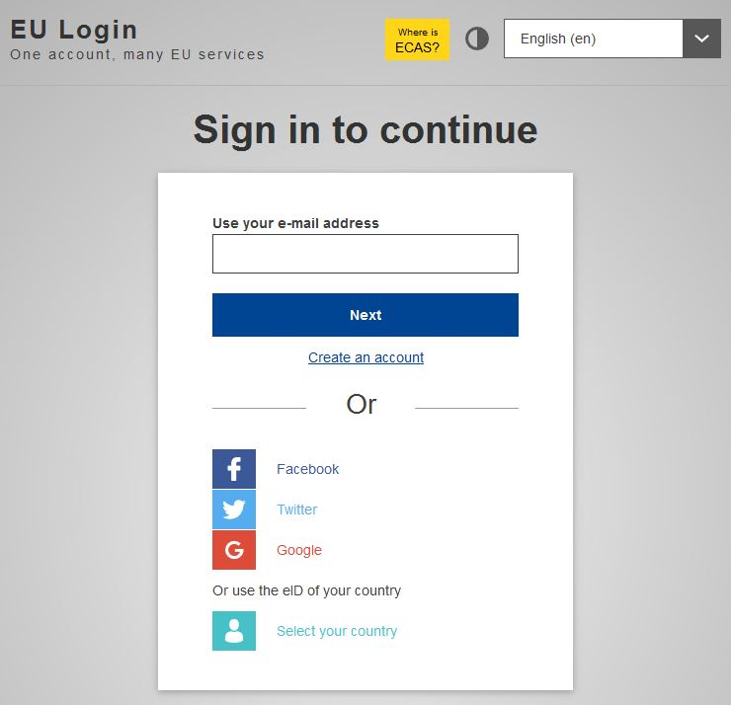

## Registration in DECLARE

Once logged into *EU Login*, you can access DECLARE (where you will also need to register). Firstly, you need to select Nagoya policy domain.

## Select NAGOYA policy domain to register

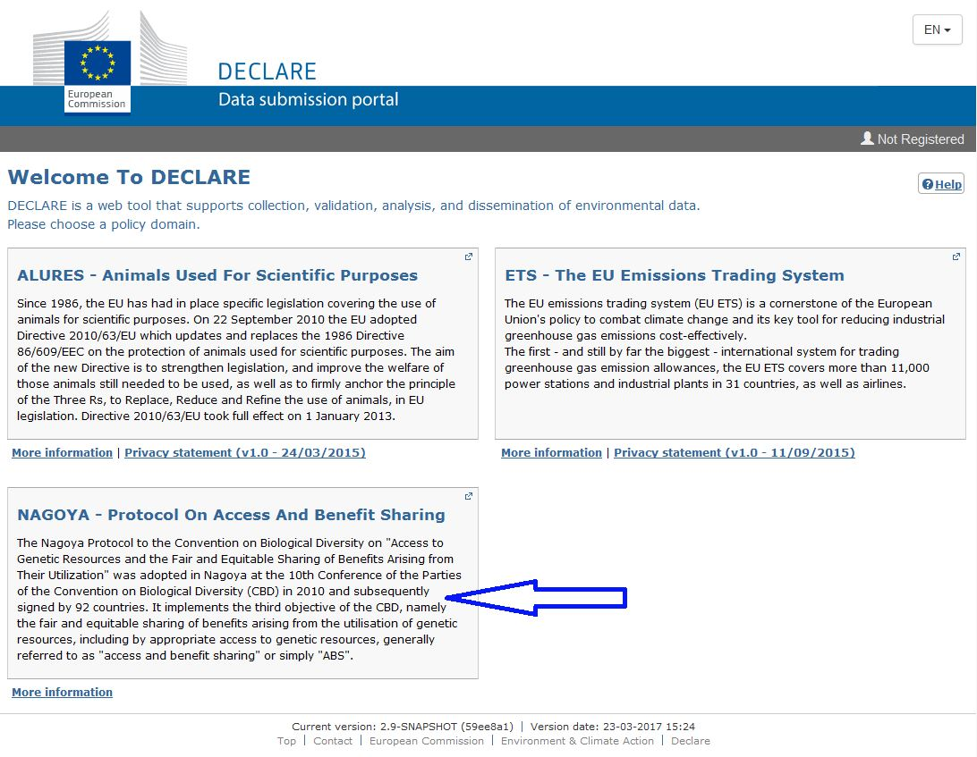

## Register in DECLARE system

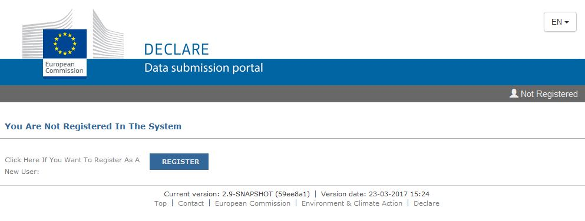

Information submitted in EU Login will be automatically used by the system for the purpose of registration in DECLARE.

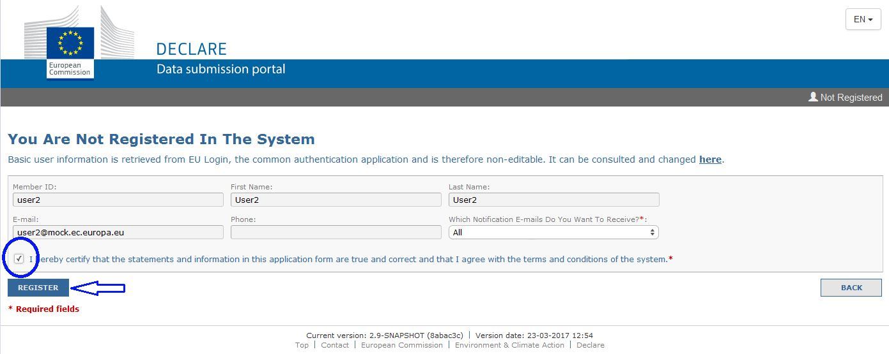

## Register your organisation

Anybody using DECLARE is seen by DECLARE as “an organization” and needs to register as an organization in the system.

Thus, next, you need to provide information about the genetic resource user – this is the entity which will submit due diligence declarations (see below, no. 8).

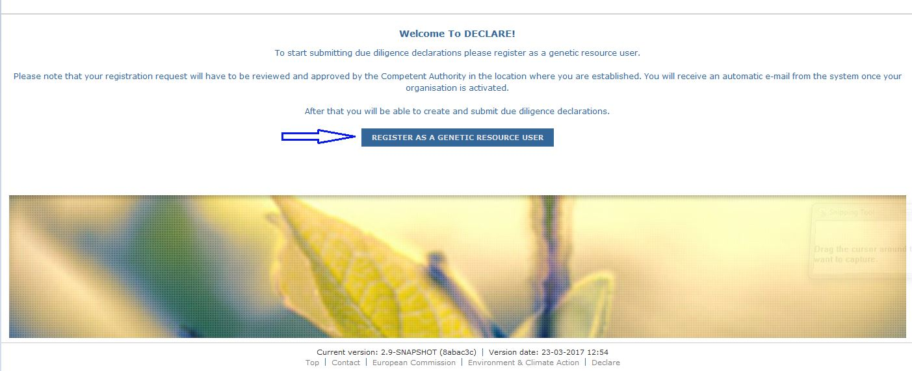

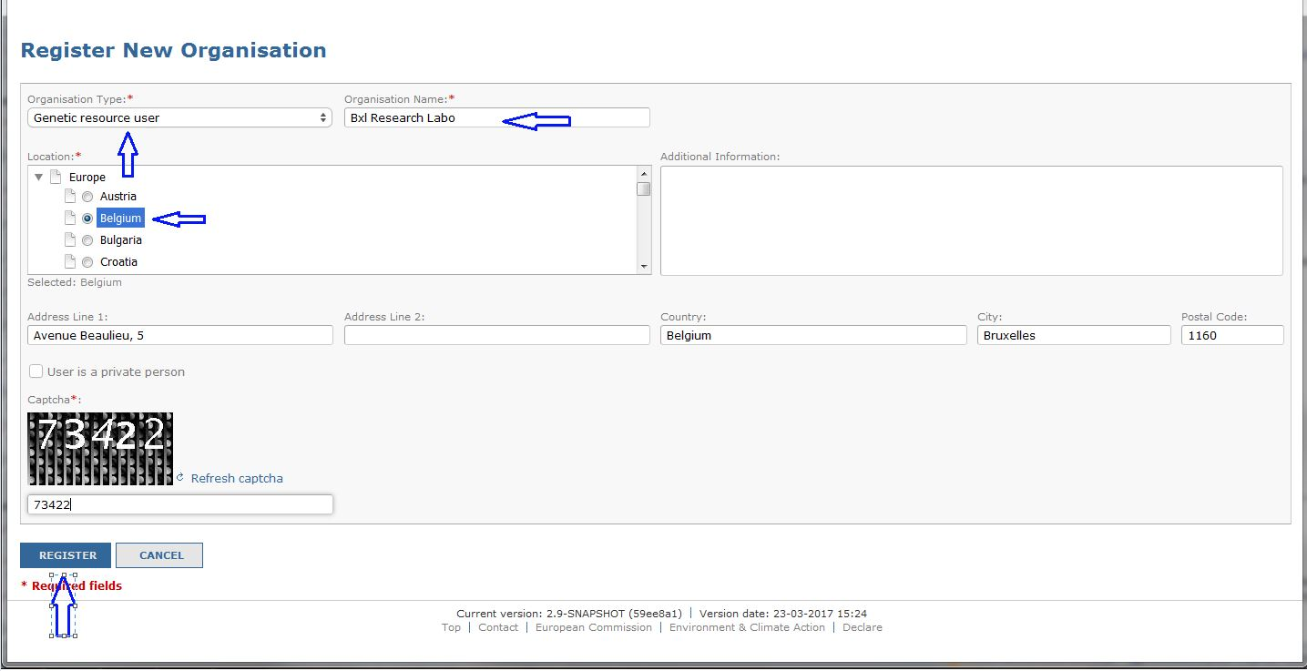

The registration of genetic resource users’ organizations will have to be validated by the relevant competent authority (a body designated for that purpose by the Member State's government – see also above, no. 4).

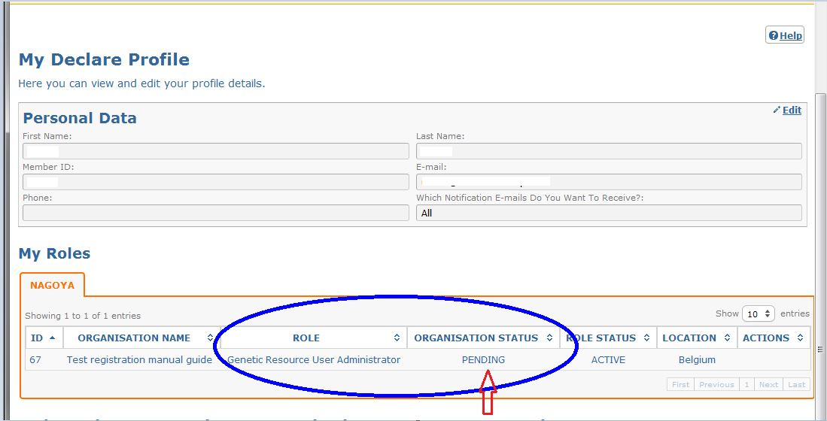

After validation of the registration, the person who created the entry of the organization in DECLARE receives an email confirming that he/she has the access rights required to use DECLARE and submit due diligence declarations.

Once e-mail is received giving access rights to use DECLARE, the user can log in and submit due diligence declarations.

# How do “organizations” function in DECLARE?

In accordance with the EU ABS Regulation and the Commission Implementing Regulation, declarations need to be submitted by users of genetic resources. The user of genetic resources can be an individual person or an entity (laboratory, university, company etc.). If the user in question is an individual person, he/she should register as such.

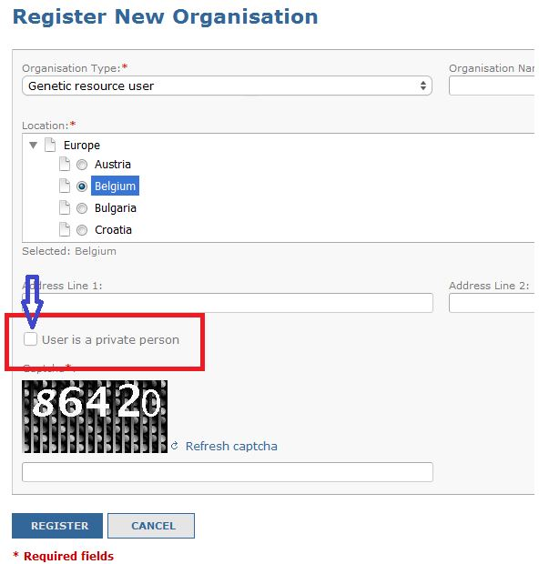

Most typically, however, individual users work within organisations/entities such as research laboratories, industrial enterprises, etc. If the user works for such an organisation/ entity and carries out utilisation on its behalf, the name of that organisation/ entity should be provided as the genetic resource user.

It is up to the users and their organizations/entities to decide at which level of their organisation they want to make their submissions of due diligence declarations. For example, a university may decide to register itself as an organisation, or it may be decided that a department of that university will be registered as an organisation for the purposes of DECLARE. Similarly, a company may decide to register as organization in the system or register only one or several individual branch(es) as an organisation(s). This decision will imply that users within one organisation will be able to see submissions originating from other users in the same organisation.

Every organisation can have as many members active in DECLARE as it wishes to.

If more members are registered, at least one person needs to be registered as administrator so he/she can "manage" (add or modify access of) other members. The first person registering the organization receives automatically the status of administrator. There are thus two types of members in an organisation: the "administrator" member and the "regular member". Both can view, create and submit due diligence declarations. In addition, administrator can add members to the organization.

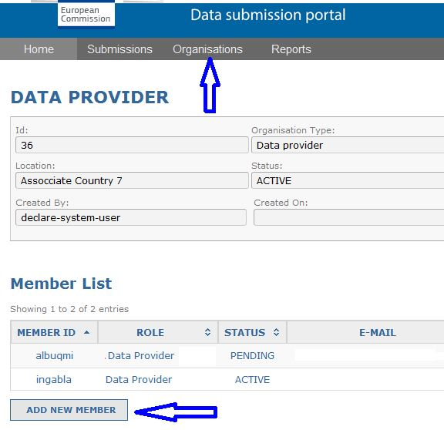

Be aware that confidential information provided by members of one organization in DECLARE will be visible to other members from the same organization. If a given organization wants to avoid such a situation, different departments should register as separate organisations, each with its own members.

**Note** also that the exchange of comments between members of one organization by using the **Add comment** option might be visible also to the competent authorities that have access to a given declaration depending on **the settings for visibility** **of comments**.

You can administer the visibility of comments in DECLARE. If you wish to use **Add comment** option for the purpose of communication between the organization’s members (and you don’t want the authorities to see this exchange), please select the option “visible only to my organization members”.

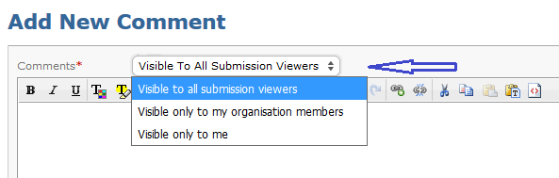

# Submitting a due diligence declaration

# What do I need to do when I want to submit a due diligence declaration via DECLARE?

Once you are logged into the system, you need to select which type of due diligence declaration you wish to submit, i.e. at the stage of research funding ("Research phase") or at the stage of final development of a product ("Final development phase"). You can at this point also view the list of submissions previously made by you or by your organization ("Submission list").

## Select the type of due diligence declaration to submit

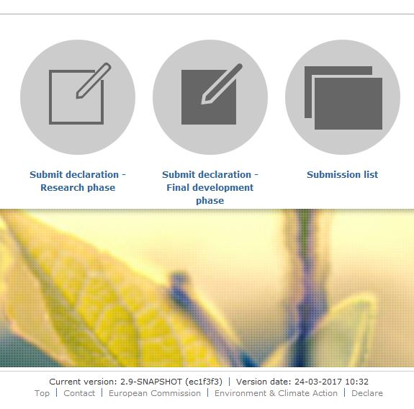

## Fill in the declaration form and save it

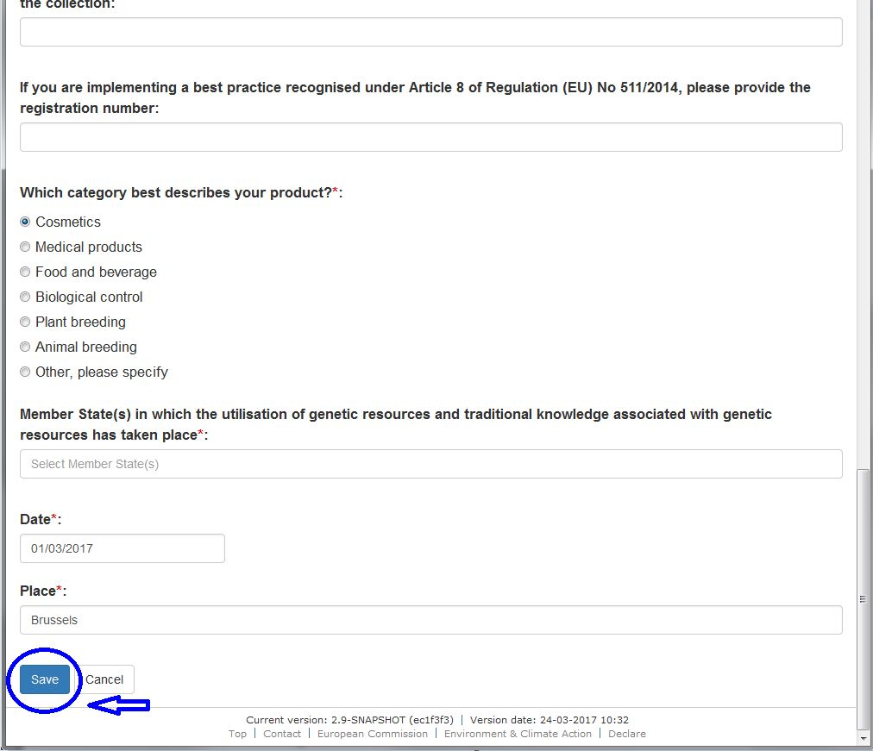

## Review and submit the due diligence declaration to the Competent Authority

Declarations can be saved as drafts for subsequent review or modification until the moment they are submitted.

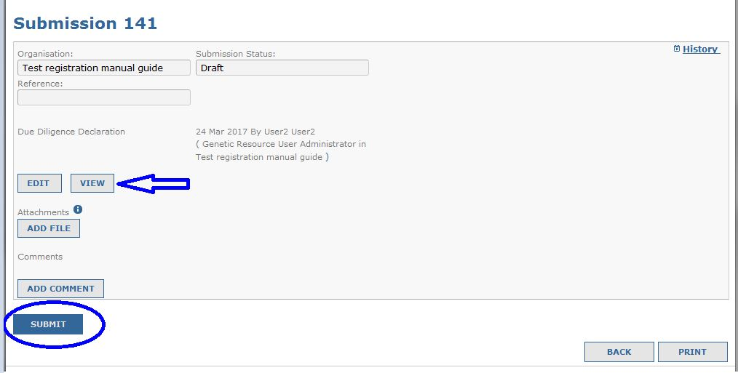

When you are satisfied with the information put in the declaration, you can submit it to the competent authority in relevant Member State.

# What if I utilised more than one genetic resource in my research project?

Only one due diligence declaration is required per research project, even if more genetic resources are used in the project.

There are different situations possible:

* multiple genetic resources utilised in a project are covered by the same permit;
* multiple genetic resources utilised in a project are covered by different permits from the *same* providing country;
* multiple genetic resources utilised in a project are covered by different permits from *different* providing countries;

If multiple genetic resources are covered by one permit (first scenario above), information about genetic resources should be entered in the field “Description of the genetic resources or traditional knowledge associated with genetic resource” (see also below, no 16).

In the other two scenarios (genetic resources are covered by different permits, be it from the same providing country or from different providing countries), information about such resources needs to be added. You need to use then the button “Add to the declaration” under “Number of permits you want to add”, and the system will create all additional fields that need to be filled in.

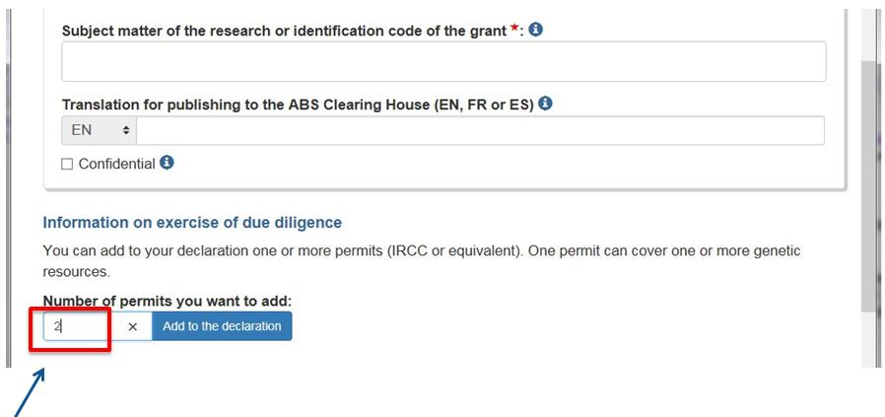

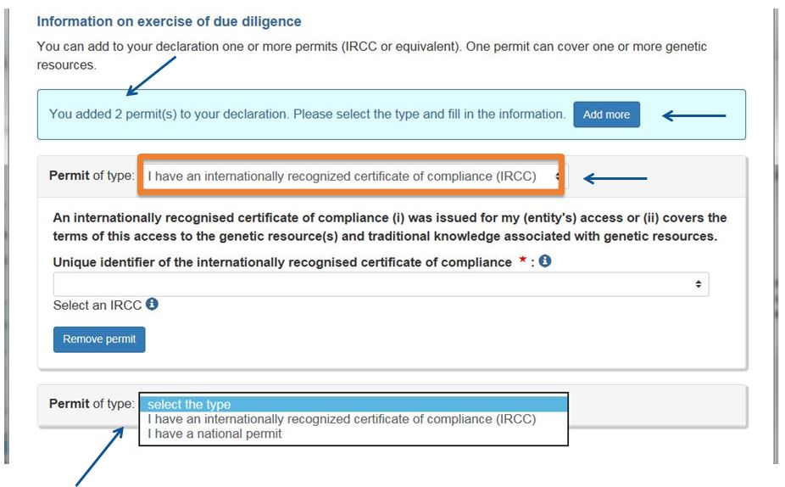

# What if I utilised more than one genetic resource in my product?

Only one due diligence declaration is required per product, even if more genetic resources are used in the given product. The same applies to result of utilisation and outcome of utilisation.

Similarly as with regard to research project, there are different situations possible:

* multiple genetic resources utilised in a product[9] are covered by the same permit;
* multiple genetic resources utilised in a product[10] are covered by different permits from the same providing country;
* multiple genetic resources utilised in a product[11] are covered by different permits from different providing countries;

If multiple genetic resources are covered by one permit (first scenario above), information about genetic resources should be entered in the field “Description of the genetic resources or traditional knowledge associated with genetic resource” (see also below, no 16).

In the other two scenarios (genetic resources are covered be different permits, be it from the same providing country or from different providing countries), information about such resources needs to be added. When you use the button “Add to the declaration” under the heading “Number of permits you want to add”, the system will then automatically create all additional fields that need to be filled in. 

# When exactly do I need to submit a due diligence declaration at the second checkpoint (final stage of development of a product)?

According to the Commission Implementing Regulation, the due diligence at the final stage of development needs to be filed prior to the first of the following events occurring:

* Market approval or authorisation is sought for a product (developed via the utilisation of genetic resources and traditional knowledge associated with genetic resources);
* A notification is required prior to placing for the first time on a Union market is made for a product (developed via the utilisation of genetic resources and traditional knowledge associated with genetic resources);
* Placing on the Union market for the first time a product (developed via the utilisation of genetic resources and traditional knowledge associated with genetic resources) for which no market approval, authorisation or notification is required;
* The result of the utilisation is sold or transferred in any way to a natural or legal person within the Union in order for that person to carry out one of the activities referred above (market approval, notification, placing on the market…);
* The utilisation in the Union has ended and its outcome is sold or transferred in any other way to a natural or legal person outside the Union.

Users of genetic resources thus need to determine which of the above applies to their situation. The first three events are linked to the placing of a product on the market. Some products require market approval (for example pharmaceutical products); for some, a notification needs to be made (for example for cosmetic products); others are placed on the market without market approval/authorisation or notification (for example, a new variety of an ornamental plant). The declaration needs to be submitted prior to placing the product on the market, making the notification or seeking approval/authorisation, as the case may be.

The fourth and fifth events are not directly linked to the placing of a product on the market (or the intention to do so). In the fourth case, the result of utilisation is sold or transferred to another actor in EU and it is the intention of that actor to place the product on the market but he/she no longer carries out utilisation (and hence is not in scope of the Regulation). In the fifth case, the outcome of utilisation leaves the EU; it may allow for manufacturing of the product without further utilisation, or the outcome may still be subject to further research and development, which however, takes place outside of the EU. Both in case four and five, the declaration needs to be filed by the last actor in the value chain that performed utilisation in the EU and before the result or outcome of utilisation is transferred.

More detailed explanation of the two events can be found in the *Guidance document on scope…* in section 4.2.

<http://eur-lex.europa.eu/legal-content/EN/TXT/?uri=uriserv:OJ.C_.2016.313.01.0001.01.ENG&toc=OJ:C:2016:313:TOC>

# Content of the due diligence declaration

# What information should be provided in the field “Subject matter of the research or identification code of the grant”?

Information on the subject matter of the research should be provided; the project title and a brief description will be sufficient for that purpose. Alternatively, a code should be given; such code is usually assigned by the funding agency by which the grant can be clearly identified and information on the subject matter of the research can be found.

This information – transmitted through the ABS Clearing House or, if essential information is confidential, directly to the providing country’s authorities - will allow the providing country to check whether the use of the genetic resource is in conformity with the prior informed consent and mutually agreed terms, and that benefits are shared in accordance with MAT.

# What information should be provided in the field “Name of the product”?

A name should be provided which allows identifying both the type of the product in question (for example facial cream, plant variety, etc.) as well as the specific product by its brand or other name which allows unequivocal identification, (e.g. in case of a plant variety, its denomination or commercial name).

As in the case of research grants (no. 13 above), the information provided will allow the provider of the genetic resource to check whether the use of the genetic resource is in conformity with the prior informed consent and mutually agreed terms, and that benefits are shared in accordance with MAT.

# What is the “Place of access”?

“Place of access” refers to the provider country. Provider country should be understood as country of origin of the genetic resources or any (other) Party to the Protocol that has acquired the genetic resources in accordance with the Convention. If a genetic resource was accessed directly in a provider country, then the place of access is that country.

If a genetic resource was accessed indirectly from an intermediary, such as an ex-situ collection not located in a provider country, then the place of access is still the provider country and not the country in which the intermediary is located. In short, “Place of access” always refers to the provider country.

# What information needs to be provided in the field “Description of the genetic resources or traditional knowledge associated with genetic resource”?

This refers to information which will allow the provider country to identify the genetic resource or traditional knowledge associated with genetic resources; the unique identifiers should be used wherever they are available.

It is advised to use terms from the original permits. For example, if a permit concerned 10,000 unsorted arthropods, it will be helpful if the information in the due diligence declaration referred also to 10,000 unsorted arthropods even if only one of them was utilised; the user could refer then in the due diligence declaration to the particular genetic resource used, i.e. “Curculio oblongus, one of 10,000 unsorted arthropods”. This will facilitate the work of competent authorities of the providing countries. Reference only to one particular genetic resource (in this case “Curculio oblongus”) would likely trigger a clarifying request on behalf of the providing country.

The information provided in the field “Description of genetic resource” can refer to biota at any taxonomic rank (species, genus, family etc.), which may carry a taxonomic name. It may also include a reference to the location where material was collected. It may also be possible to identify a genetic resource through reference to a voucher specimen or fields notes held in an identified archive or collection.

# What is an “Identifier of access permit”?

A number or other code used by the issuing authority to identify the permit.

# What is an “Equivalent of an access permit”?

Parties to the Protocol may have specific rules for different types of access to their genetic resources. For example, they may require access permits only for the utilisation in the commercialisation phase, whereas in the non-commercial utilisation only a notification or registration may be required. Such notification or registration is considered to be equivalent to an access permit, as it also constitutes an access requirement. As such, this also needs to be reported in the due diligence declaration.

# What is an “Entity which granted prior informed consent”?

Depending on national legislation of the provider country, prior informed consent (PIC) may be granted through a decision issued at governmental or regional level. It is also possible that countries delegate the authority to issue PIC to local communities. Who is responsible for granting prior informed consent is defined in the legislation of the provider country.

The information about entities which at some point granted prior informed consent is retrieved by DECLARE from the ABS Clearing House and can be seen in a drop-down menu. If the entity which granted PIC for the genetic resource covered in the particular DDD does not have a corresponding record on the ABS Clearing House, such record needs to be created.

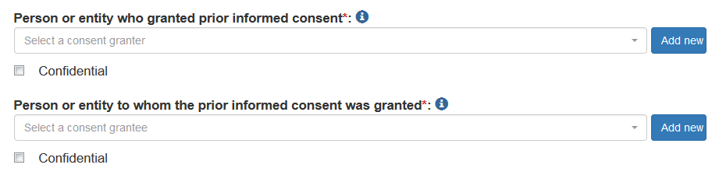

# What is an “Entity to whom the prior informed consent was granted”?

This is the entity which received the permit (prior informed consent).

As with regard to the entity which granted prior informed consent (no. 19 above), a list of these entities is retrieved by DECLARE from the ABS Clearing House. If the entity which obtained PIC in a particular case does not have a corresponding record on the ABS Clearing House, such a record needs to be created.

# What is a “Direct source of genetic resource”?

This is the person or legal entity from whom the user obtained the genetic resources directly, i.e. the previous actor in the value chain. If a genetic resource is obtained directly from the provider country, the name of the country should be provided. If a genetic resource is obtained from a collection, the details of the collection need to be provided. If a genetic resource is obtained from a different user in the value chain, contact details of that user need to be provided.

# What is a “Registered collection”?

The EU ABS Regulation provides for collections of genetic resources to become registered when certain criteria (set up in the Regulation and further specified in the Commission Implementing Regulation) are fulfilled. According to the Regulation, a user who obtains a genetic resource from such a registered collection is considered to have complied with the duty of being duly diligent in relation to *seeking information*. Other obligations, including to submit a due diligence declaration, remain applicable.

For the moment (July 2017) there are no registered collections in the EU. If and when any collections have been registered, those will be listed on the ABS website of the Commission. http://ec.europa.eu/environment/nature/biodiversity/international/abs/legislation_en.htm

Due diligence declarations are also required for genetic resources obtained from a registered collection.

# What do I mark in response to the question on restrictions in mutually agreed terms?

There are three possible ways to answer the question on possible restrictions in the mutually agreed terms limiting the possible utilisation of genetic resources (or traditional knowledge associated with genetic resources): “yes”, ”no”, ” not applicable”.

Where no mutually agreed terms have been established, “not applicable” should be selected. If there are restrictions in the mutually agreed terms concerning utilisation and allowing, for example only non-commercial utilisation “yes” should be selected. If there are no restrictions in mutually agreed terms, “no” should be selected.

# What if my product falls within more than one category and the system allows ticking only one?

Tick the box “other” and specify.

# What do I enter in the fields “Date” and “Place” at the end of the declaration?

“Date” is the date on which the declaration is submitted, just as it would be done when submitting a declaration in writing. The date is automatically filled in by the system.

“Place” is the location where you are when you submit the declaration, just as it would be done when submitting a declaration in writing.

# Other considerations

# Who can see my declaration?

The non-confidential information in a due diligence declaration can eventually be seen by anybody, as they are transferred to the ABS Clearing House and thus made public. Prior to transmission of the information to the ABS Clearing House, the non-confidential information can be seen by the relevant competent authority (to whom the user submitted the due diligence declaration), by the Commission (when the due diligence declaration is validated by the competent authority) and by other EU competent authorities (in cases where a product is put on the market of more than one Member State).

# What will happen with confidential information?

Confidential information included in a due diligence declaration in DECLARE can be accessed by the other members of the same user’s “organisation” (see no. 8 above) and by the competent authorities to whom the due diligence declaration is submitted. These are the only entities which can see confidential information. Other competent authorities (for example from other EU countries where the product is put on the market) or the European Commission cannot see the confidential information. Confidential information is also not transferred to the ABS Clearing House.

In some situations information might be indicated as confidential in a due diligence declaration while being crucial for creating a “checkpoint communiqué” (see no. 3 above), for example the place of access). Such due diligence declarations will not be published on the ABSCH as they do not allow provider countries to identify *their* genetic resources. In such a situation, the competent authority of the EU Member State where the due diligence declaration is submitted will contact directly the provider country to supply information about *its* genetic resources (see Article 7(2) of the Commission Implementing Regulation). This information will allow the provider country to check whether the use of the genetic resource is in conformity with the prior informed consent and mutually agreed terms, and that benefits are shared in accordance with MAT.

# What is the basis for confidentiality?

The Commission Implementing Regulation requires that, when information is indicated to be confidential, reasons are provided for declaring such confidentiality.

Article 7(5) of the Regulation indicates that the competent authorities shall take due account of the respect of confidentiality of commercial or industrial information where such confidentiality is provided for by Union or national law to protect a legitimate economic interest. This interest might be in particular related to information on genetic resources or their utilisation.

Users are advised to address confidentiality for relevant aspects of the agreement when negotiating the mutually agreed terms with the provider country.

# Why is there a field for translations in the due diligence declaration?

The information submitted to the ABSCH needs to be in one of six UN languages, three of which are also official EU languages (i.e. English, French, and Spanish). When users submit due diligence declarations in other languages, they are encouraged to provide translations into one of the three UN languages used in the EU. The declarations can be also submitted if no translations are provided.

If information is considered to be confidential, it is not foreseen to provide translations, as this information will not be transferred to the ABSCH.

# Is a declaration still required if a provider country did not require the establishment of mutually agreed terms?

Yes. If other conditions for applicability of the Regulation are met, the declaration needs to be filed in even if mutually agreed terms have not been negotiated. Some provider countries may not require establishment of mutually agreed terms whereas obtaining prior informed consent may still be obligatory.

It is also possible that a country requires establishment of mutually agreed terms but does not require obtaining of an access permit. A due diligence declaration is also required then.

A due diligence declaration is also required when a country just requires a notification or registration of the fact of access, as this constitutes an equivalent of an access permit.

In short, due diligence is required when a provider country put some legislative or regulatory requirements concerning access, whatever they might be.

# Why is Part B not transferred to ABS Clearing House?

The Commission Implementing Regulation requires that information from Part A but not from Part B of Annex II and III is transferred to the ABS Clearing House. The information collected in Part B is relevant rather for the implementation of the Regulation in the EU and will assist the competent authorities in carrying out potential checks on users.

1. Information about competent national authorities can be found on the Commission website: <http://ec.europa.eu/environment/nature/biodiversity/international/abs/legislation_en.htm> or on the ABS Clearing House website: [www.absch.int](http://www.absch.int); if no competent national authorities are designated in a Member State concerned, please contact National Focal Point for Nagoya Protocol (NFP); contact details for NFPs can be found on the ABS Clearing House [www.absch.int](http://www.absch.int) (see also question 4).
2. Regulation (EU) No 511/2014 of the European Parliament and of the Council of 16 April 2014 on compliance measures for users from the Nagoya Protocol on Access to Genetic Resources and the Fair and Equitable Sharing of Benefits Arising from their Utilisation in the Union; OJ L 150/59; 20.5.2014
3. Commission Implementing Regulation (EU) No 2015/1866 laying down detailed rules for the implementation of Regulation (EU) No 511/2014 of the European Parliament and of the Council as regards the register of collections, monitoring user compliance and best practices; OJ L 275/4; 20.10.2015
4. Whenever "competent authorities" or " authorities" are mentioned in the present document without further qualification, this refers to authorities responsible for *implementation of the Regulation*, designated based on Article 6 of the Regulation, and not to authorities responsible for access rules
5. Guidance document on the scope of application and core obligations of Regulation (EU) No 511/2014 of the European Parliament and of the Council on the compliance measures for users from the Nagoya Protocol on Access to Genetic Resources and the Fair and Equitable Sharing of Benefits Arising from their Utilisation in the Union, OJ C 313/1
6. <http://eur-lex.europa.eu/legal-content/EN/TXT/?uri=uriserv:OJ.C_.2016.313.01.0001.01.ENG&toc=OJ:C:2016:313:TOC>
7. See: <http://eur-lex.europa.eu/legal-content/EN/TXT/?uri=CELEX:32015R1866>)<http://eur-lex.europa.eu/legal-content/EN/TXT/?uri=CELEX:32015R1866>.
8. Or transfers result of utilisation or outcome of utilisation
9. Or result of utilisation or outcome of utilisation
10. Or result of utilisation or outcome of utilisation
11. Or result of utilisation or outcome of utilisation