Personalised Care Updates – Dec 2025

- Cancer Care Reviews – Guidance
- Think Well with Cancer – Talking Therapies for People affected by Cancer
- End of Treatment Summaries – Coding Guidance
- Cancer Health & Wellbeing Hub
- 2026 Cancer Genomics Conference – Register Now

Cancer Care Reviews – Guidance
How can I access the template?
The CCR template is available on EMIS. Navigate to the Template Picker, searching ‘Cancer’ will filter the list and show you ‘Cancer Care Review |GM Template’.
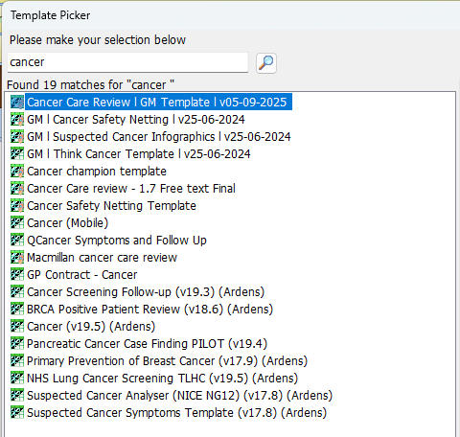

What support for conducting CCRs is available?
An on-demand webinar and resource pack showing how both GPs and non-GP staff can deliver high quality Cancer Care Reviews (CCRs) in General Practice is available through this link of the GM Cancer Academy: Cancer Care Review Webinar – Greater Manchester Cancer Academy.
For any further support or questions on CCRs, please contact max.thomasson@nhs.net

Think Well with Cancer – NHS Talking Therapies Project for People affected by Cancer
Greater Manchester Cancer Alliance in collaboration with the Greater Manchester Mental Health NHS Talking Therapies is continuing to accept referrals into the dedicated cancer pathway to support people directly and indirectly affected by cancer.
The pathway sits within GMMH Talking Therapies, which uses a stepped care model, supporting people ranging from mild, to moderate, to more severe and complex difficulties. The Step 3+ Cancer Pathway, which consists of a Principal Clinical Psychologist and a Senior Cognitive Behavioural Therapist have been providing psychological support to those affected by cancer.
As part of the project Sophie Bates (Principal Clinical Psychologist) and Heather Restall (Senior Cognitive Behavioural Therapist) have been working closely with colleagues across the Talking Therapies Service in GMMH offering a range of workshops to support upskilling the teams. This has enabled those who don’t meet the criteria for Step 3+ Cancer Pathway to have access to a range of options of support which is provided by professionals who are skilled in supporting those with cancer.
Sophie Bates (Principal Clinical Psychologist) shares ‘I have enjoyed working alongside my colleagues in Talking Therapies, offering training workshops and ad-hoc consultations to support the confidence and competence of such a brilliant workforce, to provide more effective support for people affected by cancer”
Alongside work with Mental Health teams, there has also been a focus on strengthening relationships between Physical Health and Mental Health services to improve collaboration and patient access. If you are interested in gaining further information, please contact Olivia.gunby@nhs.net.
We are continuing to accept both professional and self-referrals into the service.
Our service is free, confidential, and available to anyone registered with a GP in Manchester, Bolton, Salford, Trafford and Wigan. If you are supporting someone who can benefit from the pathway, please visit the link below to find out more.
Think Well With Cancer - Greater Manchester Cancer
For further questions please contact LTC@gmmh.nhs.uk

End of Treatment Summaries
When a patient with cancer completes their hospital treatment they should receive and End of Treatment Summary or EOTS. The EOTS includes: diagnosis and staging, treatment details, potential short- and long-term side effects, warning signs of recurrence, follow-up arrangements, and contact details for concerns (key worker, CNS, care coordinator, tumour specific hotlines).

We have received feedback that End of Treatment Summaries are often not easily identifiable amongst other letters, difficult to locate once filed, and that it can be hard to find the GP-specific information. We have therefore worked to create NEW end-of-treatment summary templates which aim to make them easily identifiable, summarises GP information clearly, and contains coding information to help them be located. The NEW templates will look like the example below:
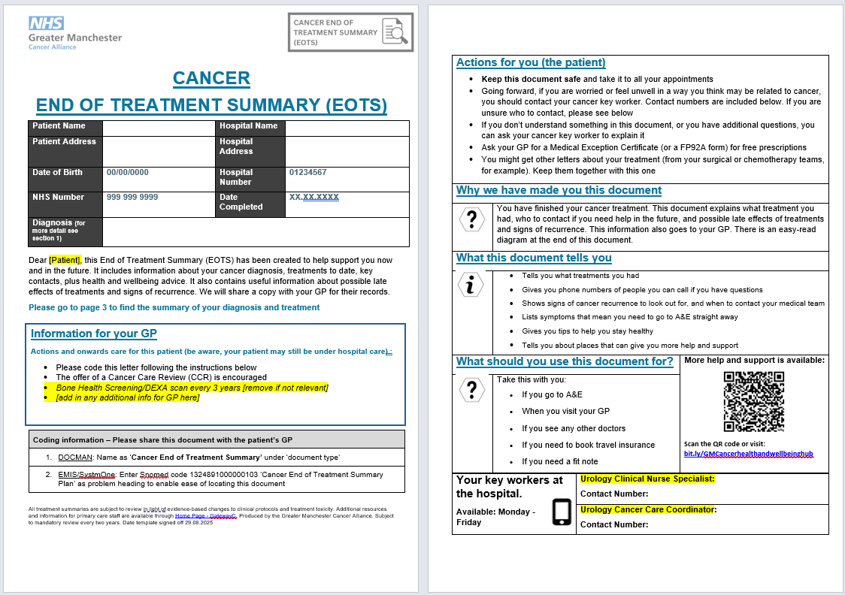
A copy of the EOTS is routinely sent to both the patient and their GP surgery, intended to be a good basis to support patients’ adjustment to self-management post discharge from hospital. There is a specific SNOMED code for an EOTS, coding instructions are on the first page of every end of treatment summary (1324891000000103 ‘Cancer End of Treatment Summary Plan).
To makes sure EOTS are easy to identify and code, all tumour teams in all trusts will be required to use the approved templates that follow the same style and look like the example above.
Please be on the look out for more End of Treatment Summaries and please follow the instructions on the first page of the document to code them to your patients’ records.

Cancer Health & Wellbeing Hub
A new digital Hub for Health and Wellbeing advice and guidance has been produced to support anyone effected by cancer. This hub contains a comprehensive range of:
- Practical Support
- Emotional Support
- Physical Health Advice
- Info on Charities and Local Support
- and much more…

This hub has resources and signposting to services relevant to patients with cancer (regardless of tumour type), people who have finished treatment and are in remission, metastatic patients, and the families/carers of cancer patients.
Click here for the hub: bit.ly/GMCancerhealthandwellbeinghub

This is an evolving resource with continuous patient and clinical feedback informing updates. If you have any content which you believe would be valuable additions to this hub, please contact max.thomasson@nhs.net
Promotional posters are available here (landscape and portrait options to accommodate TV screens)
- https://gmcancer.org.uk/wp-content/uploads/2025/09/1.-Cancer-Health-and-Wellbeing-Hub-Poster.-09.2025.pdf
- https://gmcancer.org.uk/wp-content/uploads/2025/09/2.-Landscape.-Cancer-Health-and-Wellbeing-Hub-Poster.-09.2025.pdf

Genomics Education Event – Register Now
Genomics is rapidly becoming a cornerstone of prevention and early diagnosis in primary care. The Cancer Alliance are supporting work in GM and the NW to make genomics more accessible than ever. Join us for a day of learning and collaboration, where you’ll explore current applications of genomics in cancer care and discover how it will drive equity, improve survival, and enhance early diagnosis & prevention strategies.
Don’t miss our dedicated primary care breakout session. This session will provide an opportunity to consider the referral criteria into The Clinical Genetics Service. You’ll also hear from GP, Dr Mike Clarke, NW GMSA Deputy Clinical Director Primary Care, who will also be presenting ‘The National Neighbourhood approach’ and its role in delivering genomics.
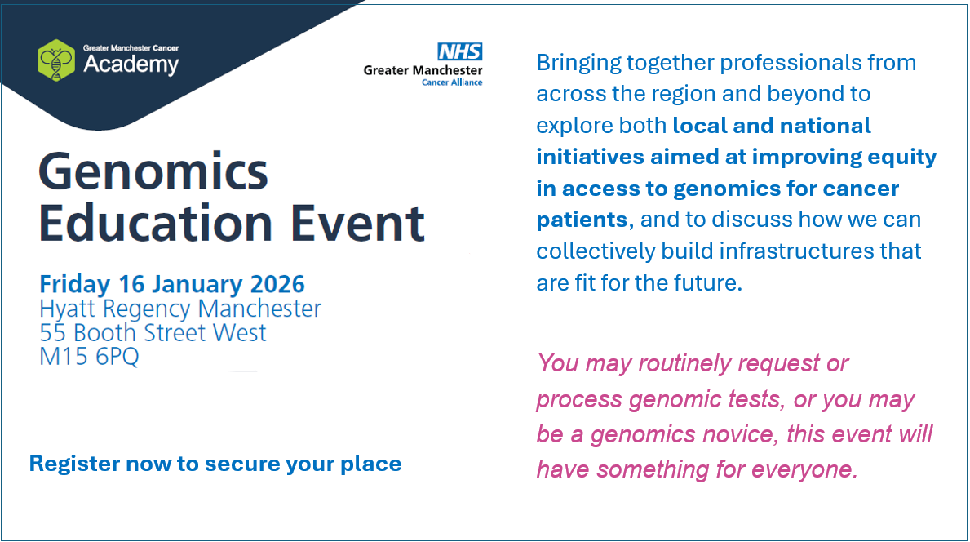
Secure your place by clicking this link: Genomics Education Event – Greater Manchester Cancer Academy

