Personalised Care Updates

- End of Treatment Summaries
- Cancer Health & Wellbeing Hub
- Cancer Care Reviews
- Think Well with Cancer - NHS Talking Therapies Project for People affected by Cancer
- 2026 GM Genomics Conference

End of Treatment Summaries
When a patient with cancer completes their hospital treatment they should receive and End of Treatment Summary or EOTS. The EOTS includes: diagnosis and staging, treatment details, potential short- and long-term side effects, warning signs of recurrence, follow-up arrangements, and contact details for concerns (key worker, CNS, care coordinator, tumour specific hotlines).
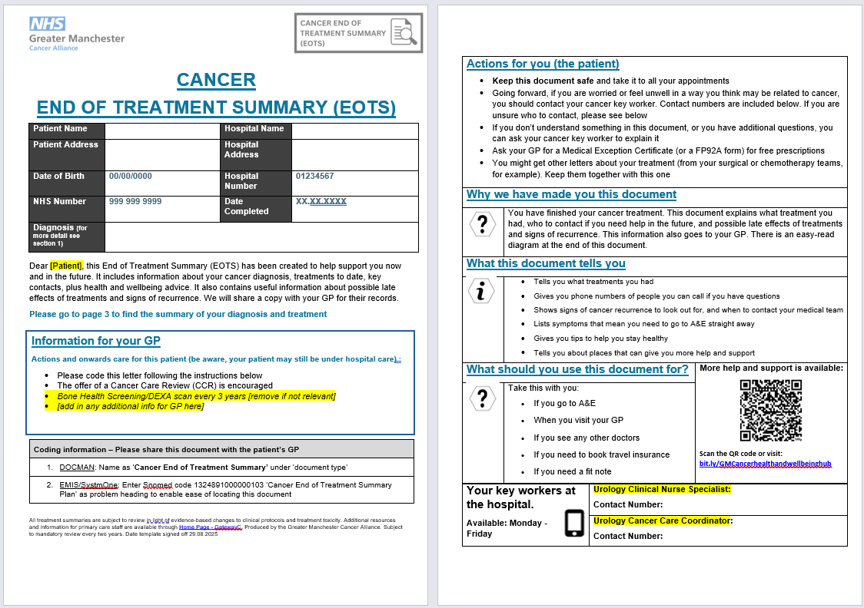
A copy is routinely sent to both the patient and their GP surgery, intended to be a good basis to support patients’ adjustment to self-management post discharge from hospital. There is a specific SNOMED code for an EOTS, coding instructions are on the first page of every end of treatment summary (1324891000000103 ‘Cancer End of Treatment Summary Plan).
To makes sure EOTS are easy to identify and code, all tumour teams in all trusts will be required to use the approved templates that follow the same style and look like the example above.
Please be on the look out for more End of Treatment Summaries and please follow the instructions on the first page to code them to your patients’ records.

Cancer Health & Wellbeing Hub
A new digital Hub for Health and Wellbeing advice and guidance has been produced to support anyone effected by cancer. This hub contains a comprehensive range of:
- Practical Support
- Emotional Support
- Physical Health Advice
- Info on Charities and Local Support
- and much more…

This hub has resources and signposting to services relevant to patients with cancer (regardless of tumour type), people who have finished treatment and are in remission, metastatic patients, and the families/carers of cancer patients.
Click here for the hub: bit.ly/GMCancerhealthandwellbeinghub

This is an evolving resource with continuous patient and clinical feedback informing updates. If you have any content which you believe would be valuable additions to this hub, please contact max.thomasson@nhs.net
Promotional posters are available here (landscape and portrait options to accommodate TV screens)
- https://gmcancer.org.uk/wp-content/uploads/2025/09/1.-Cancer-Health-and-Wellbeing-Hub-Poster.-09.2025.pdf
- https://gmcancer.org.uk/wp-content/uploads/2025/09/2.-Landscape.-Cancer-Health-and-Wellbeing-Hub-Poster.-09.2025.pdf

Cancer Care Reviews
Updates to the Cancer Care Review (CCR) template have gone live across all practice EMIS systems in Greater Manchester.
Designed following feedback from patients on how we can support them post diagnosis, CCRs are structured, holistic reviews meant to capture ongoing needs, review medications, address psychosocial issues, and signpost referral to relevant support or services. However, the template is there as a guide: none of the elements within are 'forced entry' allowing the CCR to be personalised to the patient in the most appropriate way. Cancer Care Reviews are encouraged to be carried out to aid the transition of patients away from intensive hospital based care back to community based care.
The updates to the template were:
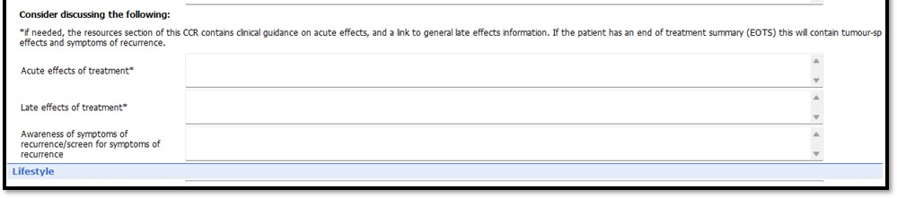
- The addition of three new question prompts (see screenshot below) aimed at supporting any discussions around acute effects of treatment, late effects, and identifying early signs of recurrence.
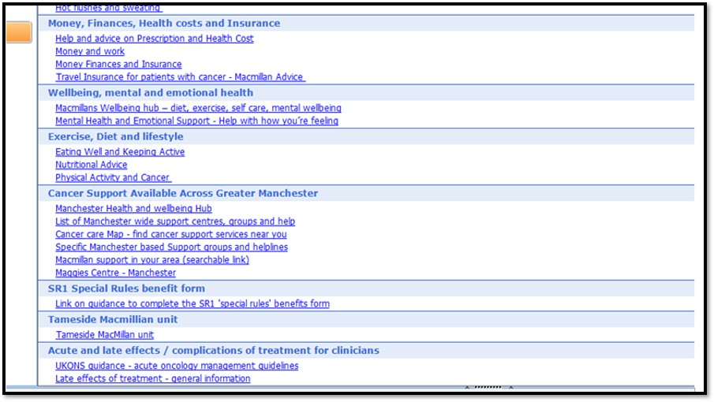
- New clinical guidance documents and health and wellbeing assets being added to ‘Resources’ tab on the template (UKONS guidance on acute oncology management, late effects information, and the new Cancer Health and Wellbeing Hub).
Please find guidance documents and a guidance/awareness webinar for conducting CCRs Here: Cancer Care Review Webinar – Greater Manchester Cancer Academy
For any support or questions on CCRs, please contact max.thomasson@nhs.net

Think Well with Cancer – NHS Talking Therapies Project for People affected by Cancer
This pilot project is a collaboration between Greater Manchester Cancer Alliance and Greater Manchester Mental Health NHS. The aim is to improve access into Talking Therapies for those impacted by cancer and a new dedicated Pathway has been developed to support individuals to help them understand their mental health challenges and explore new coping strategies.

The Think Well with Cancer Project is live and accepting referrals for people affected by cancer which includes those directly and indirectly affected such as family, friends and carers. Support is available for a range of common issues experienced by people affected by cancer, including low mood, anxiety, stress, and difficulties with coping. Addressing these concerns can lead to improved overall wellbeing and quality of life.

The Think Well with Cancer webpage includes further information and links to locality referral forms. The webpage also includes downloadable resources which are suitable for sharing, these include a poster and a patient leaflet: Think Well With Cancer - Greater Manchester Cancer

To highlight this project covers the areas Manchester, Salford, Bolton, Wigan and Trafford.

If you have any questions, are thinking about making a referral, or want guidance on the referral process, please do get in touch via LTC@gmmh.nhs.uk. We are in the process of having the poster and leaflet printed. If you are interested in having these materials available for patients, please contact Olivia.gunby@nhs.net

Genomics Education Event – Register Now
Genomics is rapidly becoming a cornerstone of prevention and early diagnosis in primary care. The Cancer Alliance are supporting work in GM and the NW to make genomics more accessible than ever.
Join us for a day of learning and collaboration, where you’ll explore current applications of genomics in cancer care and discover how it will drive equity, improve survival, and enhance early diagnosis & prevention strategies.
Don’t miss our dedicated primary care breakout session. This session will provide an opportunity to consider the referral criteria into The Clinical Genetics Service. You’ll also hear from GP, Dr Mike Clarke, NW GMSA Deputy Clinical Director Primary Care, who will also be presenting ‘The National Neighbourhood approach’ and its role in delivering genomics.
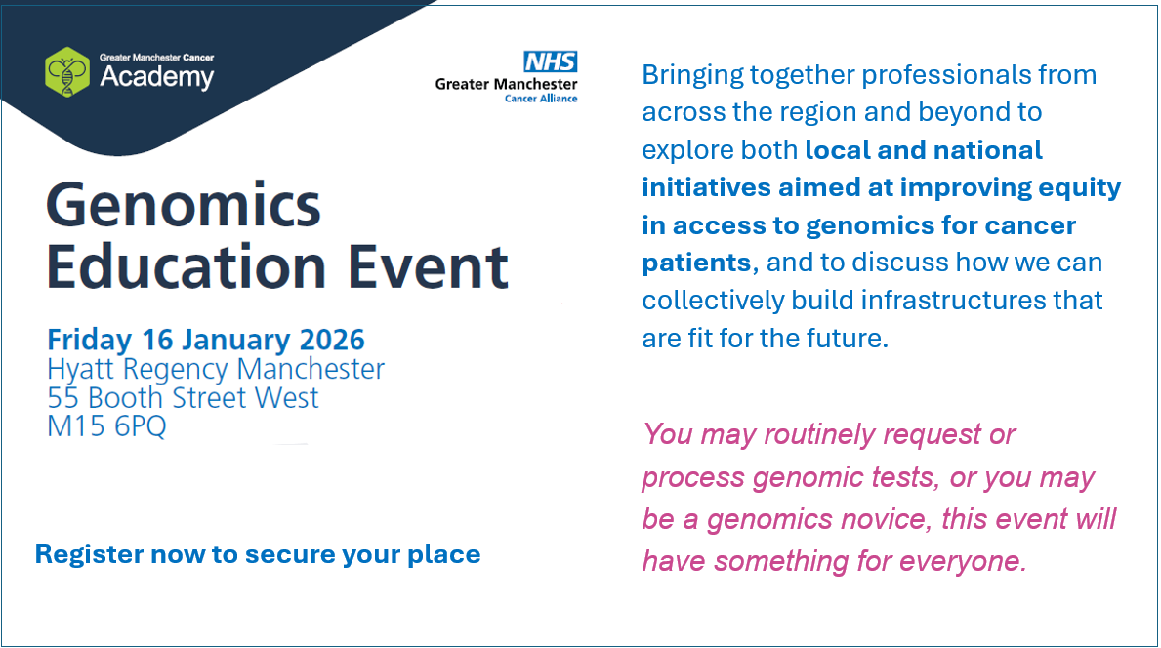
Secure your place by clicking this link: Genomics Education Event – Greater Manchester Cancer Academy

