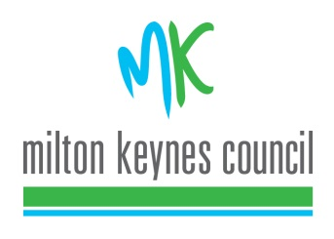

MAYOR'S ENGAGEMENTS

Saturday 6 February 2021 to Saturday 20 February 2021

Please find below brief details of the Mayor’s Engagements for the next two weeks. This is a guide only as details, particularly timings can, and do, change at the last minute. ***Please note all engagements are carried out with social distancing as per government guidelines***

DATE & TIME | EVENT | ATTENDED BY
Saturday, 6 February 2021 | YCAM Virtual Q&A | Mayor

