Kickstart 2026 with Free Coding Skills
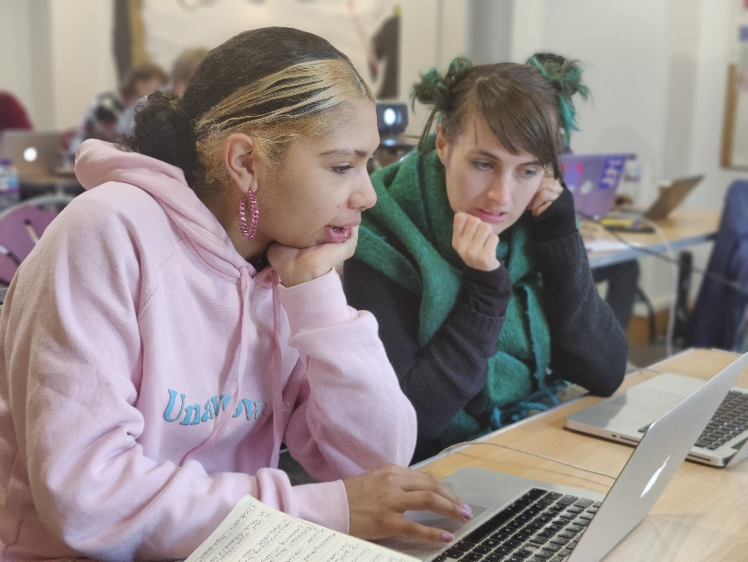

MadLab is running a FREE 4-week Intro to Web Development Course for Greater Manchester residents aged 18–30. This blended learning course covers HTML, CSS, JavaScript and GitHub, and will take students from zero experience to building interactive websites and creating a relevant skills portfolio. The course also covers careers advice, an insight into working in the digital industry and building relevant experience that can increase chances of a successful career.

Dates: 21st Jan - 12th Feb (four weeks)
Time: 10am-3pm
Where: Stockport Museum (Staircase House)
When: Every Wednesday and Thursday, plus approximately 6 hours of self-study at your own pace

For full details and to apply, visit the Shift Click website.

