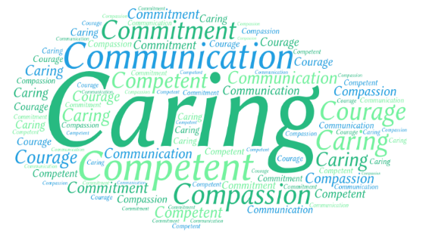
Level 1 Certificate in an Introduction to Health & Social Care
This programme is a developmental introduction into thinking about your desired career in the essential and rewarding health and social care sector. You may or may not be ready to transition into work, but this programme will be person centred and will provide you with the fundamental skills needed to work in this sector. Each session will guide you through important values needed when working in any health or social care role. The values which underpin this course are: Care, Compassion, Courage, Communication, Competence and Commitment.

Programme Units:
- Introduction to working in health care, adult care and childcare
- Effective Communication
- Introduction to Safeguarding in health care, adult care and childcare
- Awareness of equality & diversity
- Introduction to working in a person-centred way in health, adult care and childcare
- Introduction to health & safety in the workplace
- Understanding conflict at work
- Awareness of stress & stress management

Programme Dates & Venue: Start Date – Monday 1st September 2025
8-weeks, Mondays and Tuesdays each week
(9.30am – 3.00pm)

Venue – Gorton Hub, 27 Garratt Way, Manchester M18 8HE

Contact: Emma Stewart
estewart@tmc.ac.uk / 0161 674 3047

(Please contact to see if you are eligible for the programme. This programme is free for people in receipt of a benefit and 19 years of age and older)
