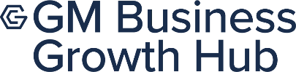

Empowering Greater Manchester with vital skills development
GM Business Growth Hub, Greater Manchester’s Business Support Organisation, is encouraging Greater Manchester to strengthen their skills position and take control of free skills solutions to overcome their barriers to learning, solve workplace pain points to achieve skills success and reimagine learning.

Background:
As organisations grow and expand it is important to ensure the people grow with it, and this could be in form of relearning, enhancing or improving skills like budgeting, corporate communications and digital skills.

From SMEs and volunteer organisations to public sector and GM residents, this Skills Development service provides accessible growth opportunities for both organisations and individuals alike, simultaneously raising the value and economy of Greater Manchester.

This toolkit includes social media and newsletter assets, and website copy for different stakeholders.

- Eligibility: GM Based Organisation: Sole Trader, SME, Large and Public Sector, VCFSE, employed 19+ GM Based.
- Skills Development Landing Page - GM Business Growth Hub | Skills Development

Please share and tag @GM Business Growth Hub (LinkedIn and Facebook) / @BizGrowthHub (X Twitter and Instagram) and use the hashtag #ReimagineLearning on your own social channels, website, internally with colleagues, across your networks and in any relevant newsletters.
Accompanying digital assets and social cards are attached.

Social Media posts
Below is the suggested social content to promote the events.

Channel | Post Date | Graphic | Copy
LAUNCH
Facebook/LinkedIn/X | w/c  12th May | 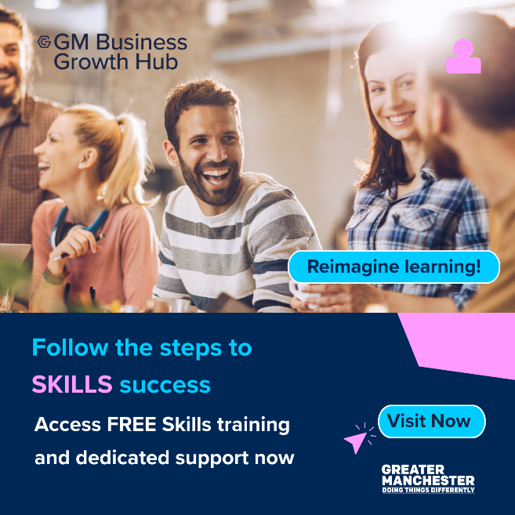  Alt Text: People at a table with blurred faces. Text: 'GM Business Growth Hub', 'Reimagine learning!', 'Follow the steps to SKILLS success', 'Access FREE Skills training and support', 'Visit Now'. Greater Manchester Combined Authority logo. | Access FREE training and dedicated business support from GM Business Growth Hub.  Upskilling, Development and Growth for Greater Manchester’s workforce, organisation and volunteers.  Options to suit your need, schedule and learning requirements.  Start Now!  0161 359 3050  GM Business Growth Hub | Skills Development  #SkillsCourses #CoreSkills #GreaterManchester
Restricted Characters
X |  | Alt Text: People at a table with blurred faces. Text: 'GM Business Growth Hub', 'Reimagine learning!', 'Follow the steps to SKILLS success', 'Access FREE Skills training and support', 'Visit Now'. Greater Manchester Combined Authority logo. | It’s time to take control and access FREE skills training and dedicated support.  There are options to suit your need, schedule and learning requirements  Start now!  Call: 0161 359 3050  Visit: GM Business Growth Hub | Skills Development  #ReimagineLearning
Alternative images |  | 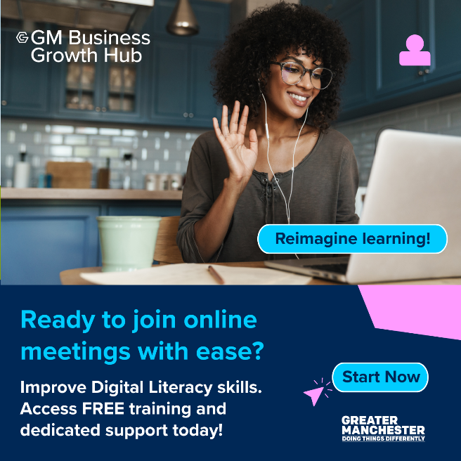  Alt Text: Person wearing earphones raises a hand while using a laptop, promoting free digital literacy training by GM Business Growth Hub.  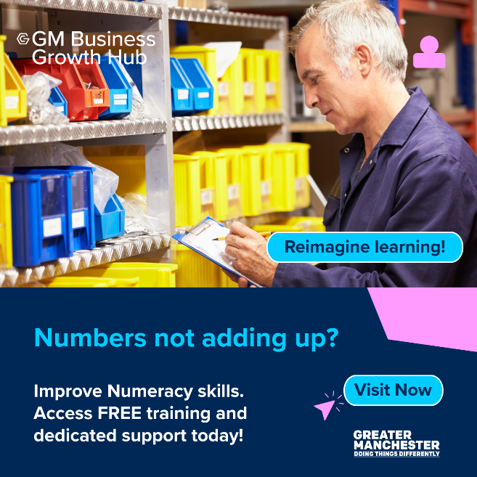  Alt Text: Person with grey hair holding a clipboard in front of shelves with colourful bins, promoting free numeracy training by GM Business Growth Hub    Alt Text: People in light blue shirts engage with digital devices under a white tent, promoting free digital literacy training by GM Business Growth Hub.

Newsletter Copy

Skills opportunities at all levels. Increase Your Impact; Invest in Your People.
GM Business Growth Hub, Greater Manchester’s Business Support Organisation, is encouraging Greater Manchester workers to strengthen their skills position and take control of free skills solutions to overcome their barriers to learning, solve workplace pain points to achieve skills success.
And it's not just for businesses. Whether you run a business or a non-profit organisation you can empower yourself and your team with the relevant skills your organisation needs at no cost to you!
Ready to find the solutions to suit your needs? Start now!
Call: 0161 359 3050
Visit: GM Business Growth Hub | Skills Development
#SkillsDevelopment #GMCA

