

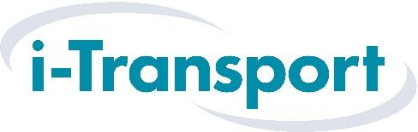

Trainee Highway Designer

Location: Manchester
Job Type: Full-time, entry-level
Ideal For: School leavers (age 16+) with an interest in design, transport, or engineering
Salary: Competitive starting salary and benefits package, with training and development provided

What is the job?
We are looking for someone motivated, practical, and ready to learn. As a Trainee Highway Designer, you will help plan the roads, streets, and paths that connect communities and jobs. This is a hands-on design role where you will be learning from experienced professionals while working on real-life projects around the North West and beyond. No prior experience is needed – just enthusiasm and a willingness to get stuck in. The role allows the opportunity to progress through the company and develop an exciting career path for themselves.

Who Are We?
i-Transport is an independent transport planning consultancy, with five offices across the UK. We work on exciting development projects, from gallery extensions to Garden Villages, ports to new offices, and even a Ryder Cup-standard golf course. Our job is to help design better, safer, healthier, more connected places, and we are proud to play a key part in shaping the communities of the future.

What Will You Do?
- Learn how to design roads & junctions using CAD (computer aided design -we will train you)
- Help with drawing plans, maps, design figures and layouts for new developments
- Collect and analyse data, like land ownerships, vehicle speeds and travel patterns
- Work with teams of architects, planners and developers
- Help solve real-world design challenges

What We are Looking For
- An interest in transport, design, engineering, or the built environment
- Good communication skills – someone who asks questions and shares ideas
- Confidence using a computer and aptitude to learn AutoCAD, ArcGIS and Excel
- Attention to detail and pride in your work
- A willingness to learn every day
- GCSEs in English and Maths,
- An interest in how things are built and how places are planned

What You will Get
- Opportunity to study part-time while you work (if required)
- A dedicated mentor to support your learning
- A dedicated training programme including in house training
- Full support to gain new skills and industry qualifications
- A friendly, supportive office with regular socials and team events
- Real responsibility on real projects that shape how people live and travel

