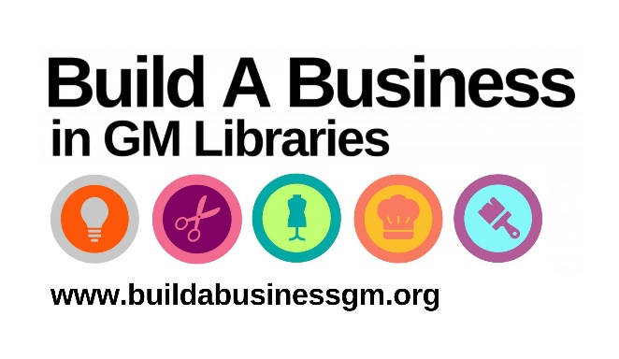
Build A Business in GM Libraries
www.buildabusinessgm.org

Starting up? Growing a business? Got a brilliant idea?

From artisan baker to zumba instructor, our FREE business support programme can help you get the skills, information & know-how to succeed.

Access over £5 million worth of industry standard information to make informed decisions and save time and money.

Prepare your business plan, find new markets, analyse competitors, check on patents and trademarks, and much more.

Workshops and events
Learn the basics of running a business, know your market & get ready to launch. Plus, meet other local businesses at our regular networking events.

One-to-one help
Our local Enterprise Officers will help you research your business and market using industry-standard databases and information.

Research your market
You’ll find industry-standard business information at each location: discover the latest trends, research the competition, and even find how many similar businesses are in your area.

Protect your ideas
Get insights into protecting your intellectual property (IP) such as copyright and trademarks.

Build a Business locations across Greater Manchester
Dedicated library space to work on developing your business: desks, Wi-Fi, PC access, business books to borrow, & print services.

Sign up for a library card to access these resources!
If you live in the UK, you can join Manchester libraries for free. Complete the online form to join the library.

Build A Business is a project funded by UK Shared Prosperity Fund and GMCA working with the Manchester City Council.

