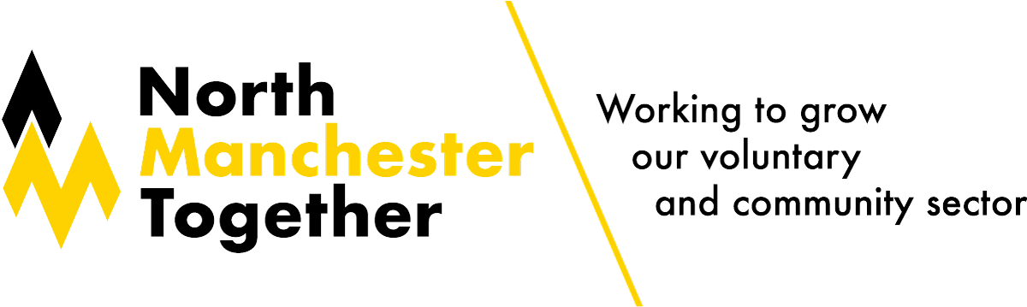North Manchester Training & Development Programme
Course | Type | Date | Time | Venue/Link
Writing Successful Bids  - know how to prepare for writing proposals so you can respond to opportunities quickly and efficiently  - be confident deciding whether you should bid  - be aware of how to write in an appropriate and effective style  - understand what makes a successful application or tender | In-person | Wednesday 20th November | 10:30am – 3:30pm  (lunch provided) | Turkey Lane & Monsall Neighbourhood Centre,  1 Jocelyn Street,  Harpurhey,  M40 8PR  Writing Successful Bids for North Manchester groups Tickets, Wed, Nov 20, 2024 at 10:30 AM | Eventbrite
 | Online | Tuesday 4th February | 10am – 3pm
Charity Trustee Induction & Refresher  - understand what governance and trusteeship are  - know who trustees are and what they do  - understand the personal liabilities of trustees and the protection available  - be able to identify and implement principles of good charity governance  - know how to govern and work with your fellow trustees to agree ways of working as a board | In-person | Tuesday 26th November | 10am – 4:30pm  (lunch provided) | The Grange Community Resource Centre,  Pilgrim Drive,  Beswick,  M11 3TQ  North Manchester Together VCFSE training | Eventbrite
 | Online | Thursday 20th February | 10am – 4:30pm | North Manchester Together VCFSE training | Eventbrite
Tools & Methods for Measuring Outcomes  - develop skills to take a more strategic approach to evaluation be able to confidently choose appropriate data collection methods  - know how to design and use tools to gather qualitative and quantitative data  - know how to organise insightful interviews and develop strong questionnaires  - understand good practice in applying data collection processes | In-person | Tuesday 3rd December | 10am – 3:30pm  (lunch provided) | Redbank House,  4 St Chad's St,  Cheetham Hill,  M8 8QA  North Manchester Together VCFSE training | Eventbrite
 | Online | Wednesday 12th February | 10am – 3pm | North Manchester Together VCFSE training | Eventbrite
Carbon Literacy for Community Leaders  - developed by the Carbon Literacy Project and the Our Manchester Funds team  - specifically designed for voluntary & community sector organisations  - awareness of the carbon costs and impacts of everyday activities  - ability & motivation to reduce emissions on an individual, community & organisational basis  - Receive certification of being carbon literate | In-person | Thursday 12th December | 9am – 4pm  (lunch provided) | The Guidance Hub,  389 Waterloo Road,  Cheetham Hill,  M8 9AB  North Manchester Together VCFSE training | Eventbrite
 | Online | Thursday 27th February | 9:30am - 4pm | North Manchester Together VCFSE training | Eventbrite
Safeguarding Essentials for Trustees  - understand your safeguarding duties within current law and policy in England. This includes your responsibilities to staff, volunteers, children and adults at risk of harm, and others in contact with your organisation  - understand the governance and assurance role of trustees in building a safeguarding culture  - be aware of safer working responsibilities as a trustee | In-person | Monday 3rd March | 10am – 1pm  (lunch provided) | Simpson Memorial Hall,  Moston Lane,  Moston,  M40 9NB  North Manchester Together VCFSE training | Eventbrite
 | Online | Friday 14th March | 2pm – 5pm | North Manchester Together VCFSE training | Eventbrite
Safeguarding Essentials for Charities  - understand different safeguarding law and policy in England, including main safeguarding duties to:  - staff  - volunteers  - children and adults at risk of harm  - others in contact with your organisation  - understand different types of harm and how to spot signs of abuse  - know how to effectively manage concerns and allegations  - be able to implement safer working practices for your organisation whih embed safeguarding practices | In-person | Tuesday 4th March | 10am – 3pm  (lunch provided) | Simpson Memorial Hall,  Moston Lane,  Moston,  M40 9NB  North Manchester Together VCFSE training | Eventbrite
 | Online | Monday 17th March | 10am – 3pm | North Manchester Together VCFSE training | Eventbrite
Christmas Networking Event  - opportunity to meet up and connect  - information and contact sharing  - reflect on the last 12 months and the year ahead  - discuss funding opportunities you may not be aware of  - chat in a dedicated space with refreshments provided!  - guest speakers to be announced | In-person | Monday 9th December | 11am – 1pm | Higher Blackley Community Centre,  Victoria Avenue,  Higher Blackley,  M9 0RA  North Manchester Together VCFSE training | Eventbrite

More Resources and Courses from Macc (not North Manchester specific)

Membership | Manchester Community Central
Training and events | Manchester Community Central
Search Macc trusteeship and governance training
You can go straight to the Macc-provided training here on the microsite: Trusteeship Macc-provided training or amend the ‘Provider’ search box to look for training delivered by other providers in the sector. Macc bite-sized online training starts tonight and it’s not too late to book on!

https://manchestercommunitycentral.org/support-groups/trusteeship-and-governance/learning-and-resources

Trustee Roles & Responsibilities | Online | Available now | 30-minute bitesize | Intro resource pack: Get to know Trusteeship – Trustee Resource Pack  AGM planning: How to plan successful Annual General Meetings (AGMs)  Running AGMs: How to run successful Annual General Meetings (AGMs)
 |  | Wednesday 13th November |  | Macc Trustee Training Video Series: Session 2 - Demonstrating Good Governance | Manchester Community Central
Trustees Connect  space for trustees to support each other, share challenges and successes | Online | Begins Wednesday 20th November  Quarterly event |  | Macc: Trustee Connect Space | Manchester Community Central
Trustee Roles & Responsibilities | Online | Thursday 21st November | 12pm - 12:45pm | Macc: Trustee Training Video Series: Session 3 - Risk Management | Manchester Community Central
Introduction to Diversifying Income | Online | Thursday 5th December | 1pm-2:30pm | Macc: An Introduction to Diversifying Your Income | Manchester Community Central
GM Ethnic Communities Network Event  GM Ethnic Communities Network members and allies to connect, share experiences and learn from one another as well as hear from guest speakers on relevant topics | In-person | Monday 9th December | 9am – 1pm  (lunch provided) | St Thomas Centre, Ardwick Green North, Manchester, M12 6FZ  GM Ethnic Communities Network Event | Manchester Community Central

