



Emergency FIRST Aid

Free course offering Level 3 certificate
Upon completion of this course you will have the confidence and knowledge to understand the role and responsibilities of a first aider, be able to assess an incident and much more

Where: Gorton Hub 27 Garratt Way Gorton M18 8HE

When: Wednesday 3 April 2024 9.00 – 4.00

Find out more
Email: jenny.rankinmills@clarionhg.com
Call: 07703889215

www.myclarionhousing.com Part of Clarion Housing

Course content includes: Recovery Position Seizure
CPR
Choking
External Bleeding Shock
Cuts and grazes Burns and scalds Splinters
Accident Reporting

Our trained employment
ADVISORS CAN SUPPORT you to:

Write a CV Improve interview skills
Access further training opportunities
Apply for jobs Connect withemployers

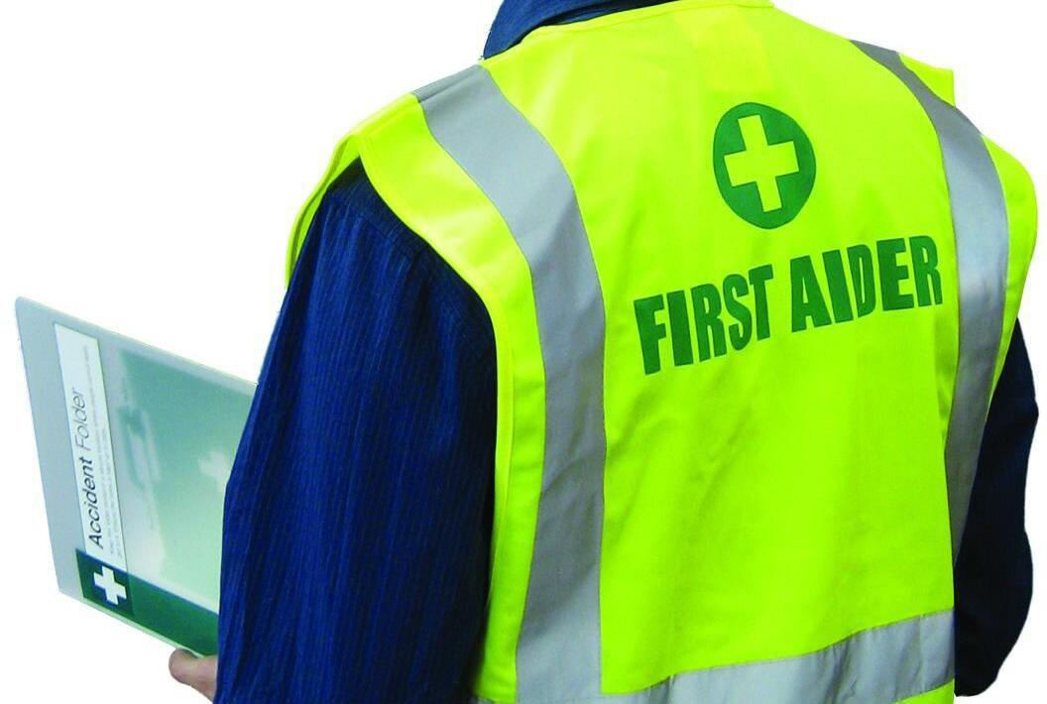




Find out more
Email: jenny.rankinmills@clarionhg.com
Call: 07703889215
www.myclarionhousing.com

