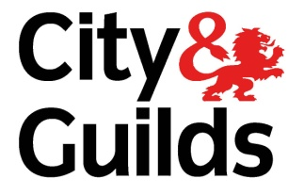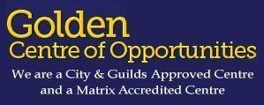

HEALTH AND SOCIAL CARE LEVEL 2 COURSE AVAILABLE AT GOLDEN CENTRE OF OPPORTUNITIES
Golden Centre of Opportunities are offering you the chance to take Health and Social Care Level 2 Course with a guaranteed job interview at the end of the course.
The Health and Social Care Level 2 begins in January 2024 and is a four month course which will run 2 days a week, every Monday and Tuesday from 9:30AM to 2:45PM.
You'll cover things such as:

- Communication
- Equality, diversity and inclusion
- Personal development
- Role of the social care worker
- Handling information
- Health and safety
- Safeguarding
- Duty of care

Eligibility:
- You must be 19 years old or older on/before 31st August of this academic year
- Be a resident in the Greater Manchester area
- Unemployed and claiming state benefits or in receipt of low wages
- Employed but earn less than £20,888.00 annual gross salary
- Not receiving any other funded training with another provider
- A resident must have lived in the UK or EU country for the last 3 years
- Where a resident who does not meet the 3-year residency rule, they may still be eligible for funding if they have Refugee status, Discretionary leave to enter or remain, Exceptional leave to enter or remain, Indefinite leave to enter or remain, Humanitarian protection, Leave outside the rules, Section 67 of the immigration act 2016 leave or Calais leave to remain.
If you would like to begin the enrolment process or have any further questions please call us at 0161 226 6181 or send an email to radwan@golden-centre.co.uk so that we can answer any questions or book an appointment for your enrolment.

Centre Location
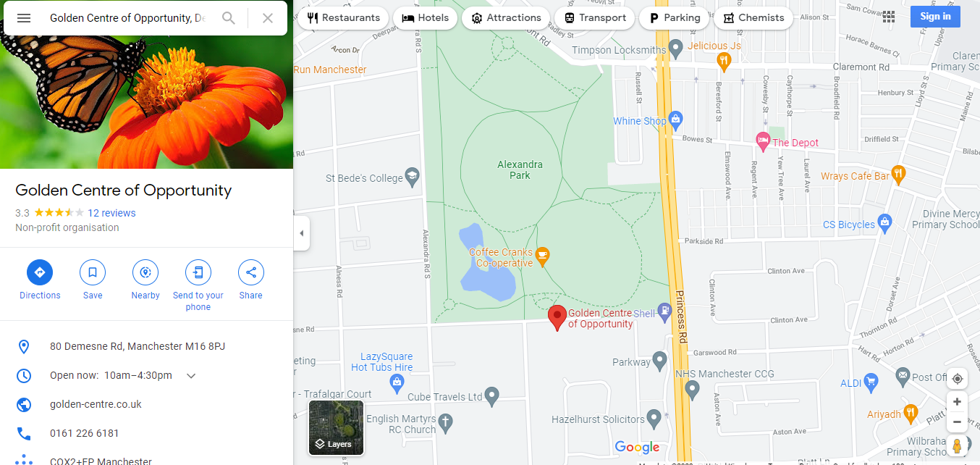
Services we provide at Golden Centre of Opportunities
- Information, Advice and Guidance in Education
- Employment Training Work Club
- Assessments to access learners’ education attainment in English using Enrolment Forms, BKSB, Free Writing and IT Screeners
- Health and Social Care Level 2 Course
- English ESOL Entry 1, Entry 2, Entry 3 and Level 1
- Welfare Benefit Advice Appointments
Contact Information
If you need to contact us please call 0161 226 6181 OR alternatively email us at radwan@golden-centre.co.uk.

