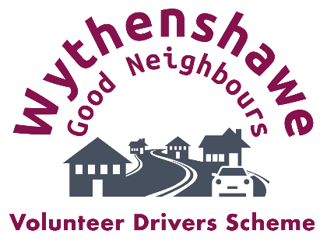
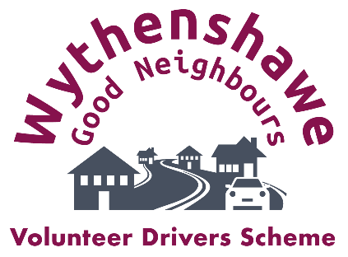
Wythenshawe Good Neighbours
Volunteer Drivers Support Worker – paid role.
6-month, fixed-term, part-time contract 22.5 hrs per week (over 3 days). £13,455 per annum (£11.50 per hour, FTE £22,425) Workplace pension (employer contributes: 3%). Working mileage: 45p per mile.
This is a dynamic role for a community-focused person who is keen to help improve quality of life for older residents, working with partners and stakeholders across Wythenshawe.
Admin: supporting the development and running of the new Volunteer Drivers Scheme, including contributing to volunteer recruitment and coordination and booking and scheduling journeys - using bespoke software.
Driving: connecting WGN members to their local community by driving them to appointments etc. (post-holder will be a confident/careful driver). As the scheme develops, more of the driving will be done by volunteers. Working mileage paid at 45p per mile.
22.5 hours per week over 3 days, Mon – Fri (which days will be agreed with the successful candidate). Occasional evening/ weekend work, with notice given.
Bespoke training will be offered as relevant to the role, and on-the-job skills will be built through this 6-month, fixed-term and part-time role.
Working alongside the rest of WGN’s Team, the post holder will enable the organisation to strengthen and expand the newly-launched WGN Volunteer Drivers Scheme. The post-holder will be integral to this exciting and community-minded project.
Who would suit this role?
- This role would suit job seekers wanting to gain professional experience in a community/ third-sector setting.
- A strong team player, able to work effectively to deliver against individual and team objectives.
Skills required:
- Confident driving with passengers.
- Able to communicate effectively with older people from diverse backgrounds.
- Able to communicate effectively with volunteers and other third-party organisations.
- Good time management, organisational skills and attention to detail.
- Computer literate.
- Able to work well in a fast-moving and reactive environment.
Deadline for applications: midnight on Sunday 5 November 2023.
Interviews: week commencing 13 November 2023.
For details/Application Pack/to discuss the role: contact Samantha Days, WGN Manager: Email: assist.thegpprojects@outlook.com Mobile: 07816 960025 Or access the details online here. https://wythenshawegoodneighbours.com/were-hiring-a-volunteer-drivers-support-worker/
Volunteer Driver – voluntary role.
Volunteering with Wythenshawe Good Neighbours (WGN) is a great opportunity to help provide services to those most in need in your neighbourhood. It can also be a very rewarding activity that will utilise and enhance your skills and experience. WGN Volunteer Drivers will make a real difference to people's lives across Wythenshawe by:
- taking WGN members to/from health appointments, organised events and activities and social arrangements across Wythenshawe
- delivering our monthly newsletter
- delivering and/or distributing other items, such as seasonal information, and cost-of-living support materials, on an ‘as-and-when’ basis.
All Volunteer Drivers attend an induction and training programme. For this scheme, Volunteer Drivers must have their own vehicles. They are reimbursed at 45p per mile to contribute to the cost of petrol when volunteer driving, insurance and maintenance of their vehicles.
Skills and qualities to fulfil the role
- Valid, clean UK driver’s license and safe driving record. (A maximum of 6 penalty points can be discussed at interview.)
- Be able to produce full insurance to cover carrying passengers. (Most insurance companies will insure a volunteer driver within the existing schedule. However, you must make it clear that you are a volunteer driver to your insurance company.)
- Access to your own vehicle - that is roadworthy, reliable and suitable for service users’ needs, and where points 1&2 above apply.
- No health conditions that may impair ability to drive safely (vision, hearing, perception, reflexes, certain medications, etc.).
- Understand the limitations experienced by some of WGN’s service users, such as mobility and hearing/vision loss.
Benefits of volunteering with us
- Opportunity to contribute to making life better for older people in Wythenshawe.
- Opportunity to be part of a dynamic WGN volunteer team.
- Opportunity to support, celebrate and be directly involved with Wythenshawe’s Age Friendly community.
- Opportunity to benefit from training opportunities offered by WGN; to prepare you for your role, then ongoing support.
- Opportunity to help develop WGN’s Volunteer Drivers Scheme for the benefit of WGN’s members and the wider community.
To apply to be a Volunteer Driver, please follow the link below or call 0161 9053898
https://wythenshawegoodneighbours.com/volunteer-drivers/

