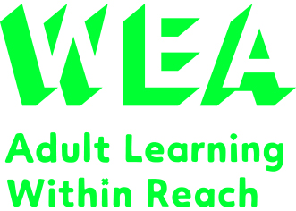

**Progression Opportunities**

Successful completion of the Level 3 Award in Education and Training can provide a pathway to further study in education and training. Learners may choose to progress onto the Level 4 Certificate in Education and Training, which is the next level of qualification in this area. Alternatively, learners may choose to apply their newfound knowledge and skills in a teaching or training role.

Overall, the Level 3 Award in Education and Training is an excellent starting point for anyone interested in a career in teaching or training. It provides a solid foundation of knowledge and skills that can be applied in a variety of educational settings, and it is recognized by employers and educational institutions alike.

**Course Start: 09th May 2023, every Tuesday for 7 weeks. Classes are 09.30 – 2.30pm.**

**Location: Online using Zoom & Canvas – Apart from the last lesson which is face to face.**

**Courses are FREE if you are in receipt of income related benefits, or earning under £21,000.00. Course is also FREE if you have not previously completed a Full Level 3 qualification in the UK.**

To reserve a place, you can enrol onto the initial assessment session by phoning 0161 696 5472 or email [manchesterskills@wea.org.uk](mailto:manchesterskills@wea.org.uk) and quoting the following reference – C3848819

The Level 3 Award in Education and Training is a recognized qualification accredited by the National Awarding Organisation NCFE. This course is designed for individuals who are interested in teaching or training, as well as for those who already have some experience in teaching and want to enhance their skills.

Throughout the course, you will develop a comprehensive understanding of the teaching and learning process, including the roles and responsibilities of a teacher, the importance of inclusive teaching, and assessment methods. You will learn how to plan and deliver effective lessons, and how to use a variety of teaching techniques to engage and motivate learners.

It is also suitable for people who are considering this kind of work in the future. The Award offers an introduction to teaching and covers topics such as the roles and responsibilities of a teacher/trainer, planning and delivering inclusive sessions, and assessing learning.

The course is divided into three mandatory units, each focusing on different aspects of education and training. These units are:

Unit 1: Understanding Roles, Responsibilities, and Relationships in Education and Training

Unit 2: Planning to Meet the Needs of Learners in Education and Training

Unit 3: Delivering Education and Training





The WEA is a charity registered in England and Wales   
(no. 1112775) and in Scotland (no. SC039239).

**L3 Award in Education & Training**