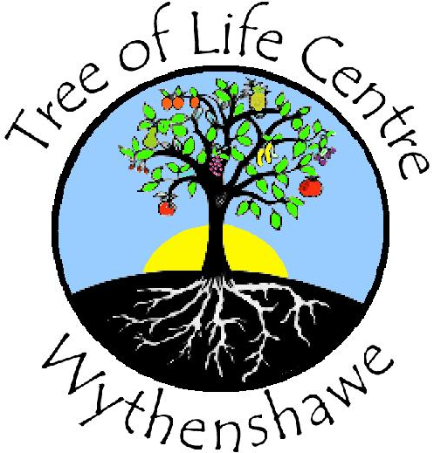Tree of Life Centre Wythenshawe
Job Description

Job Title: Income and Partnership Manager
Hours: 21 hours per week
Salary Grade: £30,000 - £36,000
Branch: Greenbrow Road, Newall Green, Wythenshawe. M23 2UE
Responsible to: CEO
Responsible for: Fundraising, Monitoring and Evaluation, Partnership Engagement

Job Purpose
Research and identify sources of income that match the charity’s needs and aspirations for growth and development. You will also be responsible for carrying out monitoring and evaluation of funded activities. You will work under the direction of the CEO and Board of Trustees

Main Duties
- To establish and maintain partnership with a variety of voluntary, statutory and commercial organisations that support and enhance the aims of the organisation.
- To successfully complete applications for funding to increase the sustainability of the organisation.
- To identify and implement a range of income generation streams.
- To monitor, evaluate and prepare feedback progress reports to funders, General Manager and Trustee
- Work towards achieving and exceeding the grant targets set by the General Manager and the board of Trustees.
- To work with the General Manager to establish budgets, cash flows and annual accounts.
- To work under the direction of the General Manager and deputise for her as required.
- To ensure compliance with all relevant legislation and company policies and procedures.
- To receive supervision and undertake management and professional development training as required.

Skills and Experience

Essential
- Minimum 1 year experience of researching and writing successful funding bids to a variety of funding providers.
- Proven experience of reaching funding sources, achieving targets & working to set deadlines.
- Experience of preparing financial information in an accessible format.
- Experience and knowledge of working in the voluntary sector
- Ability to respect confidentiality
- Experience of accurately recording information
- Good communication skills- verbal, written, IT
- Ability to identify, assess and manage risk
- Willingness to work flexibly and undertake work outside normal hours

Desirable
- An interest in the 3 R's- Reduce, Re-use Recycle - and the local community of Wythenshawe
- Be self motivated, well organised, able to manage own time and have good admin skills
- Willingness to undergo training
- Experience of working with vulnerable people
- Knowledge of building and facilities management
- Full driving licence

