GROUNDWORK  GREATER MANCHESTER |  |  | 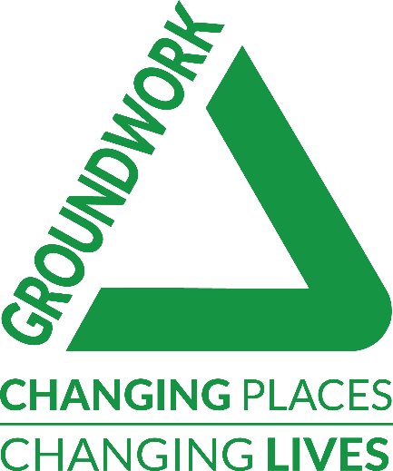
 | Communities Project Assistant  (Green Space Regeneration Worker)  Job Description &  Person Specification

SALARY
30 hours per week

DURATION OF THE POST
31st March 2023

BUSINESS UNIT
Communities

LOCATION
Groundwork Greater Manchester office in Trafford

ACCOUNTABLE TO
Communities Manager

RESPONSIBLE FOR
Will involve working with volunteers.

TEAM
Communities

OVERVIEW OF THE POST
Working with the Communities team at Groundwork you will be supporting delivery across a range of different community engagement, capacity building and environmental projects involving community groups and local residents of all ages. You will be involved in supporting project organisation and delivery as well as promoting available activities.
You will also be involved in collating and inputting of data and generating reports to support measurement of project impact. You will be based at our offices within Trafford Ecology Park but will be involved in delivering activities at various locations in Greater Manchester.

ROLE & MAIN PURPOSES OF THE POST
- To support the provision of high-quality community engagement and project management across our Sustainable Communities work programme.
- To support the communities’ team and community’s manager in the development, and delivery of high-quality community and environmental projects, ensuring they meet the needs of both communities and partners.
- To support the planning and delivery of capacity building support and training programmes to a wide range of community groups.
- To collect monitoring and business intelligence data.

PERSON SPECIFICATION
Good English and maths skills; Interest in community development work; Ability to communicate well with a diverse range of people; Good ICT skills with a practical experience of using MS Office and willingness to learn and use other software packages; Good verbal and written skills and attention to detail, able to use own initiative
Basic DBS check required.

Values and ethos:
- A genuine passion for Groundwork Greater Manchester’s mission and values;
- A commitment to the delivery of high-quality services and value for money.
- Commitment to an agile project/team culture of ‘learning in action’ to ensure the team/project learns the most it can from its work in the community and adapts accordingly
- Commitment to inclusion and team-work
- A commitment to low-carbon ways of working

ADDITIONAL FACTORS
- Able to work outside of normal office hours within a flexi time / time off in lieu system.
- Environmentally aware and sympathetic to the aims and ethos of Groundwork and other project partners.
- Undertake training and development deemed necessary for the pursuance of the post.
- Comply with the Trusts Policies and Procedures including, but not exclusively, Equality, Diversity and Inclusion, Data Protection, Health and Safety and Environment.
- This role may be subject to a Disclosure and Barring Service (DBS) check.

PREPARED BY: | Nina Burns
PREPARED ON: | 12.4.2022

