Careers Hub Short Guides
Writing good supporting information

Here are a few tips to think about when completing the “Supporting Information” section of an application on the NHS Jobs site.

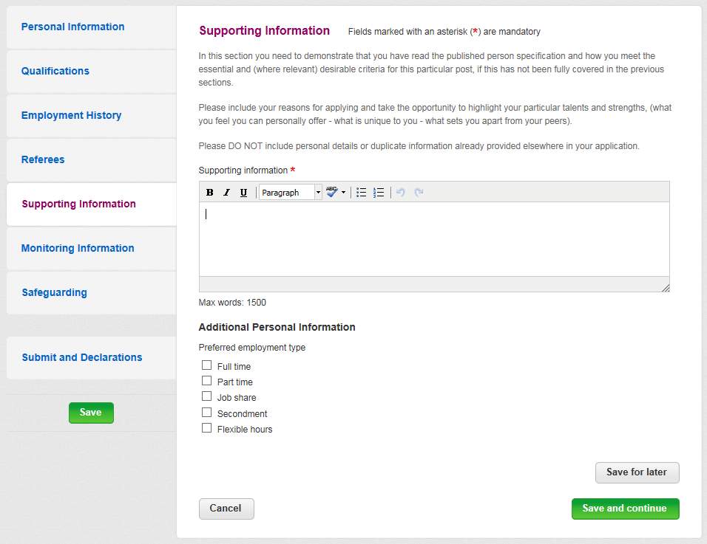
What is supporting information?
When you apply for a job in the NHS, one of the most important areas of the application is the Supporting Information section. It is located between Referees and Monitoring Information. This part of the application allows you to demonstrate why you’re the right person for the job and how you meet the criteria for the job.

Recruiting managers will often make this their main focus when shortlisting candidates for interview, so it’s important that you make sure you’ve made your case for why they should employ you. It’s also important to avoid waffling or providing information that’s not relevant.

What are employers looking for in your supporting information?

- Enthusiasm – show that you are confident in your abilities and that you see this job as a positive opportunity/challenge.
- Evidence of clarity of thought – ensure that the statement is structured, doesn’t ramble or move back and forth between subjects. Sometimes it’s good to think about the points you want to make and then think about the order you’ll make them or how you might group them in sections.
- Some awareness of what the job will entail – try to show that you’ve read and understood the job description. Often you can do this by referring to skills, abilities, knowledge or experience you have that would benefit you in the tasks and objective of the new job.
- Some knowledge about the organisation – most NHS organisations have extensive websites with lots of information about how they operate and what their Values are. Do some research and try to refer to it in your application where relevant.
- Engage the employer – you want to encourage the person reading your application to want to know more about you. You can do this by including a statement about an interesting project you’ve supported or a time when you’ve innovated.
- Details about how you can contribute to the organisation – this is really important as it enables you to show the passion you have for the role and why you want to work in this area, remember to focus on what you can do for them. Also talk about how you will contribute to the team or department and add value.
- Highlight your interest in and attraction to the organisation – this could be based on your knowledge of the organisation from personal contact, or from research you have done about the organisation and the work it is involved in.

What is a job description and person specification?

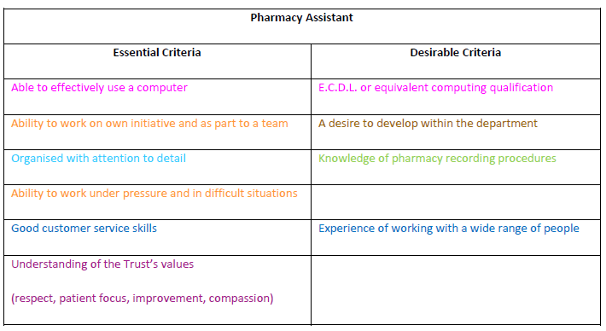
Every vacancy on the NHS Jobs site will have a job description and person specification that can be downloaded for your information, it’s really important to ensure that you carefully read through all the information detailed in both documents.

The job description lays out the essential elements of the role, along with the purpose of the job and the duties and responsibilities that would be expected of you in this role.

The person specification describes what the employer needs from a candidate in terms of skills, abilities, knowledge and experience. This is categorised into essential and desirable qualities the employer would like in a candidate.

Tips for a great application:

- The shortlisting process – during shortlisting, applicants are selected for interview based on how well they meet (or come close to meeting) the essential requirements. Therefore, the supporting information section is a perfect opportunity for you to show that you do have the skills and experience as stipulated within the person specification and provide clear examples.
- Align your ‘supporting information’ statement closely to the job specification and job description – it is really important to ensure you cover all the points of the specification and job description within your supporting information, showing how they match your own skills and experience to date, demonstrating why you would be suitable for the position. You need to convince the recruiter that you have the required skills, knowledge and experience and that they should be inviting you for an interview.
- The job description lists the duties and responsibilities of the post – this gives you an opportunity to give examples of the experience in these duties and responsibilities through previous job roles you have undertaken.

Matching the person specification when completing the supporting information
Within the supporting information section, you need to demonstrate that you have read the published person specification showing how you meet the essential and (where relevant) desirable criteria for this particular post.
Make sure to include your reasons for applying and take the opportunity to highlight your particular talents and strengths, as well as what you feel you can personally offer, what is unique to you and what sets you apart from your peers. Remember this is the perfect opportunity to sell yourself.

Supporting Information
This example of supporting information has been colour coded to show how it meets the essential/desirable requirements stated in the person specification above.
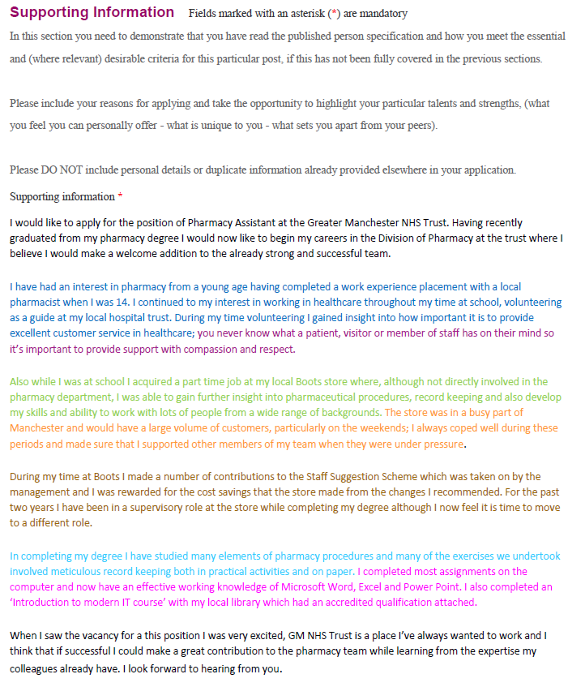

Points to remember
- Provide an example of each skill listed on the person specification – try to ensure that all points are covered using an example of when you have used those skills.
- Keep it to the point - you do need to be mindful not to make your application form too long winded, so state the facts.
- Where possible list your examples in the order they appear in the person specification – this will help the recruiter to recognise each skill when they are short listing.
- Relate your experience to the post you are applying for – try to keep it as concise as you can, matching your experience to the skills set out in the job description and person specification.

Remember - Ensure you proofread everything several times and check the spelling before submission of your application, as this is the first example of your attention to detail and the pride you take in your work
You can find more guides like this one on our website gmcareershub.nhs.uk or you can email us at careers.hub@cmft.nhs.uk for more information about NHS Careers in Greater Manchester.

