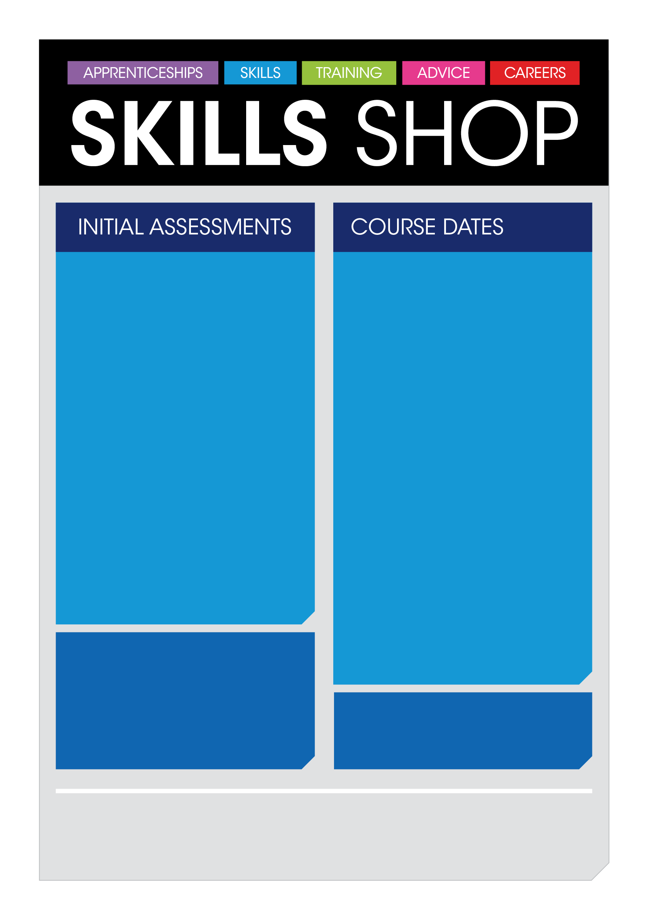
Eligibility
- Claiming benefits
- 19yrs +

Monday
16th May 2022
to
Friday
27th May 2022
10.00am - 4.00pm
The course includes
- City & Guilds qualifications in E3 Employability, E3 Customer Service, E3 Retail
- CV writing
- Interview skills
- Access to retail and hospitality positions within Trafford centre

NB Please bring either photo ID (UK passport, driving license or residents permit), birth certificate, debit card, benefit letter or utility bill.
This is required by the first day of the course at the very latest otherwise you will not be able to complete the course.
Initial assessments
will take place on
11th May at 10:30 am and 1:30pm

Time slots to be made in advance
Location
SkillsShop – Intu Trafford Centre
The day includes:

- Information giving session,
- Numeracy and literacy assessment
- 1:1 interview
To book an appointment,
please call Janine on: 0161 747 4674

