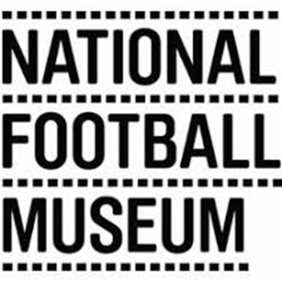

Director of Content
(Collections, Exhibitions and Programmes)

Salary: £47-55K

Based – Manchester with occasional work in Preston
Full Time (37.5 hrs), Permanent contract

This is a wide-ranging job to shape the future of a national museum by transforming the exhibition galleries, developing a fully representational collection and delivering community and public programmes which bring together football and creativity.

NFM has what is widely considered to be the world’s finest public collections relating to the football history, art, design and photography. The collection numbers over 40,000 objects relating to football and the social history of the game and includes programmes, fanzines, trophies, equipment, art, photography and film, oral history and objects relating to fan culture, behaviour and activism.

Over the last three years NFM has built a resilient business model and through the support of Manchester City Council and with Cultural Recovery Funding we have come through the pandemic stronger and are now applying to become an Arts Council National Portfolio Organisation

- Our vision is to be a leading national museum a year exploring why football is the game of our lives.

- Our cause is to champion equal opportunity for all to enjoy football culture

- Our mission is sharing stories about football

We will be looking someone who wants to shape the museum’s ‘content’ and has the experience and ability as a Cultural leader to galvanise a diverse team of permanent staff and freelancers who will focused on achieving excellence in their fields of collections, exhibitions, and programmes

We are committed to increasing representation of women’s involvement in football to 50% of our onsite and online content. We have made great strides in increasing our women’s football collection, developing links with women’s teams, and delivering activities and programming that engage the public with past and present women’s football. We are excited about the upcoming Women’s EURO 2022, which will be hosted in cities across England, including in Manchester, and we have lots planned to ensure we collect this important football history as it happens.

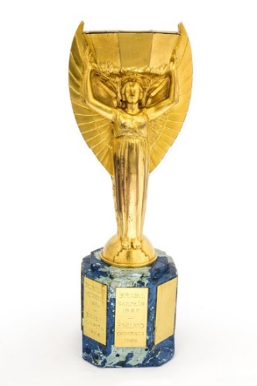
A look at some of our collection
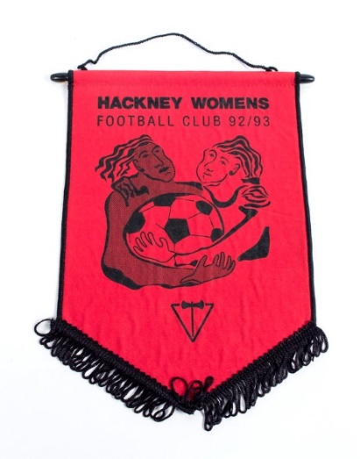
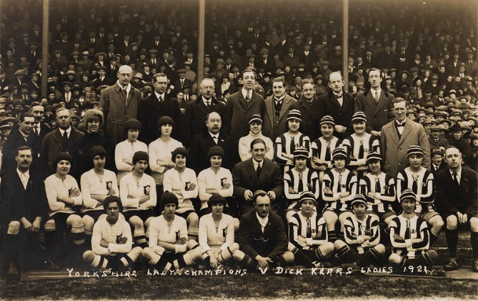

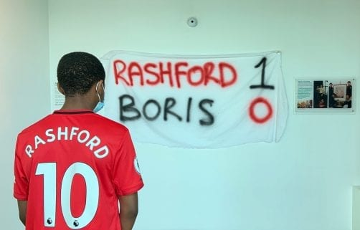
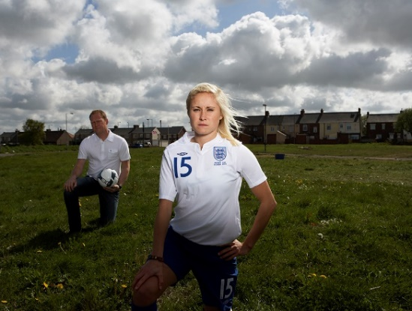

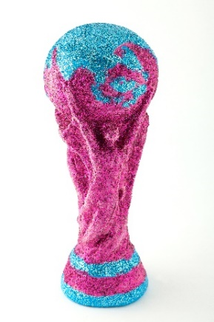
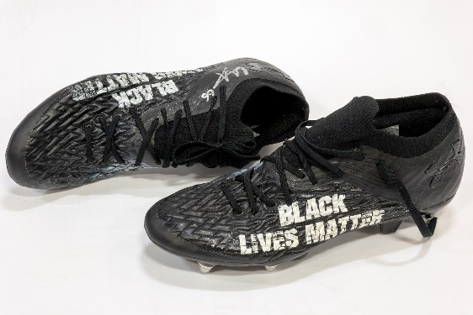

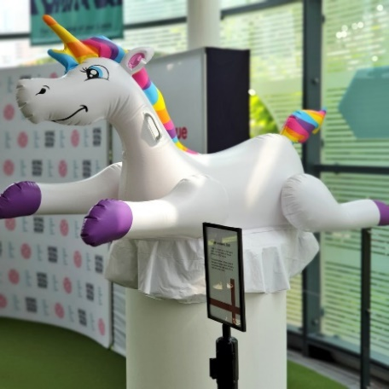
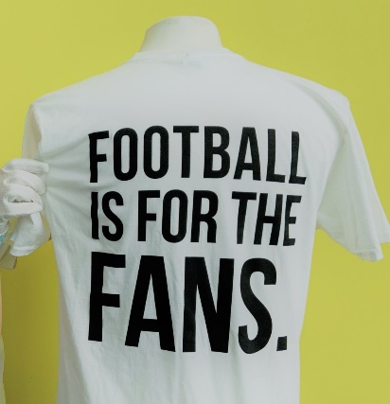

Some of the objects in our collection, including recent acquisitions: From top-bottom, left-right:
- Jules Rimet World Cup trophy, 1966
- Hackney Women's FC Pennant, 1992
- Postcard of Yorkshire Ladies v. Dick Kerr's Ladies, 19 March 1921
- Portrait of Steph Houghton by Alison Palmer, 2005
- Rashford 1 – 0 Boris banner, 2020
- Trent Alexander-Arnold Black Lives Matter boots, 2020
- The Justin Fashanu Cup, 2012
- Leeds United player-worn T-shirt protesting the European Super League, 2021
- Unicorn from St. George’s Park, 2021

You will need a proven track record in people management including a focus on visitor research to reach as wider audience as possible for your work.

A commitment to the Arts Council’s Let’s Create Strategy and its outcomes and principles will be essential,along with the imagination to recognise how football can engage our communities and world in culture.

If you are excited by this opportunity and wish to apply, please send your CV and covering letter setting out why you would like the role and showing how your skills and experience match what we’re looking for, to Heather.Cooper@nationalfootballmuseum.com

Closing Date: 3rd May
Interviews will take place virtually on 12th May
2nd Interviews will take place at the museum on 19th May

