

Apprenticeships with NG Bailey – Manchester
Our 2022 apprenticeship application window opens Monday 21st February 2022. To find out all the latest information and tips on applying, visit our website or contact our team:
www.ngbailey.com/apprenticeships

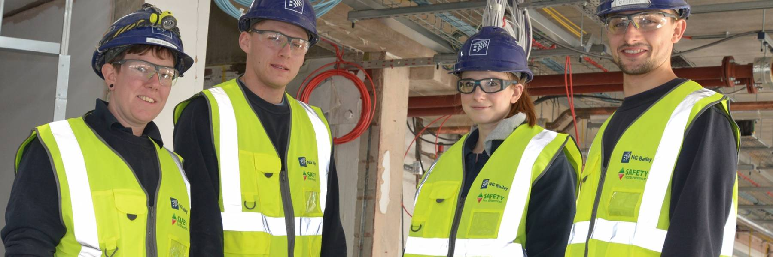

What apprenticeship roles are available in 2022 for a Sep start?
As one of our apprentices, you will be fully supported throughout your programme with us. Our apprenticeship development team are there to make sure you get the best out of the business and the business gets the best out of you.
Some of our popular apprenticeships (all 4 years) are:
- Electrician – Level 3 Electrotechnical Installation
- Industrial Plumbing and Heating – Level 3 Building Services Craftsperson
- Project Engineer – Level 4 Building Services Engineering (BSE) Technician
- Planner – Level 4 Building Services Planner
- Quantity Surveyor – Level 4 Construction Quantity Surveying Technician
Where will I study?
- Trafford College – Electrician
- Leeds College of Building – Project Engineer, Quantity Surveying, Planner
- Salford College – Plumbing & Heating
What qualifications do I need?
- Electrician - 5 GCSEs at C/4 and above (inc Maths, English and Science)
- Industrial Plumbing & Heating - 5 GCSEs at C/4 and above (inc Maths, English and Science)
- Project Engineer - 5 GCSEs at C/4 and above (inc Maths, English and Science) or the equivalent. 2 STEM A Levels at C/4 and above (or equivalent)
- Planner - 5 GCSEs at C/4 and above (inc Maths, English and Science) or the equivalent. 2 STEM A Levels at C/4 and above (or equivalent)
- Quantity Surveyor - 5 GCSEs at C/4 and above (inc Maths, English and Science) or the equivalent. 2 STEM A Levels at C/4 and above (or equivalent)

