

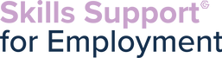
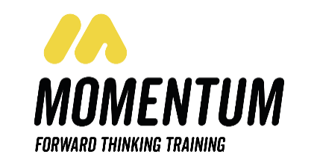

In partnership with Momentum Training we are now providing a classroom-based SIA course in Manchester. Successful completers will then be supported by Momentum to find employment within the industry.
3 ½ week course
Starting – 10th February 2022
Delivered part online & part classroom based
Methodist church Central Building oldham street M1 1JQ

Units : Team leading qualification Level 2 – online - Equality and diversity Level 2 online - Substance misuse Level 2 – online First aid qualification – Level 3 – face to face – over 7 working days - Working as a door supervisor – Level 2 face to face – over 7 working days
First three units are done from home online 9am – 3pm Monday – Friday for the first 2 weeks
Last two units are done in the classroom between 8.30am – 5pm over 7 working days
Manchester City Centre (Double Tree Hotel, Manchester)
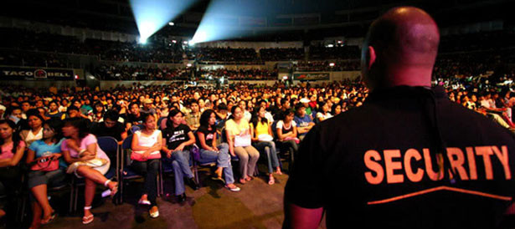
Strict time keeping and attendance required to pass the course
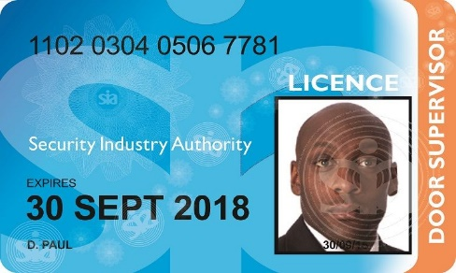

Learners to check eligibility of SIA licence if they have previous criminality, please complete link: https://www.sia.homeoffice.gov.uk/Pages/licensing-cri.aspx
You will be eligible for SSE if you are:
•Unemployed (you can be on benefits or not)
•Have Proof of Address and Identification (including proof of right to live and work in the UK if needed)
•A resident of Greater Manchester
•Not in full time education
•for the SIA course candidates need to provide in date photo ID
Candidates must also have a computer or laptop to complete registration and course

If you have any referrals for this opportunity, please email name of candidate,email address, contact number and date of birth -
to Lucy.wills@gcemployment.uk

