

**When:**

**Initial Assessments:** ongoing

**Courses Start**: Monday 29th November 2021 at 10:00 am. Classes run every Monday for 4 hrs.

**Location:**

**Online using Zoom & Canvas**

**Courses are FREE if you are in receipt of certain benefits**

To reserve a place you can enrol onto the initial assessment session by phoning 0161 696 5472 and quoting **C3846737**

**Our community interpreting courses are here to help you learn the skills and abilities to become a community interpreter and to support those around you.**

**As an interpreter you will be vital to the support and growth of the community, interpreters enable others to have a voice and to feel safe and understood.**

**L2 Award Preparation to Work in Community Interpreting with WEA**

**Suitable for students who wish to gain knowledge and skills of community interpreting, including the role of codes of practice and learn about the settings where interpreters may be required to work**.

**Community Interpreting**

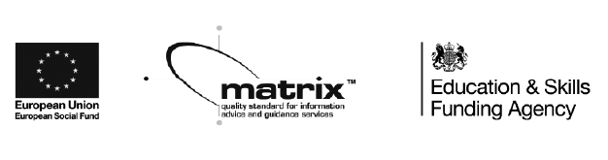

The WEA is a charity registered in England and Wales   
(no. 1112775) and in Scotland (no. SC039239).

**Community Interpreting**