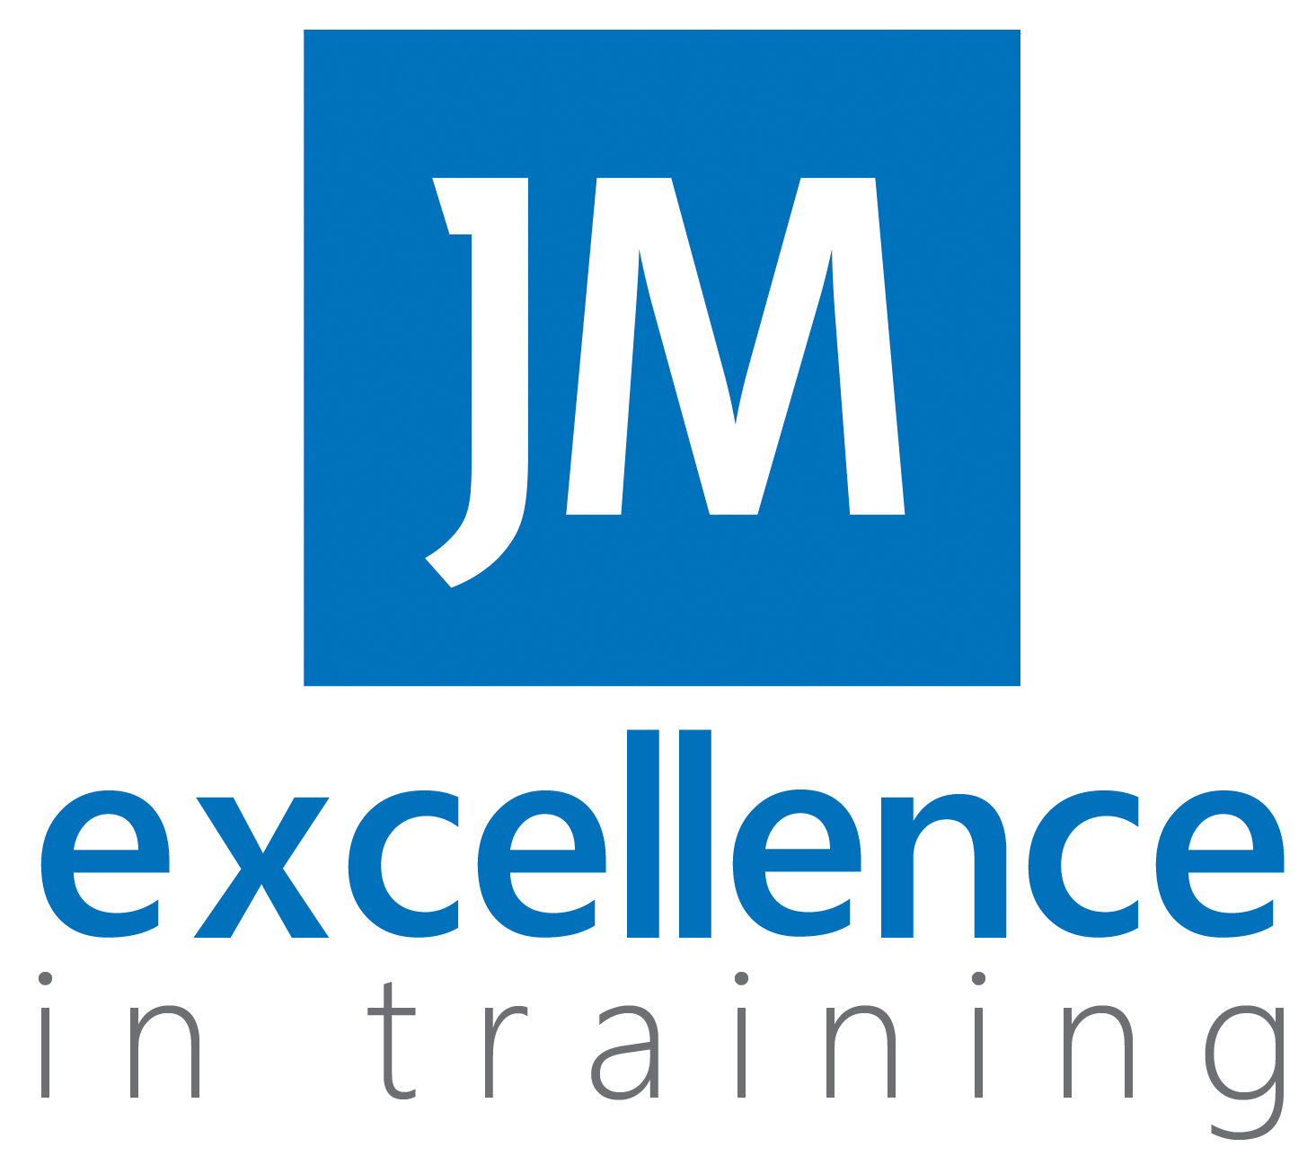  - Business ADMIN  Traineeship  12 week Traineeship programme  A Traineeship will help you grow in confidence, allow you to become familiar with the workplace and improve your professional attitude. The core aim of the programme is to improve your maths and English grades and provide a high-quality work experience that could lead to an apprenticeship.  Although Traineeships are unpaid it is valuable as it gives you the experience, qualifications and skills that can set you apart from other candidates and an opportunity to demonstrate this in the workplace.  The programme content is a blend of online classroom learning and work placement that is split over the course of the programme.  Online learning will include:  -Functional skills  -Safeguarding, prevent and equality and diversity  -Understanding your role, business organisations and work preparation training  Work placement will be for minimum 70 hours in a Local Business. | 12 week traineeship programme  ____  Starts 30th November 2021  ____  Bursary Available  ____  16-24years  ____  Online classroom delivery & quality work placement  Contact  Clare Storer  07754 220326  clare@jmet.org.uk

