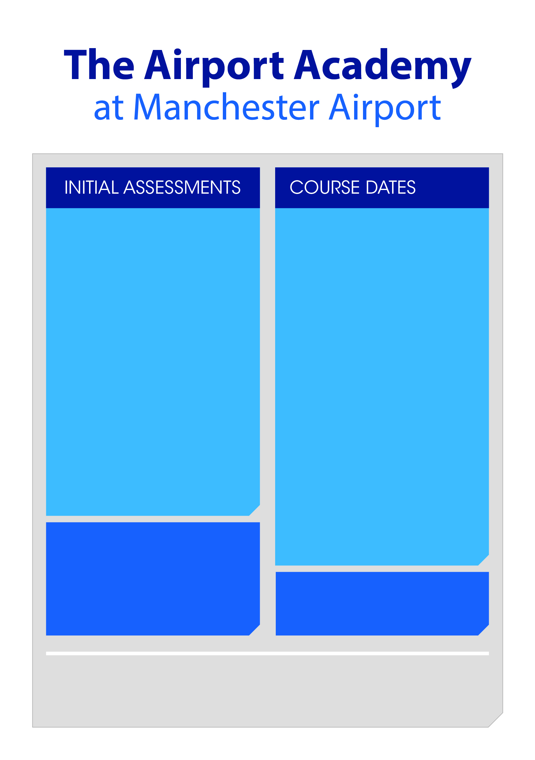

ICTS

Security Agent

Monday 10th January 2022

to

Friday 21st January 2022

**The course includes**

* **Certificate for Introduction to Customer Services (Entry 3)**
* **NCFE Certificate E3 in Employability Skills**
* **NCFE Lv1 Award in Mental Health Needs**
* **NCFE LV1 CERT IN Exploring the Aviation Industry**
* **Guaranteed Interview**

**The course includes**

* **Certificate for Introduction to Customer Services (Entry 3)**
* **NCFE Certificate E3 in Employability Skills**
* **NCFE Lv1 Award in Mental Health Needs**
* **NCFE LV1 CERT IN Exploring the Aviation Industry**
* **Guaranteed Interview**

**Eligibility**

* Claiming benefits or earning less than £18,135
* Aged 19+
* UK resident for at least 3 years

NB Please bring either photo ID (UK passport, driving license or residents permit), birth certificate, debit card, benefit letter or utility bill.

This is required by the first day of the course at the very latest otherwise you will not be able to complete the course.

Initial assessments   
will take place on Thursday 6th January a**t 10am and 1pm**

**Location**

Airport Academy, Upper Level The Station, Manchester Airport M90 3RR

**The day includes**

* Information giving session,
* Initial assessment
* Completion of Paperwork

To book an appointment,

please contact your JCP adviser