


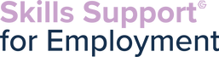
In partnership with Momentum Training we are now providing a classroom-based SIA course in Manchester. Successful completers will then be supported by Momentum to find employment within the industry.
3 ½ week course -planned start date 14th October
Delivered part online & part classroom based
Classroom based learning for 7 days- (8.30am-5pm) Monday -Friday in Manchester City Centre (Friends Meeting House, 6 Mount St, Manchester M2 5NS)
Strict time keeping and attendance required to pass the course
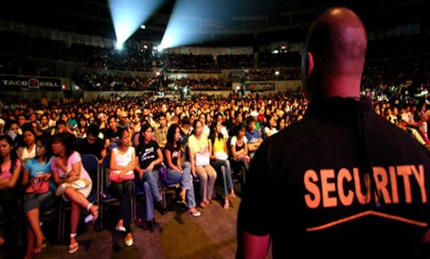
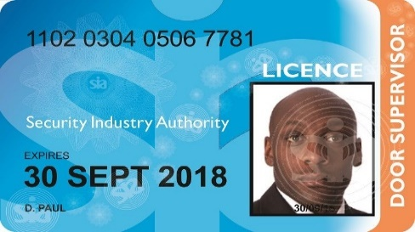

Course qualifications - Level 2 Award for Door Supervisors in the Private Security Industry, Certificate in Team Leading Principles, Certificate in Equality & Diversity L2, Level 2 Award in Substance Misuse, Level 3 First Aid & Level 2 Extended Certificate in Understanding Stewarding at Spectator Events

Learners to check eligibility of SIA licence if they have previous criminality, please complete link: https://www.sia.homeoffice.gov.uk/Pages/licensing-cri.aspx
Please Note: Learners need to be aged 18 years and over to apply for their SIA badge.

You will be eligible for SSE if you are:
•Unemployed (you can be on benefits or not)
•Have Proof of Address and Identification (including proof of right to live and work in the UK if needed)
•A resident of Greater Manchester
•Not in full time education
•Must have access to a laptop

If you have any referrals for this opportunity, please email melanie.lamb@gcemployment.uk

