
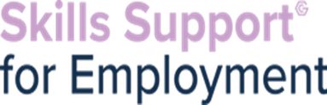


In partnership with Plato Training, we are offering a Level 2 Certificate in Support Teaching & Learning (STLS)
Starting: 19th October
Days: They run 3 days per week for 6 weeks. Usually Tuesday, Wednesday & Thursday.
Class times: 9.30am-2.30pm
Delivery Method: Online with tutor support
Learners will cover topics such as:
• About schools, colleges and organisations
• How children & young people develop
• Equality, diversity and inclusion in a learning environment
• Building professional relationships with children & young people
• Learn about positive behaviours in a learning environment and teamwork




You will be eligible for SSE if you are:
•Unemployed (cannot be working any number of paid hours or be self-employed)
•Have Proof of Address and Identification (including proof of right to live and work in the UK)
•A resident of Greater Manchester
•Not in full time education
•Must have access to a device to undertake online learning
•Must have basic IT Skills (use of emails, open documents, send attachments etc)

If you have any referrals for this opportunity, please email melanie.lamb@gcemployment.uk

