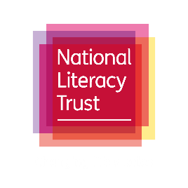

Take 10 for World Mental Health Day

Social Media pack

Introduction
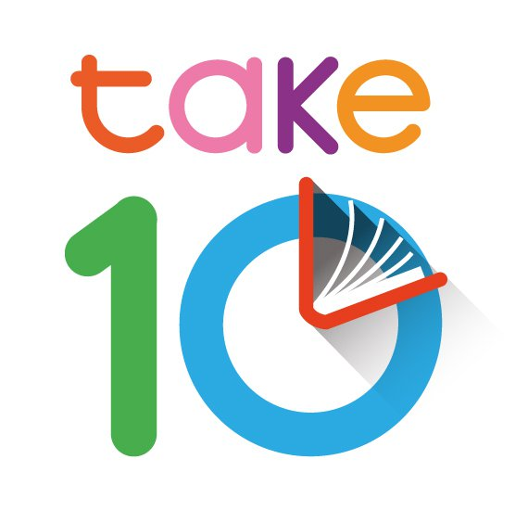
This pack includes social media assets, sample social media posts and draft newsletter copy to promote Take 10, as part of Read Manchester and National Literacy Trust’s Connecting Stories project and supported by Wesleyan.
Our research has shown us that reading can be an effective way of helping people take care of their mental health and wellbeing – and it only takes 10 minutes a day to see the benefits. That’s why, on Friday 8 October at 10am we are calling on the nation to #Take10ToRead with us in support of World Mental Health Day that Sunday.
Please feel free to adapt messaging and content for your external/internal communication channels according to your purposes and audience.
For more information please email Rosie White on: connecting.stories@literacytrust.org.uk.

Social media
Please use the hashtags #Take10ToRead, #ReadMCR and #ConnectingStories and tag Manchester Libraries and the National Literacy Trust.
 | Twitter | Facebook | Instagram | LinkedIn
Read Manchester | @manclibraries | @ReadManchester
National Literacy Trust | @Literacy_Trust | @nationalliteracytrust | @Literacy_Trust | National Literacy Trust
Wesleyan | @wesleyan | @wesleyanAS | @Wesleyan_UK | Wesleyan

Each post can be accompanied by:
- Images or social cards taken from our image bank, available to download here
- Your own images of staff holding their favourite book as they #Take10ToRead
- You’ll find ‘social frame’ assets to frame your Take 10 photos on the day on the link above
- Link to the Take 10 webpage: literacytrust.org.uk/take10

Social media copy
Twitter
Reading for just 10 minutes a day is a great way of boosting your mood and wellbeing. That’s why we’re taking part in @Literacy Trust’s and @manclibraries #Take10ToRead challenge. Join us at 10am on Friday 8 October by taking 10 minutes out of your day to read. #ConnectingStories #ReadMCR
OR
We’re taking part in the #Take10ToRead challenge with @manclibraries and @Literacy_Trust! Reading is a brilliant way of improving your wellbeing and it only takes 10 minutes a day to see the benefits. Join us by sharing what you’re reading at 10am, Friday 8 October. #ReadMCR
OR
With #WorldMentalHealthDay around the corner, it’s never been more important to find ways to take care of your mental wellbeing. Reading is a great way of doing just that, so join us, @manclibraries and @Literacy_Trust to #Take10ToRead at 10am, Friday 8 October! #ConnectingStories #ReadMCR

On Friday 8 October
Check out our team as we #Take10ToRead with @manclibraries, @Literacy_Trust and #ConnectingStories! Grab your favourite book and get involved by taking 10 minutes to sit down and read! #ReadMCR
OR
It’s time to #Take10ToRead! Reading is a great way of improving your wellbeing and it only takes 10 minutes a day. Grab a book and share what you’re reading for your Take 10! #ReadMCR @Literacy_Trust @manclibraries

Facebook
Did you know that reading for 10 minutes a day can improve your wellbeing? We’re supporting the @nationalliteracytrust and @ReadManchester with their #ConnectingStories campaign to inspire more people to read! Join us by sharing your pictures with #Take10ToRead at 10am on Friday 8 October. We can’t wait to see what you’re reading! #ReadMCR
OR
With #WorldMentalHealthDay approaching, we’re taking time to come up with ways to help support our mental health and wellbeing. Reading for just 10 minutes a day is a brilliant way of getting the ball rolling, and that’s why we’re supporting @ReadManchester, the @nationalliteracytrust and #ConnectingStories to #Take10ToRead on Friday 8 October. Join us to help get the nation reading! #ReadMCR
Instagram
Download our Instagram story template and use Instagram’s features to make your post interactive. The images/templates are available to download here.
LinkedIn
10 minutes a day is all it takes for reading to improve your wellbeing. We’re supporting the National Literacy Trust and encouraging our team to set some time aside to #Take10ToRead. Get involved yourself by sharing what you’re reading at 10am on Friday 8 October.

Newsletter copy
Here is some draft copy that can be used in your internal and external newsletters:
Did you know that reading for just 10 minutes a day can improve your wellbeing? In the run up to World Mental Health Day, we’re supporting Read Manchester by encouraging our employees to take part in the #Take10ToRead challenge. You can join us by reading for 10 minutes at 10am on Friday 8 October, and by sharing your pictures on social media using the hashtags: #Take10ToRead, #ReadMCR and #ConnectingStories

About Wesleyan
Wesleyan are here to cater for the financial needs of the teaching profession, providing expertise and experience, enabling us to assist teachers with everything from the Teachers’ Pension Scheme to retirement planning and investing.
We are also committed to supporting those children and young people who need it most, giving them the best possible chance of success in school, work and life. Literacy is a vital element of action against poverty, and we are delighted to be supporting the work of the National Literacy Trust with #Take10ToRead.

