

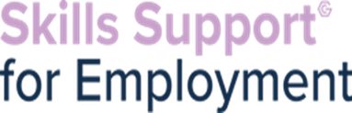
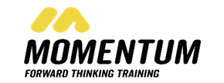

In partnership with Momentum Training we are now providing an online CSCS course in Manchester. Successful completers will then be supported by Momentum and The Growth Company to find employment within the industry.

2 Week full time course -Expected start date around 16th August- to be confirmed at sign up
Qualifications: Team Leading level 2, Equality and Diversity level 2 & Health and Safety on a construction site
Learners MUST have access to a laptop to undertake this course



On completion of the course Momentum then issue credits that allow the learner to book their exam at the local test centre, this cost would be covered by Momentum.


Eligibility:
• 18+
• Unemployed
• Proof of benefits if on benefits
• Have I.D and Proof of Address/ Have proof of right to live and work in the UK
• Must have photographic ID (valid passport, Driving licence or Biometric Residence Permit)
• Must have a laptop
• Entry 3 English/good level of spoken English (English and Maths assessment to be undertaken)
• Resident of Greater Manchester
• Not in full time education

If you have any referrals for this opportunity, please email melanie.lamb@gcemployment.uk

