
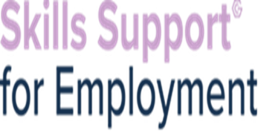
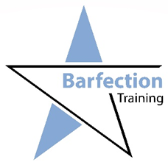

In partnership with Barfection Training we are delivering various hospitality courses which are perfect for those who are looking to start employment in the vibrant Manchester hospitality sector. On successful completion of the course customers will be linked in with various hospitality vacancies via our Employer Engagement Team.
Courses:
Barista Training -online & part face to face – 13th July 2021
Cocktail making- online & part face to face – 19th July 2021
Food safety-online – 16th and 30th July 2021
Personal licence-online – 9th July 2021

Classroom training to be in Manchester City Centre location and will be confirmed once registered.



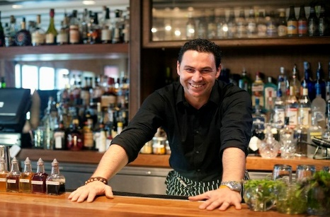

You will be eligible for SSE if you are:
•Unemployed (you can be on benefits or not)
•Have Proof of Address and Identification (including proof of right to live and work in the UK if needed)
•A resident of Greater Manchester
•Must be Entry Level 3 in English
•Must have good level of IT skills to undertake sign up and online training
•Not in full time education

If you have any referrals for this opportunity, please email: melanie.lamb@gcemployment.uk

