***COUCH TO COLLEGE VIRTUAL EVENTS – STARTING NEXT WEEK***
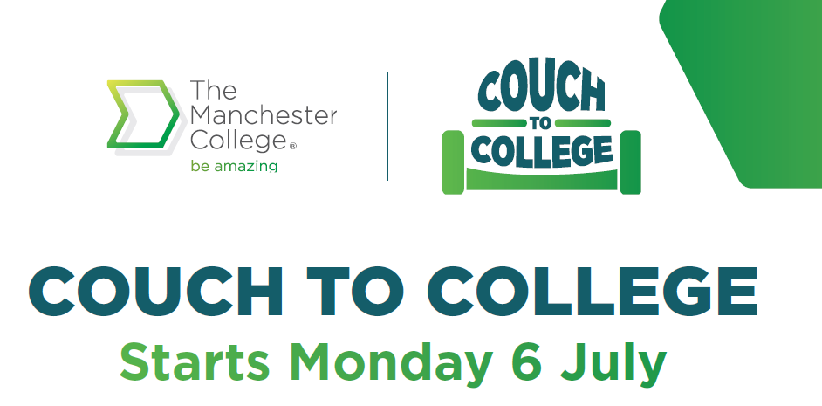
We would be grateful if you could share details of our exciting virtual Couch to College events starting next week to any interested Year 11 and 10 pupils. If you and/or any pupils/school staff would like to register for these events then please visit: www.tmc.ac.uk/couch-to-college/

The School Liaison Team will also be running a ‘Making a College Application’ session on Tuesday 7th July from 5pm to 6pm, if any pupils need support with completing their application we would encourage them to join our quick and easy step by step session!

Information for pupils

STARTING NEXT WEEK

Discover everything you need to know about studying at the no.1 college in Greater Manchester for achievement this September in our series of Couch to College online sessions.

Couch to College is not just an online open day. These events will connect you to employers, open new doors of opportunity and allow you to make informed decisions about your future.
BOOK YOUR SESSIONS NOW!
We are excited to launch our 3-week schedule of on-line sessions as part of our Couch to College activities which have been designed to help School Leavers make the right choice about your future and the next steps into.
We would encourage you to register for as many sessions as you are interested in. There is no limit, visit www.tmc.ac.uk/couch-to-college/ to get a full schedule of events and further details.
What’s happening from next week? (Please see below)
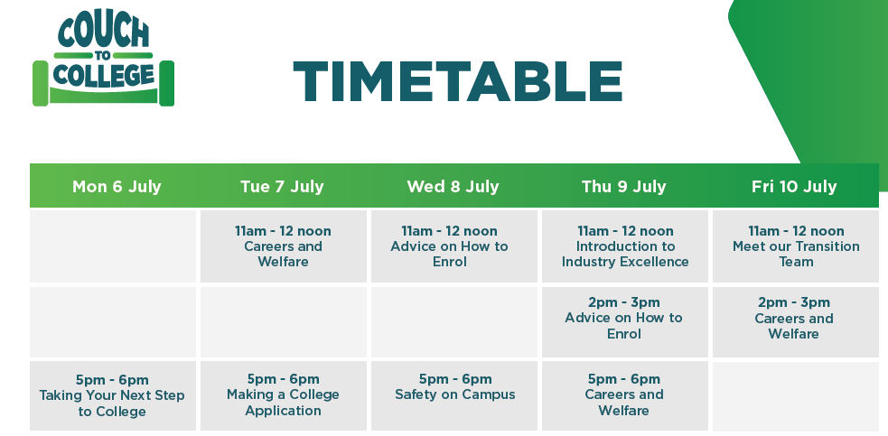

Week commencing 13th & 20th July 2020
Our industry expert curriculum departments will be delivering further interactive live sessions talking you through our fantastic range of vocational and technical programmes. During the final week you can find out more about college life and what support is available to you.
To view the full schedule and to book your place, visit: www.tmc.ac.uk/couch-to-college/

