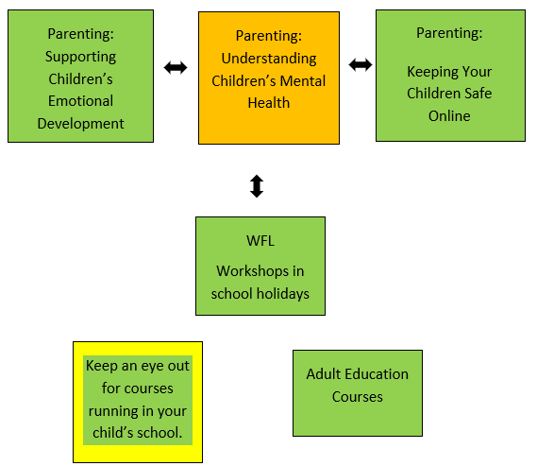


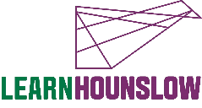
We can also provide you with information, advice and guidance for employment or further learning.
- Please speak with your tutor or
- Call 020 8583 6174 to speak to an advisor or
- Email work@hounslow.gov.uk or
- Visit www.workhounslow.co.uk

Parenting:
Understanding Children's Mental Health
Progression Pathway
020 8583 6000
courses@hounslow.gov.uk
www.hace.ac.uk
About the Course
This is an online course.
Parenting courses aim to help parents and carers enhance their relationship with their child, as well as have a chance to share ideas with other parents and develop support skills.
On this course you will explore the world from your child’s perspective. You will learn how to ‘read’ your child’s emotions and how outside factors can influence your child’s wellbeing. You will also explore ways on how to connect with your child in a way that will support your child’s emotional well-being and resilience.
Course Learning Outcomes
- Understand factors that may influence your child’s mental health.
- Understand the pressures of society and how to stay connected to your child’s needs and wellbeing.
- Discuss how to support your child’s holistic needs and the importance of building strong attachments/connections.

Please note: To successfully complete this course you must commit to 100% attendance and punctuality.
We recommend that you do only one of our online parenting courses per term due to classwork and homework commitments.
What is needed for the course?
- To be a parent/carer
If you need any additional support, please call 020 8583 6000

