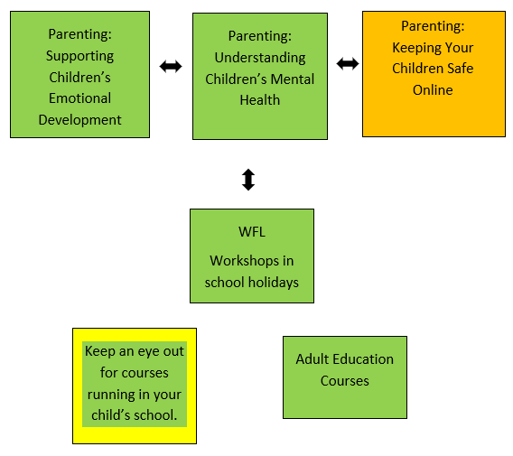



Parenting: Keeping Your Children
Safe Online
Progression Pathway
020 8583 6000
courses@hounslow.gov.uk
www.hace.ac.uk
About the Course
This is an online course.
Parenting courses aim to help parents and carers enhance their relationship with their child, as well as have a chance to share ideas with other parents and develop support skills.
The intent of this course is to support parents and carers to understand the advantages and risks of the Internet on their children’s development and develop strategies to eliminate these risks.
Course Learning Outcomes
- Understand the online risks that your child might be exposed to.
- Understand the terminology used in the online world related to online safety.
- Understand how parental controls can be used to keep your child safe.
- Research current apps and games your child might be exposed to.

Please note: To successfully complete this course you must commit to 100% attendance and punctuality.
We recommend that you do only one of our online parenting courses per term due to classwork and homework commitments.
What is needed for the course?
- To be a parent/carer
If you need any additional support, please call 020 8583 6000

We can also provide you with information, advice and guidance for employment or further learning.
- Please speak with your tutor or
- Call 020 8583 6174 to speak to an advisor or
- Email work@hounslow.gov.uk or
- Visit www.workhounslow.co.uk

