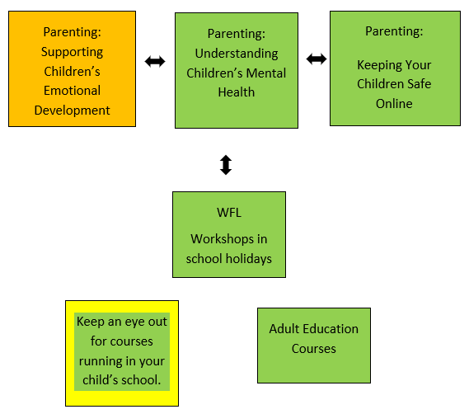


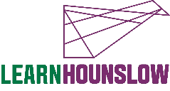
Parenting: Supporting Children’s
Emotional Development

Progression Pathway
020 8583 6000
courses@hounslow.gov.uk
www.hace.ac.uk
About the Course
This is an online course.
Parenting courses aim to help parents and carers enhance their relationship with their child, as well as a chance to share ideas with other parents and develop support skills.
This is a parenting course to support emotional attachment and security within the family.
Course Learning Outcomes
- Understand your child’s emotional world by learning to read their emotional needs.
- Support your child’s ability to successfully manage emotions and enhance the development of your child's self-esteem.
- Honour your innate wisdom and desire for your child to be secure.
Please note: To successfully complete this course you must commit to 100% attendance and punctuality.
We recommend that you do only one of our online parenting courses per term due to classwork and homework commitments.
What is needed for the course?
- To be a parent/carer (ideally to have children between the ages of 0-7 years)
If you need any additional support, please call 020 8583 6000

We can also provide you with information, advice and guidance for employment or further learning.
- Please speak with your tutor or
- Call 020 8583 6174 to speak to an advisor or
- Email work@hounslow.gov.uk or
- Visit www.workhounslow.co.uk

