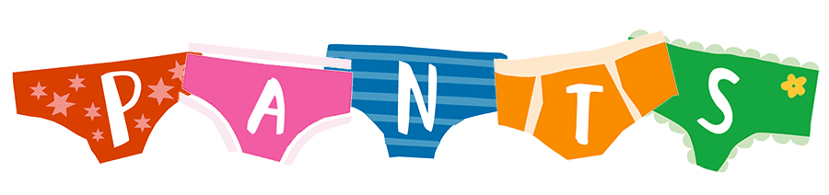
Did you know that the NSPCC has its very own dinosaur – it us known as Pantosaurus – but it’s ok, it is a friendly dinosaur!
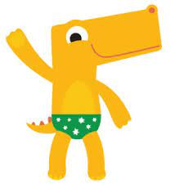
Talk PANTS helps children understand that their body belongs to them, and they should tell someone they trust if anything makes them feel upset or worried. All children need protecting and this is one of the ways we can do this.
Show a parent the website – support them in how they can teach the children the rules; if parents really feel they can’t do it themselves; go though it with the child yourself - (even better if the parent is there too).
There is a singalong video to help them remember; and you can buy books and other resources on the website, including books in other languages.
Broaching the subject can be difficult with parents/guardians but remember they want to protect their children too. Explain that it is something all children should know; that you discuss it with all parents/guardians, make them know you aren’t singling their child/children out. Be confident in your knowledge and practice active listening, looking at parent/guardian’s nonverbal communication as well as answering any spoken queries – it is a sensitive subject, and they might feel awkward – if you act like it is a perfectly normal discussion they will relax more and are more likely to do it with their child/children. Remind the parents/guardians that their young ones will be more comfortable with them going through it than a professional. Make it fun and memorable, sing with the dinosaur; if you get the parent/guardian to enjoy it while you show them the website, they will enjoy teaching their child/children who in turn are more likely to remember the message when it’s shown them in a fun way.
Privates are private
Your underwear covers up your private parts and no one should ask to see or touch them. Sometimes a doctor, nurse or family members might have to. But they should always explain why and ask you if it's OK first.
Always remember your body belongs to you
Your body belongs to you. No one should ever make you do things that make you feel embarrassed or uncomfortable. If someone asks to see, or tries to touch you, underneath your underwear, say 'NO' – and tell someone you trust and like to speak to.
No means no
No means no and you always have the right to say ‘no’ – even to a family member or someone you love. You’re in control of your body and the most important thing is how YOU feel. If you want to say ‘no’, it’s your choice.
Talk about secrets that upset you
There are good and bad secrets. Good secrets can be things like surprise parties or presents for other people. Bad secrets make you feel sad, worried, or frightened. You should tell an adult you trust about a bad secret straight away.
Speak up, someone can help
Talk about stuff that makes you worried or upset. If you ever feel sad, anxious or frightened you should talk to an adult you trust. This doesn't have to be a family member. It can also be a teacher or a friend's parent – or even Childline.
https://www.nspcc.org.uk/keeping-children-safe/support-for-parents/pants-underwear-rule

