# See the source image

# Nursery closures

**CONSIDERATIONS to AVIOD ANY TEMPORARIY CLOUSRES**

**Early years supporting the recovery**

what can i do NOW?

* **Hold a (virtual) staff meeting** including your staff and valuing their input makes the team contribution more solution based rather than barrier built
* **Make a map of your provision** a Birdseye view will help explore considerations – consider communal areas, were one-way systems could be implemented and if there is possible different entrance and exits for children and families
* **Group sizes / staff rotas** ensure that bubbles do not mix this needs to include staff as well as children. Staff breaks need to be staggered and if using a staff room cleaning will need to be implemented between each use
* **Review your risk assessment** with any changes you make to the environment you may need to consider changes to
  + Cleaning secludes
  + Emergency procedures for example evacuation procedures

The number of early years settings having to temporarily close because of Covid-19 infections appear to be rising

Closures have been raising both nationally and locally in Early Years settings this obviously has disrupted education for children. Advice has been sort from many providers from the Early Years and Childcare service about what can be done to avoid closures.

Early years staff across the country have worked incredibly hard to keep settings open through the pandemic so that young children can be educated, and parents can work.

Vicky Ford MP

Parliamentary Under-Secretary for Children and Families

The Early Years Reference Sub-group (a group made up of Hounslow settings managers, practitioners and owners) were tasked with exploring practical ways to avoid closures which is not a one size fits all approach and really is dependent on the premises providers operate from.

Therefore, the Sub-Group would like to share with you the types of considerations they have explored either through practitioners sharing these tips with them or considerations that advisors have suggested.

Many venues have more than one room, if this is the case in your provision use the space you have, creating bubbles to alleviate any possible closures

Dividing playrooms to ensure bubbles can be maintained and therefore any cases that are identified only close contacts would need to isolate.

The Sub- Group thought creatively about the ways that you can divide your setting and maintain safety for all. These included:

* use furniture to divide areas - many settings have community playthings movable cupboards which can be positioned to create divides and are lockable.
* provide more opportunities for outdoor play
* if providers operate in one room and the provision has been divided by using furniture and other resources, large group times can be provided to all with members of staff overseeing another bubble is necessary. Large group times include song and rhyme times

**organisational aspects**

* plan cleaning schedules for communal areas
* staggering staff breaks
* key groups became bubble groups / some staff have more key children
* Creating virtual options to alleviate any anxieties of parents about the arrangements put in place to keep their children safe
* ideas for creating maintained provision outside

The Early Years advisory team have provided a useful outdoor provision reflection for providers to share their teams [**Open ended resources - outdoors**](https://eur01.safelinks.protection.outlook.com/?url=https%3A%2F%2Fcontent.govdelivery.com%2Fattachments%2FUKHOUNSLOW%2F2021%2F02%2F12%2Ffile_attachments%2F1692726%2Fopen%2520ended%2520resources%2520-%2520outdoors.pdf&data=04%7C01%7CJan.Milstead%40hounslow.gov.uk%7C0752aa2816394f79e69d08d8cf6e36fa%7C5b62666662464c9bacc7716a5a94bd03%7C0%7C0%7C637487419554790954%7CUnknown%7CTWFpbGZsb3d8eyJWIjoiMC4wLjAwMDAiLCJQIjoiV2luMzIiLCJBTiI6Ik1haWwiLCJXVCI6Mn0%3D%7C1000&sdata=dhAuBylHYDddz8GUau7k2IffRujZReS%2B%2FOxjKF1RyDM%3D&reserved=0)

**funding**

# Staff anxiety

Many staff members are understandably anxious about attending the workplace during the pandemic.

as well as implementing the avoidance of closure measures above which will alleviate some anxiety

Very sensitive discussions may need to take place with staff to establish what their anxieties are and how they might best be supported moving forward.

The Sub-group have carefully explored solutions to support staff members anxiety, firstly by gathering information such as:

* completed suitability declaration
* return to work supervision meeting
* provide advice for staff about healthy eating and good sleep routines
* Sharing risk assessments or completing together
* offer training and ongoing support to help staff manage difficult situations with parents or children for example, how to speak to parents who do not follow social distancing roles
* provide training on for example new procedures and practices (Infection control)
* establish with staff the importance of the PSED curriculum, focus areas you want them to work on with children
* simplify staff workload to ensure they do not feel under pressure, there are disapplication’s to the EYFS - use them to support staff - list applications

We have been how old that some staff are reluctant coming to work during this time either due to home schooling or anxieties of the virus, managers have sought advice from the early years team who firstly have signed posted to

[](https://www.acas.org.uk/advice)

Some providers have needed to consider amendments to staff contracts or even making redundancies and acas can help providers with these sensitive arrangements.

# Links to support staff / families

We understand that there is no one size fits all solution now when it comes to trying to keep our heads above water, we all face unique challenges in both our personal and professional lives. Below is a selection of resources that may be able to offer help if you need it.

[www.giveusashout.org](http://www.giveusashout.org)

If you are finding life tough and are struggling to cope, text the word ‘SHOUT’ to 85258. They have trained volunteers available 24/7 to listen to you and support you to get to a calmer and safe place. Shout is a free, confidential and anonymous service for anyone in the UK and won’t appear on your phone bill.

[www.nhs.uk/oneyou/every-mind-matters](http://www.nhs.uk/oneyou/every-mind-matters)

Expert advice and practical tips to help you look after your mental health and wellbeing. Topics include stress, anxiety, low mood and fatigue.

[www.hounslowiapt.nhs.uk](http://www.hounslowiapt.nhs.uk)

Hounslow’s IAPT (Improving Access to Psychological Therapies) Service provides information on workshops and therapies and offers a self-referral service.

Virtual Support



* Calm and Headspace both help with sleep, meditation and relaxation techniques
* Colorfy – offers digital mindfulness colouring
* Dare – how to cope with anxiety
* Nature Sounds Relax and Sleep – to help calm racing thoughts
* Breathwrk – breathing exercises to help alleviate anxiety



Type in “Guided Meditation” for some help to take your mind elsewhere



* Feel Better, Live More – Dr Rangan Catterjee
* All in the Mind – BBC Radio 4
* The Calmer You – Chloe Brotheridge
* Happy Place – Ferne Cotton

Top tips to show kindness and support to staff teams

Bake a cake for the team 

Send small gifts

A bar of chocolate

Flowers

Chamomile tea

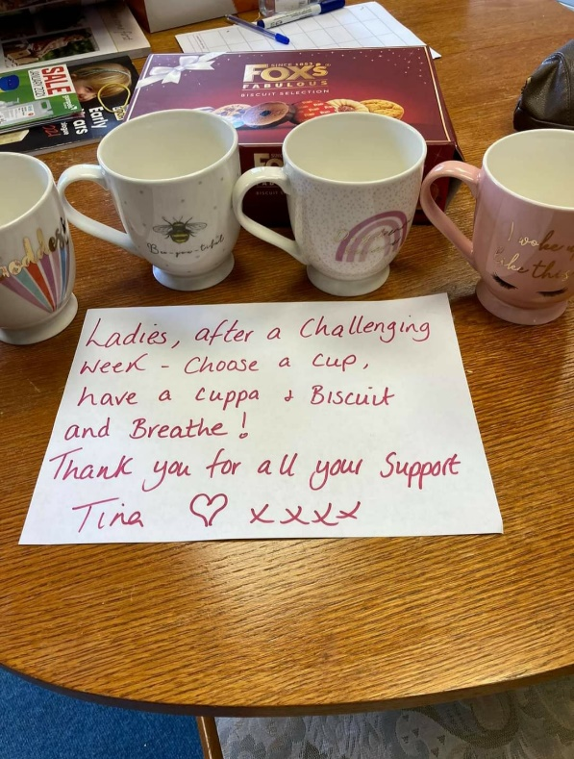



Put a note on someone’s car thanking them

Phone staff more regularly to see how they are doing

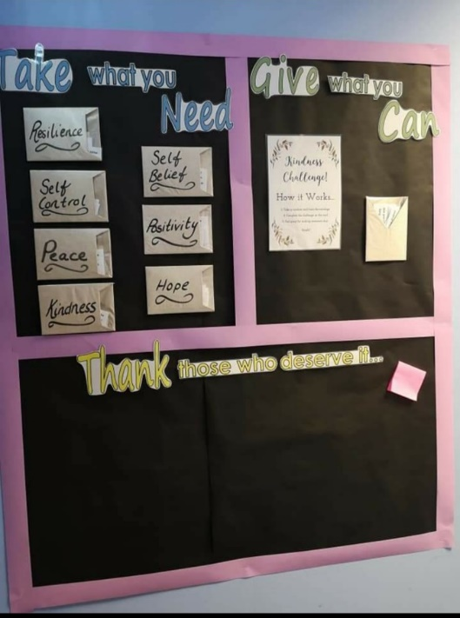

Wellbeing basket

Staff room team challenge