HbA1c Guidance Protocol
**** NEW ****
The Data Quality Team and Diabetic Prevention Leads have created a protocol to help with the possible coding and referral of Non-Diabetes Hypoglycaemia and possible Diabetes.

Please add the below protocol to your F12 key to be used in patients who have had a HbA1c results in the last 12 months.

Adding a Protocol to F12 Launcher

- When in a patient’s medical records press F12
- The protocol launcher will appear, select the letter you would like to add the protocol to H for HbA1c if free
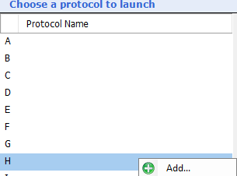
- Right click
- Add
- Navigate the folders to:
00 l Data Quality NHS GM l Diabetes l HbA1c Protocol launcher
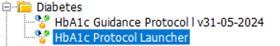
- The HbA1c Protocol will now be linked to your launcher
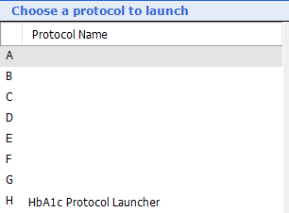

Launching Protocol

When the protocol is launched from the F12 Key, the following prompt will appear please click which ever register shows.
If blank, please choose the no diagnosis coded in medical records.

No Diagnosis coded in medical records scenario

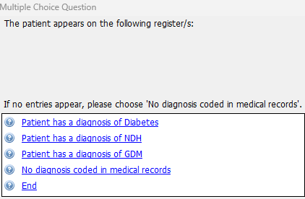

If the result was to be 42-47.9

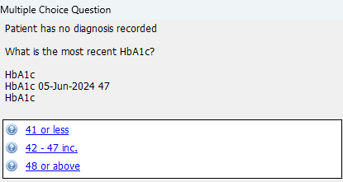

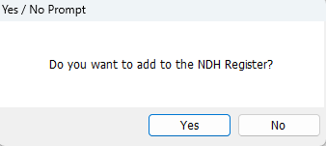

If yes is chosen a diagnosis code of Non-Diabetic Hyperglycaemia will be added to the patient medical record with the following message

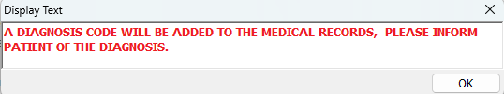

The Yes or No option will then lead you to the NDPP referral as the patient can still be referred without a diagnosis

If no referral status is coded within the records this will be blank, please choose an option
the referral /invite will populate the referral letter

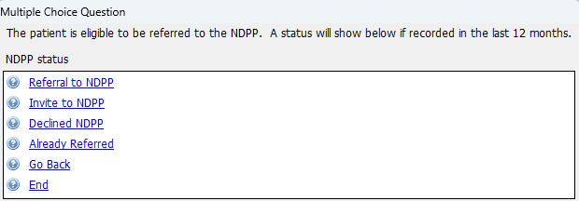

Declined referral will add a code in the background to the patient medical record Once the letter is actioned or already referred is clicked you will be presented will the following.

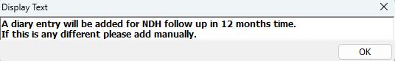

If the result was to be <41
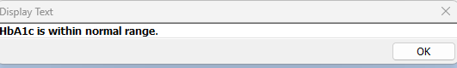

If the result was to be >47.9 you will see the message below and a task will be opened.
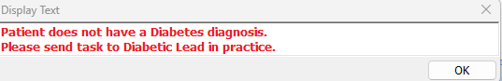

Non-Diabetic Hyperglycaemia coded in medical records scenario

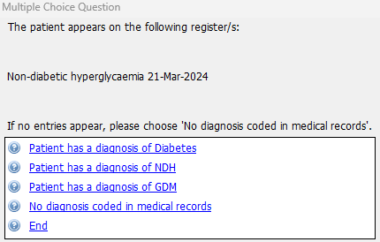

If the result was to be <41
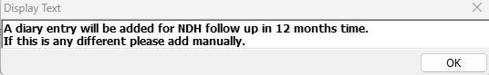

If the result was to be 42 – 47.9
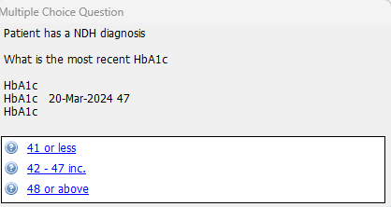

Patient is eligible for a referral to NDPP if not completed in the last 12 Months.
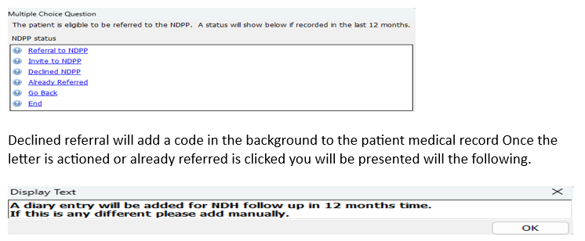

If the result was to be >47.9
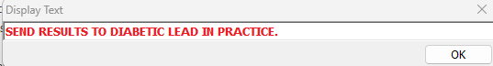

A task can now be sent to your chosen Diabetic lead within the practice.

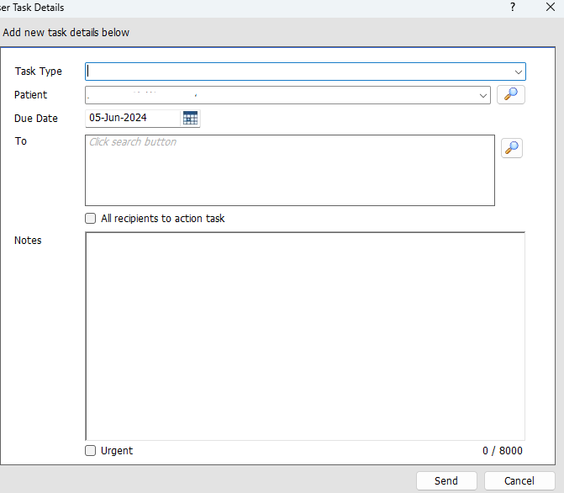

Gestational Diabetes Mellitus coded in medical records scenario

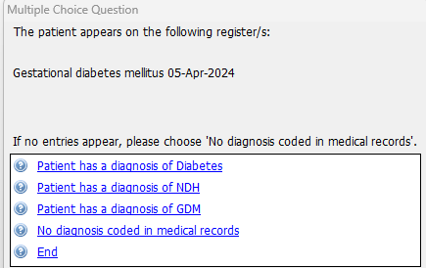

If the HbA1c was to be <41

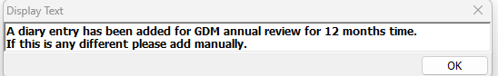

If the Hba1c was to be over 42

A diary entry will be added as a backup.

Diabetes coded in medical records scenario

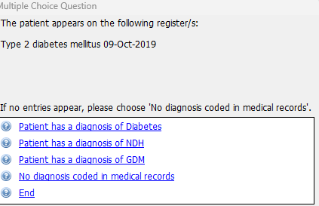

Please choose which ever range the Hba1c falls into
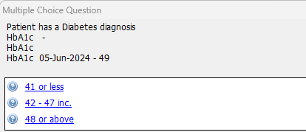
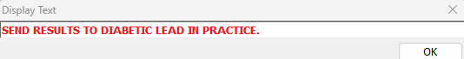

A task can now be sent to your chosen diabetic lead within the GP Practice

If the result was to be 42-47 this message will appear
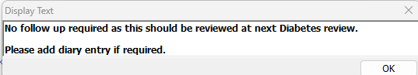

If the result was to be 41 or less
