The Robin Performance Status Report

PerFormance FOR THE PERIOD: 1 January 2024 to 31 MARCH 2024
Report Date: April, 2024 | SERVICE NAME: The Robin (DRT) | Prepared By: T Rumer

HIGHLIGHTS For THIS PERIOD (Operations)
Operator: Lydney Dial A Ride
Robin area/territory: South Forest Of Dean
- Service usage remains high.
- The mobile phone App is used for most bookings, and Call Centre plays an important role in bookings as well.
- After software and hardware issues and delays, contactless became functional on the two Forest vehicles (11.04.24).

Operator: Pulhams Coaches
Robin area/territory: North Cotswold
- New marketing publicity (A4 poster and window sticker) were produced externally, received by GCC in February. Distribution is underway, and a press release and animation publicity have been circulated.
- The mobile phone App is used for almost all bookings.

MONTHLY PERFORMANCE STATISTICS
NORTH COTSWOLDS | JAN 24 | FEB 24 | Mar 24
Passenger trips (total number of people who travelled. More than one person can travel in one booking) | 374 | 428 | 529
Journeys (%) booked through App / Web portal / Call Centre | 95 / 2 / 3 | 90 / 4 / 6 | 90 / 3 / 7
Newer users (number of people who booked who  on average book less than 5 times a month) | 45 | 50 | 54
Repeat users  (between 5 to 20 bookings a month & more than 20 trips a month) | 16 & 2 | 18 & 2 | 17 & 4
FOREST OF DEAN | JAN 24 | FEB 24 | MAR 24
Passenger trips (total number of people who travelled. More than one person can travel in one booking) | 828 | 849 | 856
Journeys (%) booked through App / Web portal / Call Centre | 71 / 13 / 16 | 65 / 16 / 19 | 70 / 7 / 23
Newer users (number of people who booked who  on average book less than 5 times a month) | 64 | 86 | 88
Repeat users  (between 5 to 20 bookings a month & more than 20 trips a month) | 34 & 5 | 38 & 4 | 33 & 7

Robin Update (Planning & strategy)

Robin Project element: Call Centre for all Robin areas
Highlight this period: New supplier
- The Robin Call Centre contract is now provided by Lydney Dial a Ride. The previous contract with Lincolnshire County Council has come to an end via mutual agreement. Transfer of phoneline took place on the 10th of January.
- Outcomes from training days between Padam and LDAR, and user feedback, show that the new provision of the phone line is an advantage to (i) GCC as the owner and accountable for The Robin, and (ii) provides an improved service to Robin users.
- Call Centre functions (bookings through the Call Centre, the ability to answer public questions and communicate in a thorough manner, and shift management / cancelations) continue to be invaluable to functionality and easy-access to The Robin.

Robin Project element: Areas of operation (Robin territories)
Highlight for this period: Tenders completed for three new Robin areas
- Three tenders for the new Robin areas were published by ITU in January.
- The three areas are Berkeley Vale, South Cotswold and Tewkesbury District
- More detail to follow in due course (including the winning operators and proposed launch dates)

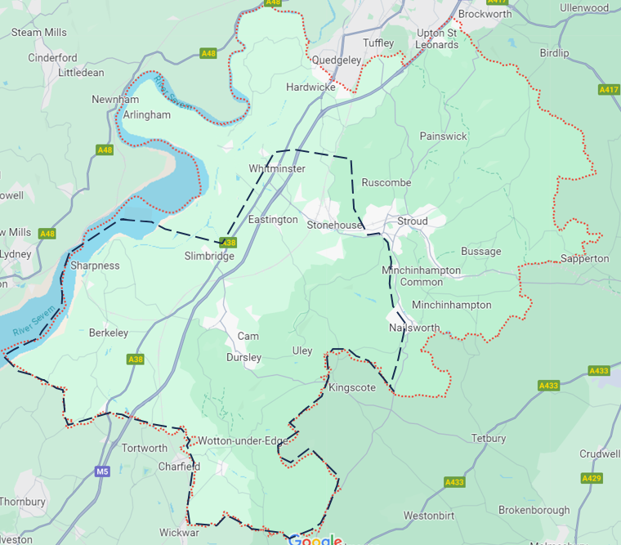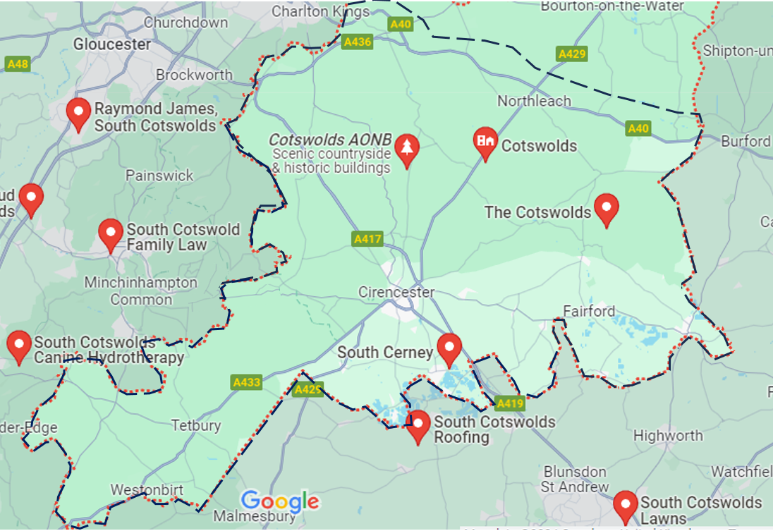

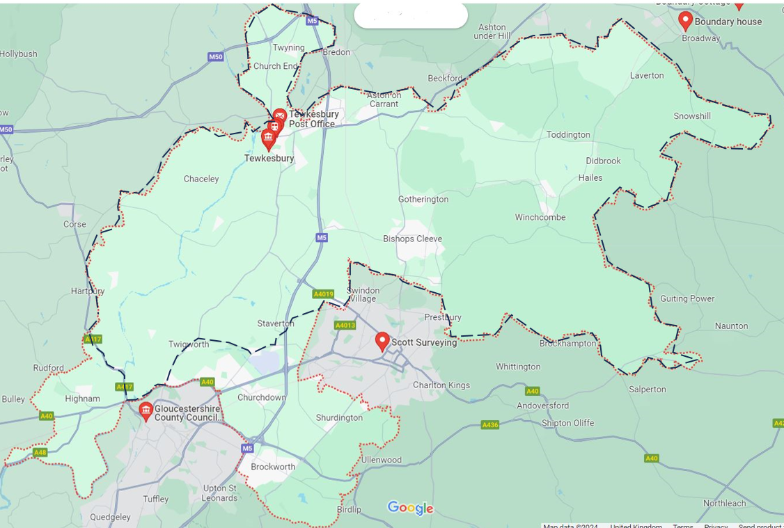
- Areas shown in dashed black line.

Berkeley Vale (above left), 90 sq miles
South Cotswold (above right), 250 sq miles
Tewkesbury District (left), 100 sq miles

- Red dotted line is district boundary.
- Square miles listed are estimates (+/- 10 sq miles)

