

Our Corporate Memory
135 years of local government in Gloucestershire

Saturday 6 April 2024 1pm-4pm

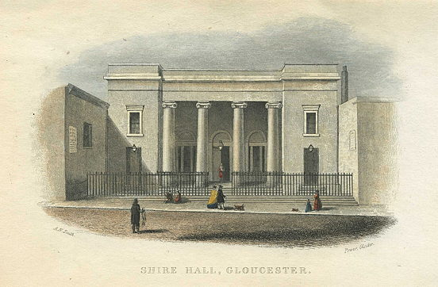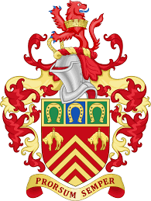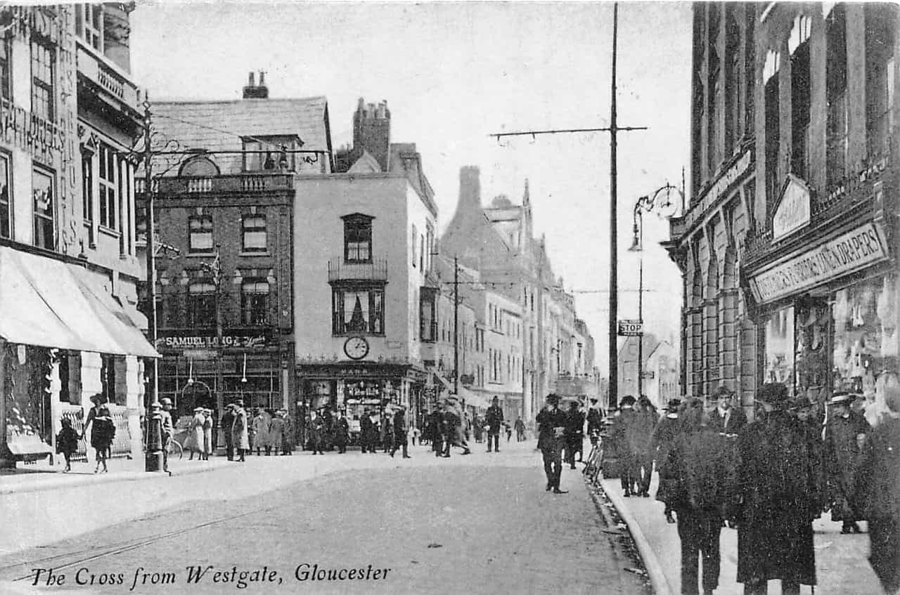

Talks: [booking essential due to room capacity limits]

- 1.15pm – ‘Public Servants All – A selection of officers and councillors illustrating 135 years of change in Gloucestershire Local Government’ by Chas Townley
- 2.30pm - ‘Great Intentions: the education service in Gloucestershire in the 20th century’ by Karen Davidson, Senior Archivist (Gloucestershire Archives)

- A new attraction! Come and see ‘The Big Drawers – our Cabinet of Curiosities’ featuring 20 mini dioramas of County Council functions!
- Document display of parish, district and County Council collections held at the Gloucestershire Archives
- Free refreshments throughout the afternoon
- Employed by the Council or proud to represent your local community? Discover your family history at the Gloucestershire Family History Resource Centre, open from 10am

[Main event starts at 1pm] Booking essential for the talks.
Heritage Hub, Clarence Row, Alvin Street, Gloucester GL1 3DW. Parking on-site For more information, see our website at www.heritagehub.org.uk
Image courtesy of antiqueprints.com

