A guide about the safe use of all belts – our duty of care.
Please read this leaflet and keep it safe

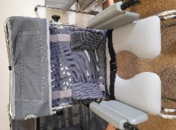
What is a safety lap belt for?

- Safety lap belts help to stop the person slipping out of equipment as they are moved.

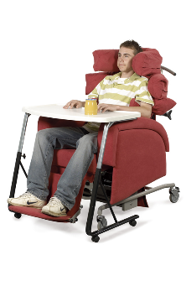
What is a Pelvic lap belt for?

- To help the person have a good sitting position.
- To try to stop the person slipping out of the specialist chair.

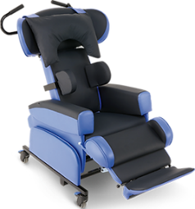
What other equipment supports a person to be safe?

- Footplates add safety by taking the weight of the person in sitting.
    - Side supports (laterals) can help keep a person in the middle of the chair.
    - Tilt in space moves the persons position. This keeps them safe so they are not leaning forwards or to the side.

What are the risks of using belts incorrectly?

Sadly, every year injuries and deaths happen due to equipment not being used correctly.
People have fallen onto the floor or suffered strangulation when equipment is not fitted, kept in good condition or used correctly. It is everybody’s duty of care to understand how to use equipment correctly.

How do I know I have it right?
It is essential the below points are followed to minimise risk of harm or serious injury when using equipment with belts, this is the responsibility of all carers and managers working with the person.
- All equipment with a belt has been demonstrated and handed over to a carer/Make sure it fits and is used as taught.
- Follow written guidelines provided.
- Speak to your manager if you are unsure how to use the equipment.
- Contact the service that provided the equipment if the person’s needs have changed or you are concerned.
Contacts for concerns:
Wheelchair services – 0300 421 7170

Gloucester CLDT - 01452 894280 North CLDT - 01242 634300
Forest CLDT - 01594 593075 Stroud CLDT - 01453 563103

An example:
The person sits with their bottom at the back of the seat before the belt is fastened. In this example the person is sitting on a shower chair, this guidance is for all seating and wheelchairs where a belt is provided.

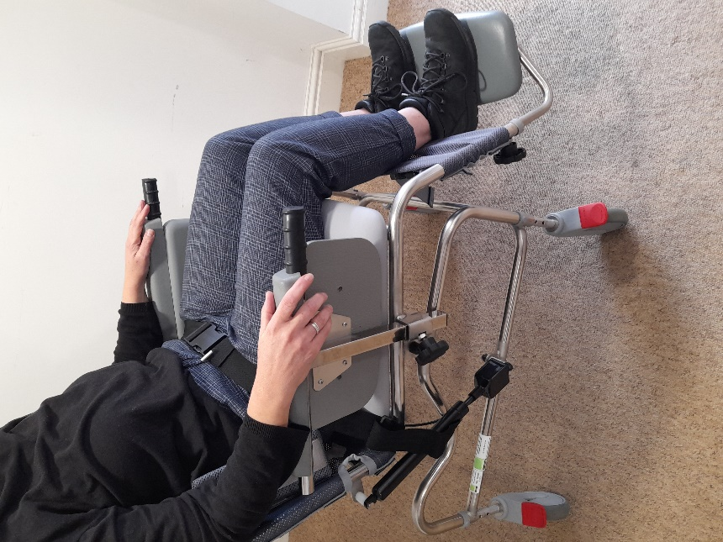
The person should also have their feet on the footplate. This takes the weight of the person and provides stability.
The lap belt or lap strap should fit snuggly to the person in the equipment.
If the belt is loose, it becomes a risk to their safety.

