Recognising signs of deterioration in people with learning disabilities
 |  |  |  | Resources:
1 | Something anyone who knows the individual well can do.  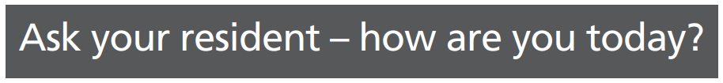 |  |  | Soft signs Video  Possible signs of deterioration – Stop and Watch Video  Recognising deterioration in people with a learning disabilities Video  SBARD Video  Restore 2 mini & SBARD form
 | 2 | Something you can use to help take and record physical observations and escalate onwards |  | Restore 2 video  Watch these films  NEWS: What is it?  Measuring the respiratory rate  Measuring oxygen saturation  Measuring blood pressure  Measuring the heart rate  Measuring level of alertness  How to measure temperature  Calculating and recording a NEWS score  Restore 2 and SBARD form
 |  | 3 | Telehealth
Introduction to sepsis and serious illness

