Hello

We are working on a project with the NHS called Careers that Care
We would like to get more people to work in health and social care in all sorts of roles!
We would like to hear about what is good about having support (like a Personal Assistant (PA), support worker or social worker) or having a heath care worker (like a physio, a speech and language therapist or a Health Care Assistant in hospital)

We think that people who get support and use health care services or people that work in Health and Social Care are the people who know what a good professional in these jobs is like.
To encourage people who would be good at caring jobs to work in this area, we would like people who use these services to tell us the difference having these services makes to them. We would also like people who already work in health and social care to tell us how rewarding their job is and how they can see their making a difference.
We want people to make videos to tell us about their story. We will have a website with videos from people with autism or Learning Disabilities saying how they feel about the people who support them.
There will be videos of people who work in health and social care about what they do and why they do it as well.
The website where the stories and videos will be saved is www.careersthatcare.co.uk
We will also put the stories and videos on Facebook, Instagram and other websites if you agree. You will be able to decide where your story is put.
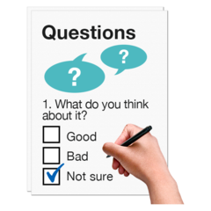
We are asking people with Learning Disabilities and or autism who don’t want to make a video, to answer a survey to tell us their story.

We have sent some Call to Action postcards with this email if you could please share these with people with Learning Disabilities or Autism that you know. Could you also send them to anyone you know who works in Health and Social Care?

Please share this with as many people as you can. We want to hear from anyone with autism and/or learning disabilities in the South West.
Thank you for your help

Kind Regards
Careers that care

