

**POA Learning - Dartmoor and the South West**

**October 2019 Newsletter**

With the summer holidays now well behind us and Winter around the corner, maybe it’s time to focus on some self- development!!

If you have been thinking about learning some new skills or further developing current ones, why not take a look at the distance learning courses that POA Learning has on offer? Don’t forget that all of our NVQs are fully funded* and nationally accredited. Email us for a full list, or take a look at two of our featured courses below:

**Level 2 Certificate in Understanding Behaviour that Challenges**



This course takes 8 – 12 weeks to complete and includes the following:

**Unit 1: Understand behaviour that challenges**

**Unit 2: Understand how to support positive behaviour**

**Unit 3: Understand the importance of effective communication and the management of behaviour that challenges**

**Unit 4: Understand the role of reflection and support for those involved in incidents of behaviour that challenges**

**Level 2 Certificate in Counselling Skills**



This course takes 16 - 20 weeks to complete and includes the following:

**Unit 1: Using Counselling Skills**

**Unit 2: Introduction to counselling skills theories**

**Unit 3: Diversity and ethics in the use of counselling skills**

**Unit 4: Counselling skills and personal development**

* To qualify for funding the Learner must be aged 19 or above, have been an EU Citizen for 3 or more years and currently reside in England.

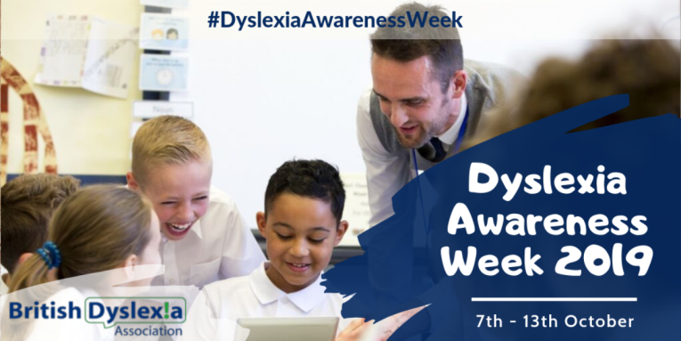October 7th to 13th is Dyslexia Awareness Week. Look out for more from us next week!

To see what POA Learning is up to nationally, have a look at our [Facebook](https://en-gb.facebook.com/POALearningOfficial/) and [Twitter](https://twitter.com/POALearning?ref_src=twsrc%5Egoogle%7Ctwcamp%5Eserp%7Ctwgr%5Eauthor) pages!

If you are interested in our featured courses, or would like to explore our full list of 47 NVQs, please contact us and we will be happy to help.

**Contact Sue or Ivan at POA Learning Dartmoor**

**Call: 01822 322241**

Email: [susan.hunt@poalearning.org.uk](mailto:susan.hunt@poalearning.org.uk) or [ivan.judd@poalearning.org.uk](mailto:ivan.judd@poalearning.org.uk)